Explanatory document of the methodology for performing the probabilistic dimensioning of FCR in CE synchronous area according to Article 153(2) of Commission Regulation (EU) 2017/1485 of 2 August 2017 establishing a guideline on electricity transmission system operation
Date: __ ________ 2023

Contents
1 Acronyms and references 3
2 Introduction 3
3 Description of FCR 5
4 Methodology for probabilistic approach for FCR dimensioning 6
4.1 Overview and description of the methodology 6
4.2 Functionality for DFDs statistics and DFDs random extractions 9
4.3 Functionality for LLFDs statistics and LLFDs random extractions 9
4.4 Functionality of outages random extractions and calculation of associated power imbalances 10
4.5 Functionality of combination of extracted DFDs, LLFDs and outages to generate global power imbalance trends 11
4.6 Model to calculate the steady state frequency deviation in every minute. 12
4.7 Model to calculate the dynamics of the frequency deviation in each minute. 14
4.8 Assessment of the acceptability criteria on the resulting simulated frequency deviation 16
5 Input to be used for the FCR dimensioning 18
5.1 Frequency deviation 18
5.2 Outages 18
Outages on production units 19
Outages on HVDC 19
5.3 Load and inertia 19
5.4 LER Presence and TminLER 19

Acronyms and references
ACE Area Control Error
CE Continental Europe
LER FCR providing units or groups with limited energy reservoir
FCR Frequency Containment Reserve
FCP Frequency Containment Process
FRR Frequency Restoration Reserve
FRP Frequency Restoration Process
FSM Frequency Sensitive Mode
Non-LER FCR providing units or groups without limited energy reservoir
NP RES Non Programmable Renewable Energy Sources
RES Renewable Energy Sources
SO GL System Operation Guideline
SA Synchronous Area
T_{min LER} As of triggering the alert state and during the alert state, time for which each FCR provider shall ensure that its FCR providing units with limited energy reservoirs are able to fully activate FCR continuously.
FAT Full Activation Time of FRR
ROCOF Rate of Change of Frequency

[1] COMMISSION REGULATION (EU) 2017/1485 of 2 August 2017 establishing a guideline on electricity transmission system operation.
[2] ENTSO-E, SPD, “Frequency Stability Evaluation Criteria for the Synchronous Zone of Continental Europe”, 2016.
[3] ENTSO-E, SPD – Inertia TF, “Inertia and Rate of Change of Frequency (RoCoF)”, 2020.
[4] ENTSO-E, “ENTSO-E HVDC Utilization and Unavailability Statistics 2021”, 2022.

Introduction
The System Operation Guideline (SO GL) drafted by European Network of Transmission System Operators for Electricity (ENTSO-E) with guidance from the Agency for the Cooperation of Energy Regulators (ACER) was approved in comitology in May 2016 and adopted by European Commission in August 2017.
Article 153(2) of the SO GL provides the possibility for TSOs in CE SA to “define a probabilistic dimensioning approach for FCR taking into account the pattern of load, generation and inertia, including synthetic inertia as well as the available means to deploy minimum inertia in real-time […], with the aim of reducing the probability of insufficient FCR to below or equal to once in 20 years”.
This document contains an explanation of the methodology the CE TSOs have defined in order to fulfil such probabilistic dimensioning approach.
After a brief introduction on FCR (Section 3), the document is divided into two main sections:

- Description of the methodology proposed for the FCR probabilistic dimensioning (Section 4)
In this section, the model developed by CE TSOs to perform the dimensioning is described. To allow a better understanding, the model is divided into different functionalities which interact each other:
- Calculation of DFDs statistics and DFDs extractions (Section 4.2).
- Calculation of LLFDs statistics and LLFDs random extractions (Section 4.3).
- Outages random extractions and calculation of associated power imbalances (Section 4.4).
- Combination of extracted DFDs, LLFDs and outages to generate global power imbalance trends (Section 4.5).
- Simulation model to calculate the steady state frequency deviation in every minute (Section 4.6).
- Simulation model to calculate the dynamics of the frequency deviation in every minute (Section 4.7).
- Assessment of the acceptability criteria on the resulting simulated frequency deviation (Section 4.8).

- Description on the input data to be used by the methodology (Section 5):
  - Historical frequency deviations (Section 5.1).
  - Outages on generation units and HVDCs (Section 5.2).
  - Load and inertia (Section 5.3).
  - LER presence and their minimum activation time period (Section 5.4).

The presented methodology will be adopted by all CE TSOs as a tool to periodically re-calculate the FCR dimensioning. The periodical re-calculation will take place depending on scenarios variability (e.g., every 1-2 years), and the input to be used will be updated accordingly.

Description of FCR
Frequency Containment Reserve (FCR) in the European Union Internal Electricity Balancing Market refers to operating reserves necessary for continuous containment of frequency deviations from nominal value in order to constantly maintain the power balance in the entire synchronous interconnected system.
A definition of FCR is provided in Article 3(6) of the SO GL where the FCR represents "the active power reserves available to contain system frequency after the occurrence of an imbalance".
Activation of this reserve results in a restored power balance at a frequency deviating from nominal value.
The FCR in a synchronous area is of utmost importance for the operational reliability of the area since it allows the stabilization of the system frequency in the time-frame of seconds at an acceptable stationary value in case of a disturbance or an incident. FCR depends on the reserve made available to the system by FCR providing units (e.g. generating units, controllable load resources and HVDC links). FCR provided by generating units is a fast-action, automatic and decentralized function that adjusts the generating units’ power output as a consequence of the system frequency deviation. FCR is activated locally and automatically at the site of the FCR providing unit, independently from the activation of other types of reserves.
Further details on this topic can rather be found in the European Union SO GL. Especially, the guideline require at article 156, at least for the CE & Nordic synchronous areas, that:
- An FCR providing unit shall guarantee the continuous availability of its FCR during the period of time in which it is obliged to provide FCR (with the exception of a forced outage);
- An FCR providing unit with an energy reservoir that does not limit its capability to provide FCR shall activate its FCR for as long as the frequency deviation persists;
- An FCR providing unit with an energy reservoir that limits its capability to provide FCR shall activate its FCR for as long as the frequency deviation persists, unless its energy reservoir is exhausted in either the positive or negative direction with the following clarifications:
- during normal state, the FCR from FCR providing units with limited energy reservoirs shall be continuously available.
- as of triggering the alert state and during the alert state, the FCR from FCR providing units with limited energy reservoirs shall be fully activated continuously for a time period to be defined according to a CBA. Where no period has been determined, each FCR provider shall ensure that its FCR providing units with limited energy reservoirs are able to fully activate FCR continuously for at least 15 minutes or, in case of frequency deviations that are smaller than a frequency deviation requiring full FCR activation, for an equivalent length of time, or for a period defined by each TSO, which shall not be greater than 30 or smaller than 15 minutes.

Methodology for probabilistic approach for FCR dimensioning

Overview and description of the methodology

A general overview of the proposed probabilistic approach for FCR dimensioning is described in this section. Further details on each component/functionalities of the model can be found in the following sections.

The methodology proposed by CE TSOs to perform a probabilistic calculation of the FCR required in the CE SA is based on a probabilistic model which randomly combines the most important source of power imbalance in the system and simulate the resulting frequency deviation.
The model works on a large set of simulated years (e.g., 200), in order to reach probabilistic significant results.
The purpose of the model is to determine the minimum amount of FCR which allows to ensure that a set of critical conditions occur less than once in 20 years.
A Critical Condition is defined as one of the following conditions, which are derived from [1], [2] and [3]:
- The Steady State Frequency Deviation as simulated by the Probabilistic Simulation Model exceeds the steady state maximum frequency deviation.
- The frequency nadir or frequency zenith during a frequency transient exceeds the Maximum Transient Frequency Deviation.
- The absolute value of ROCOF exceeds the Maximum Initial ROCOF.
The model iterates increasing step by step the FCR until the number of critical detection in the simulated frequency deviation is such that they occur not more often than once in 20 years.
The model takes into account the potential presence of LER (Limited Energy Reservoir FCR providers) in the calculation of the results.

The sources of power imbalance considered in the model are those which can have the large impact on frequency. They are:
- Outages on generation plants and HVDC. Detailes on how the power imbalance is calculated are provided in Section 4.4.
- Power imbalance associated with Deterministic Frequency Deviations (DFDs). Detailes on how the DFDs are calculated are provided in Section 4.2.
- Power imbalance associated with Long-Lasting Frequency Deviations (LLFDs). Detailes on how the LLFDs are calculated are provided in Section 4.3.
DFDs and LLFDs are calculated starting from historical data of frequency deviations while the power imbalances due to outages are derived from outages statistics. A statistically significant basis of past frequency data will be identified to model the expected presence of LLEFD based on the target year, considering at the same time the efforts made by TSOs to reduce the occurrence of LLEFD.

A global power imbalance is randomly generated from these three different sources of disturbance. Such power disturbance is used to calculate simulated frequency deviation trends which are then analysed to verify whether they fulfill the minimum acceptance criteria.
The whole model operates with a time granularity of one minute. Hence the power input power imbalance as well as the derived simulated frequency deviations are trends with 525600 minutes a year.
The overview of the process is shown in the following Figure 1.
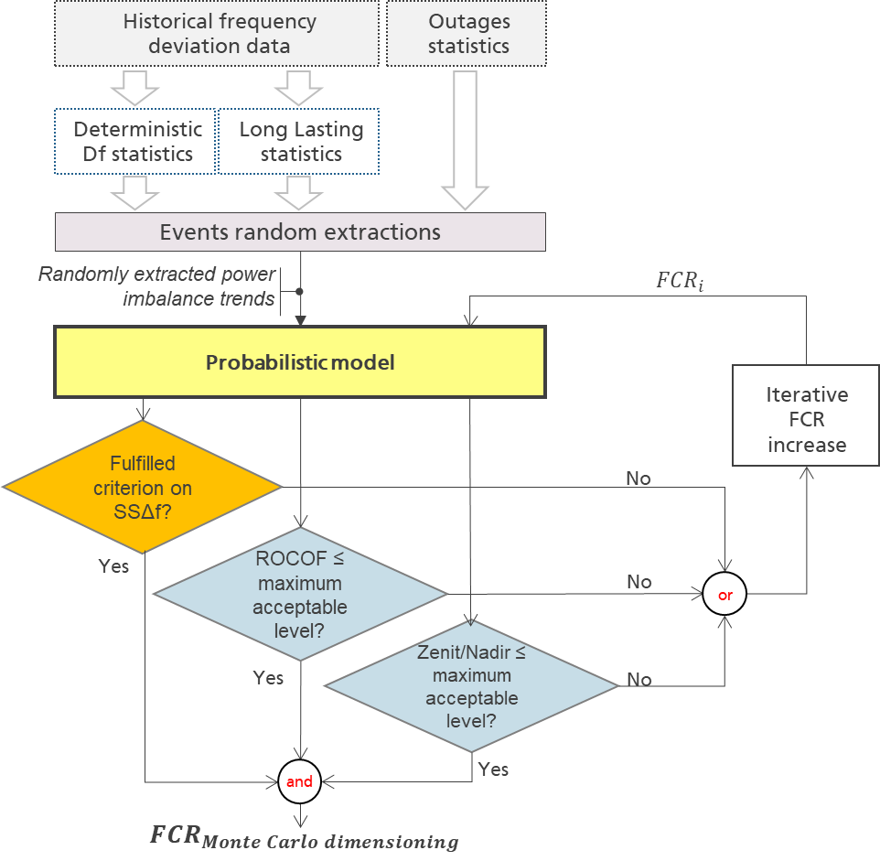
Figure 1: General overview of the model adopted for the probabilistic approach for FCR dimensioning
To help a better understanding of the functionalities described in the following sections, Figure 2 provides a more detailed depiction of how the input statistics (frequency, outages) are exploited.

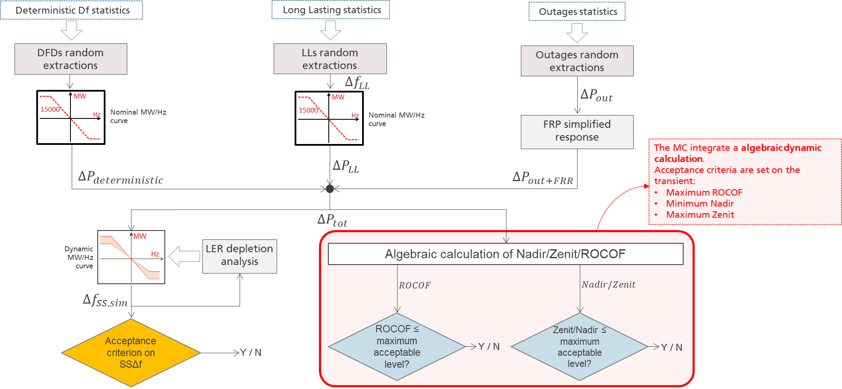
Figure 2: Detailed overview of the model adopted for the probabilistic approach for FCR dimensioning

Functionality for DFDs statistics and DFDs random extractions
DFDs are market-induced frequency deviations which regularly occur around the change of the market time unit (usually the change of hour).
In the model, the statistic of DFDs are directly calculated from the historical frequency trends with 1-minute granularity. The model extracts the frequency around the change of hour: are considered as DFD all the frequency samples in the minutes [55, 05].
For each simulated year, this functionality is aimed at calculating a trend of the frequency deviation due to DFDs.
This trend will be equal to 0 for all the minutes m which do not belong to the DFD interval (m ∉ [55, 05]). The minutes m belonging to the interval m ∈ [55, 05] are taken from the input historical frequency trends.

DFDs are randomly selected for the input of the model, looking at homologous days in past years. For example the DFDs to be assigned to 1st January of the simulated year are directly taken from the DFDs which actually occurred in the system during the 1st January of a randomly selected past years (e.g. 2018). This mechanism allows to keep the daily pattern of occurrence for DFDs: for example, the DFDs occurring around 6 am are taken from the same hour in the same day of another year.

The random choice of the year the DFDs is biased towards most recent years. The probability of the past year $y$ is indeed calculated with the following formula:

$$p_{y}=\frac{1}{N_{years}}e^{-\frac{y-y_{last}}{N_{years}}}$$
Where:
$y_last$ is the most recent year for which data are available;
$N_{years}$ is the number of years for which historical trends are available.

The functionality results in a frequency trends composed by randomly extracted DFDs.

Functionality for LLFDs statistics and LLFDs random extractions
The definition of long-lasting frequency deviations (LLFDs) is an “event with an average steady state frequency deviation larger than the standard frequency range over a period longer than the time to restore frequency”.
The tool scans the frequency trends acquired as input to detect all the events which occurred.
The scan operates following these rules:
- A moving average (with a width equal to Time to Restore Frequency) scans the data of a whole year.
- If the moving average frequency deviation exceeds a threshold equal to the standard frequency range, a LLFD is detected.
- The LLFD length is calculated looking at its average frequency. The LLFD lasts as long as its average frequency exceeds half1 the standard frequency range. This average is calculated from the beginning of the LLFD).

A list of all the detected LLFDs is created. Each LLFD is associated with the following information:
- Year of occurrence;
- Minutes in which it started;
- Duration
- Frequency trend (vector of df characterizing the event).

These statistics are than exploited to generate a random extraction of LLFDs to be used as input by the model.
The random extraction of LLFDs uses as input these LLFD statistics.

The procedure iterates on all the minutes of the year. The procedure proceeds as follows:
- The occurrence of a generic LLFD starting at minute m is decided. This choice depends on the probability that a LLFD starts at the generic minute m of a day (e.g., at 02.15 PM). The latter probability is equal to the ratio between the number of LLs detected in the whole frequency dataset which started in the minute m and the number of days in the frequency dataset ($365*N_{years}$).
If no LLFD occurrence is extracted, the procedure analyses to the following minute (m+1).
If a LLFD occurrence is extracted, the procedure proceeds at the step 2.
- The year y from which select a LLFD starting at minute m is randomly extracted. For this selection the following probability is used:
$$p_{m,y}=\frac{1}{N_{m,years}}e^{-\frac{y-y_{last}}{N_{m,years}}}$$
Where $N_{m,years}$ is the number of years for which at least one LLFD starting at minute m has been detected.
- The specific LLFD to be used is than chosen from the set of all LLFDs started at minute m and occurred in the year y (chosen in the step 2). The random choice of the specific LLFD to be used is based on an uniform distribution: all LLFDs in the set have the same probability to be chosen.
- The selected LLFD is assigned to the trend. If the LLFD lasts for k minutes, the LLFD frequency trend is assigned to the interval between minute m and minute m+k.
- The procedure returns to step 1 for minute m+k+1.
The functionality results in a frequency trends composed by randomly extracted LLFDs.

Functionality of outages random extractions and calculation of associated power imbalances
The outages are provided as input already in a statistical form: each potential event is associated with its:
- power loss: power change as of the event occurs;
- probability of occurrence: average number of events in a year
Further details on these outages statistics are provided in Section 5.2.

The random extraction of outages uses as input the list of possible events with their probability of occurrence (FR, Failure Rate: number of event per year) and their power (P, Power loss).

The extraction operates cycling on all the minutes of the year. For each minute m, all the possible events are tested to verify whether they occur or not.
For each possible event v, a random value in [0, 1] is generated and it’s compared with the probability that the event occurs in the minute ($p_{v,m}$):

$$p_{v,m}=1-e^{-\frac{FR}{365*24*60}}$$

Where $FR:Failure Rate$ is the average number of occurrence in a year for a specific outage.

If the random generated value is below $p_{v,m}$ the outage occurs. It means that the system must cope with the power imbalance associated with the event.

The total amount of power imbalance in each minute is equal to the sum of the power imbalances of all the events which occur.

The result of the calculation is a yearly power imbalance trend due to extracted outages.

FRR effects are applied to such calculated power imbalance yearly trend. The FRR is modelled as a simplified 1st order dynamic system. The power imbalances are brought to zero by FRR with a time constant equal to 1/3 of the FRR FAT.
After 3 time constants the transient is ended, this condition simulates the restoring effects of FRR in balancing the power imbalance due to outages within FRR FAT.
The following Figure 3 shows an example of the FRR effects on the power imbalances due to outages.

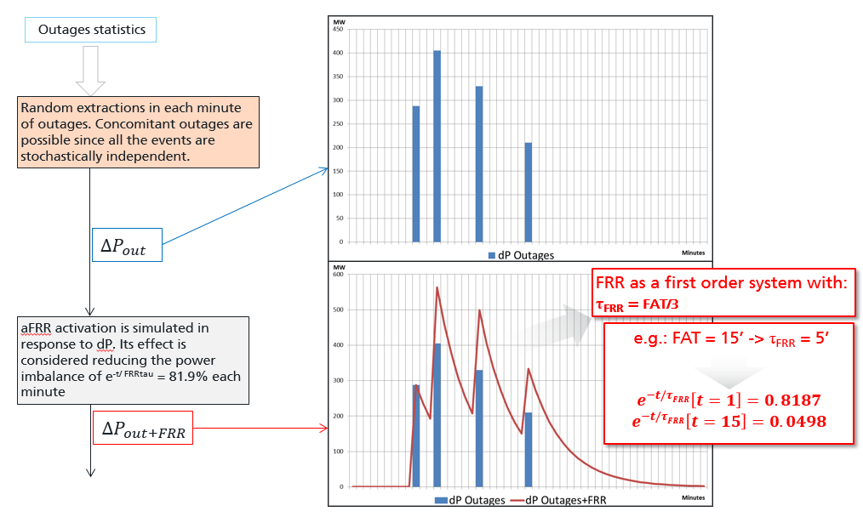
Figure 3: Example of FRR effects on power imbalance due to outages

The functionality results thus in power imbalance trends due to outages and consequenct FRR activation.

Functionality of combination of extracted DFDs, LLFDs and outages to generate global power imbalance trends

The combination of the input due to different sources takes place in terms of power imbalance: the power imbalance due to outages is combined with the power imbalance corresponding to DFDs and LLFDs.
In order to convert the frequency deviation trends into equivalent yearly power imbalance trends, a converting module is used. The module operates the conversion using a MW/Hz curve (given as an input). In other words, the frequency deviations due to DFDs and LLFDs are converted into power imbalances assuming the conversion factor which was in place at the moment of their real occurrence. Such converting factor is the MW/Hz dependency with a FCR equal to 3000 MW. Such MW/Hz dependency doesn’t change during the iteration since it is related to historical data trends.

The global power imbalance is obtained by summing the three power imbalances (due to LLFDs, DFDs, and outages).

To avoid overlaps between DFDs and LLFDs the priority is given to LLFDs. LLFDs and DFDs are not summed each other, but - on each minute - the presence of a LLFD override the presence of a DFDs.

Model to calculate the steady state frequency deviation in every minute.

This functionality progressively simulates system operation (in terms of frequency control) over the 525600 minutes of a year.

For each minute m it calculates the stady state simulated frequency deviation (${∆f}_{sim, m}$) considering as input:
  - The global power imbalance: ${∆P}_{ m}$
  - current regulating energy: ${reg.en.}_{ m}$

The regulating energy depends on the FCR amount in the current interation and on the possible exhaustion of LER potentially present in the FCR provision.

The output of the functionality is the simulated steady state frequency deviation for each simulation step (${∆f}_{sim,m}$).
${∆f}_{sim, m}$ is obtained considering the current regulating energy (${reg.en.}_{ m}$). Such variable is modelled though a MW/Hz curve as shown in the example of Figure 4.

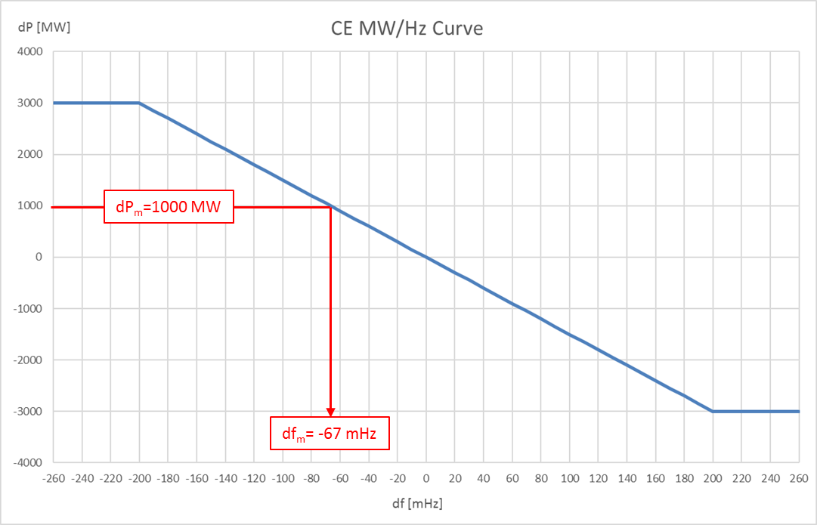
Figure 4: Example of using the MW/Hz curve to calculate df from dP

A change in the regulating energy (${reg.en.}_{ m}$) leads to a different frequency deviation, starting from the same power imbalance.

The standard regulating energy depends on the procured FCR. For instance, if in the current iteration a condition with FCR = 3000 MW is considered, the regulating energy (${reg.en.}_{ m}$) is equal to 15000 MW/Hz (i.e., 3000 MW of FCR with full activation at 0.2 Hz).

Should a LER depletion be detected, the regulating energy (${reg.en.}_{ m}$) decreases and the modelled curve has to be rescaled.

When LER reservoirs are depleted, their FCR contribution is indeed considered as instantaneously lost (they cannot provide anymore upward/downward regulation power).
Only the non-LER providers are still available to regulate the system. Given an input power imbalance, the resulting frequency deviation is thus greater than in the situation with all the LER available.

This condition is modelled with a reduction of regulating energy (i.e., a rescale of the MW/Hz curve) equal to the proportion of FCR lost due to the LER depletion. This proportion is the LER share.

For instance, if the LER share is 50%, once the LER are depleted the regulating energy is reduced by a factor 2 (the MW/Hz is rescaled of a factor 2). It means that the frequency deviation associated with a power imbalance is doubled if compared to the standard condition.
The following Figure 5 shows the reduction in such example.

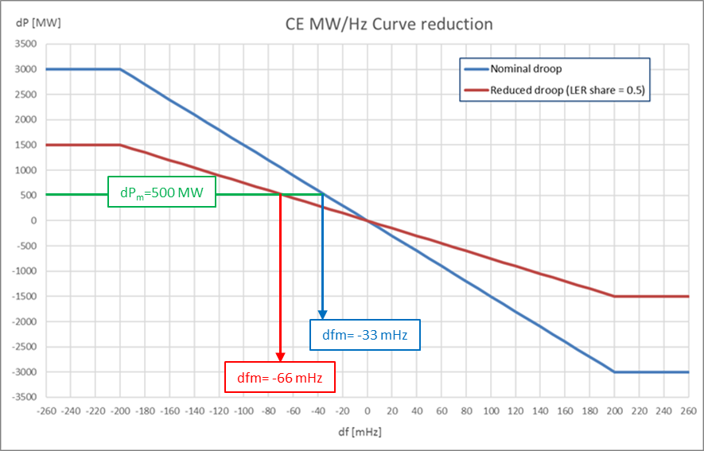
Figure 5: Example of rescale of MW/Hz curve
The model update at each minute m the current regulating energy (${reg.en.}_{m}$). The formula is:

$${reg.en.}_{m}=\left\{\begin{aligned}{reg.en}_{standard}∙\left(1-LER share\right), if LER are depleted \\ {reg.en.}_{standard}, if LER are not depleted\end{aligned}\right.$$ | (1)

To check whether the LER are depleted or not, the energy content of LER reservoir shall be calculated in each minute.
The Figure 7 schematically shows the process by which the regulating energy is rescaled as a consequence of the a LER depletion.

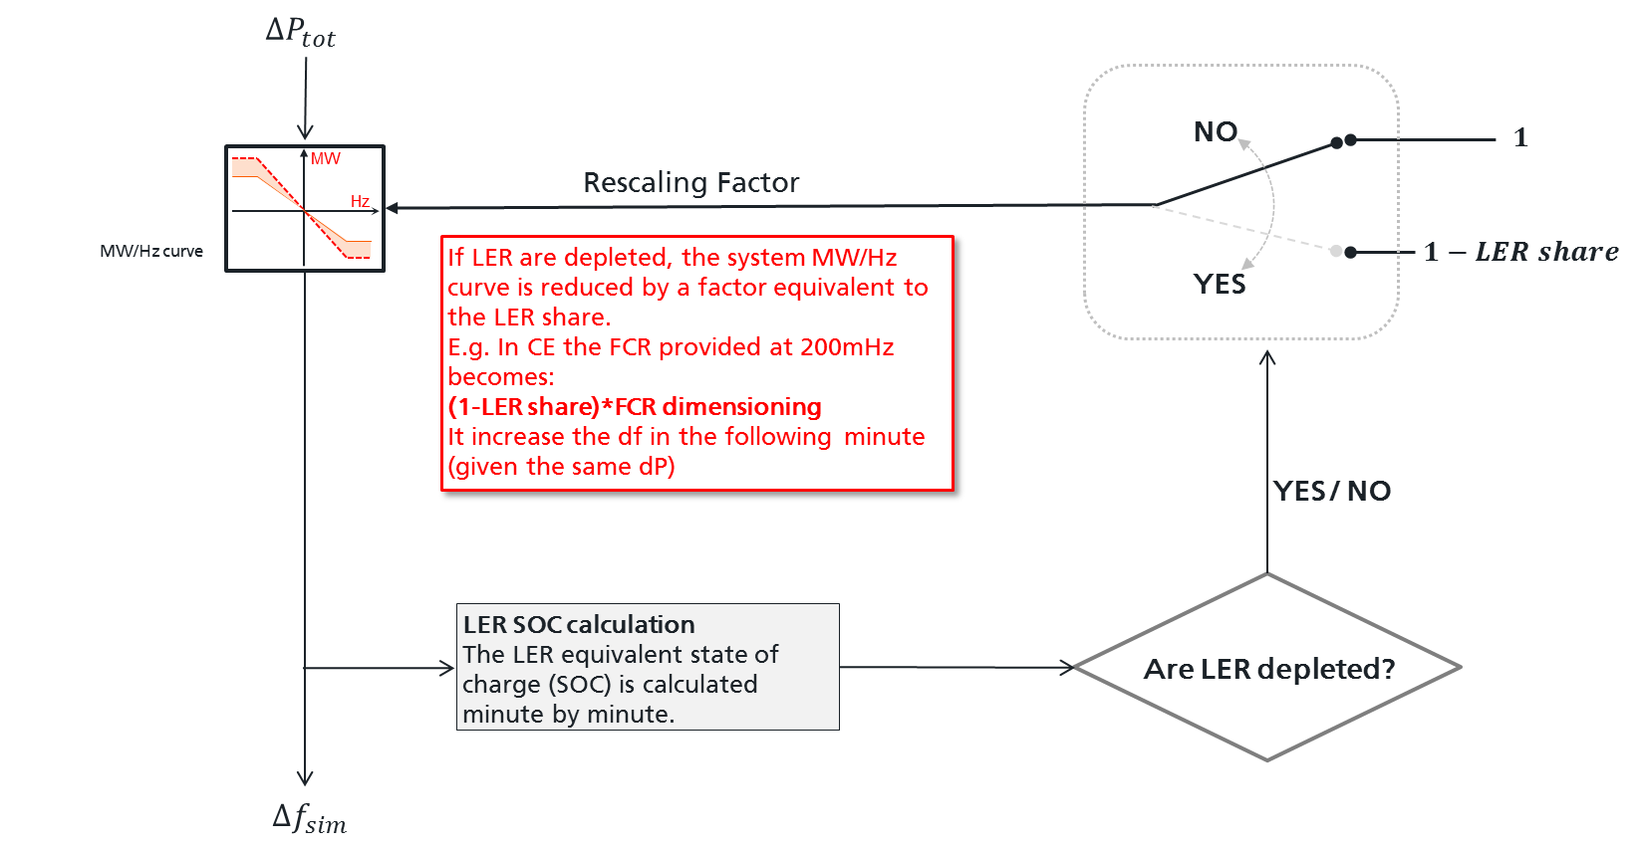
Figure 7: Schematic procedure for rescaling MW/Hz curve as a result of LER depletion
The combined effects of the recharging strategy and of the simulated frequency deviation can lead the LER to recover from a depletion condition. As this occurs, the regulating energy returns to its standard condition (e.g., 15000 MW/Hz if FCR = 3000 MW).

The LER are considered without energy limitations while frequency remains inside the standard frequency range.
If a continuous exceeding of the standard frequency range includes the triggering of an alert state, the activated energy and the residual energy in the reservoir is calculated from the first exceeding of the standard frequency range limits.
LER deplete as their reservoir reaches the maximum or minimum energy level. The capacity of the reservoir depends on the minimum activation time period the LER are subject to.

Model to calculate the dynamics of the frequency deviation in each minute.
According to Art.153(2), TSOs are expected to consider also the dynamic phenomena that take place during a frequency transient. Also the characteristics of the frequency during a transient - such as the frequency peak (Nadir or Zenit) and the ROCOF – need to be considered for the FCR dimensioning process (Figure 8).
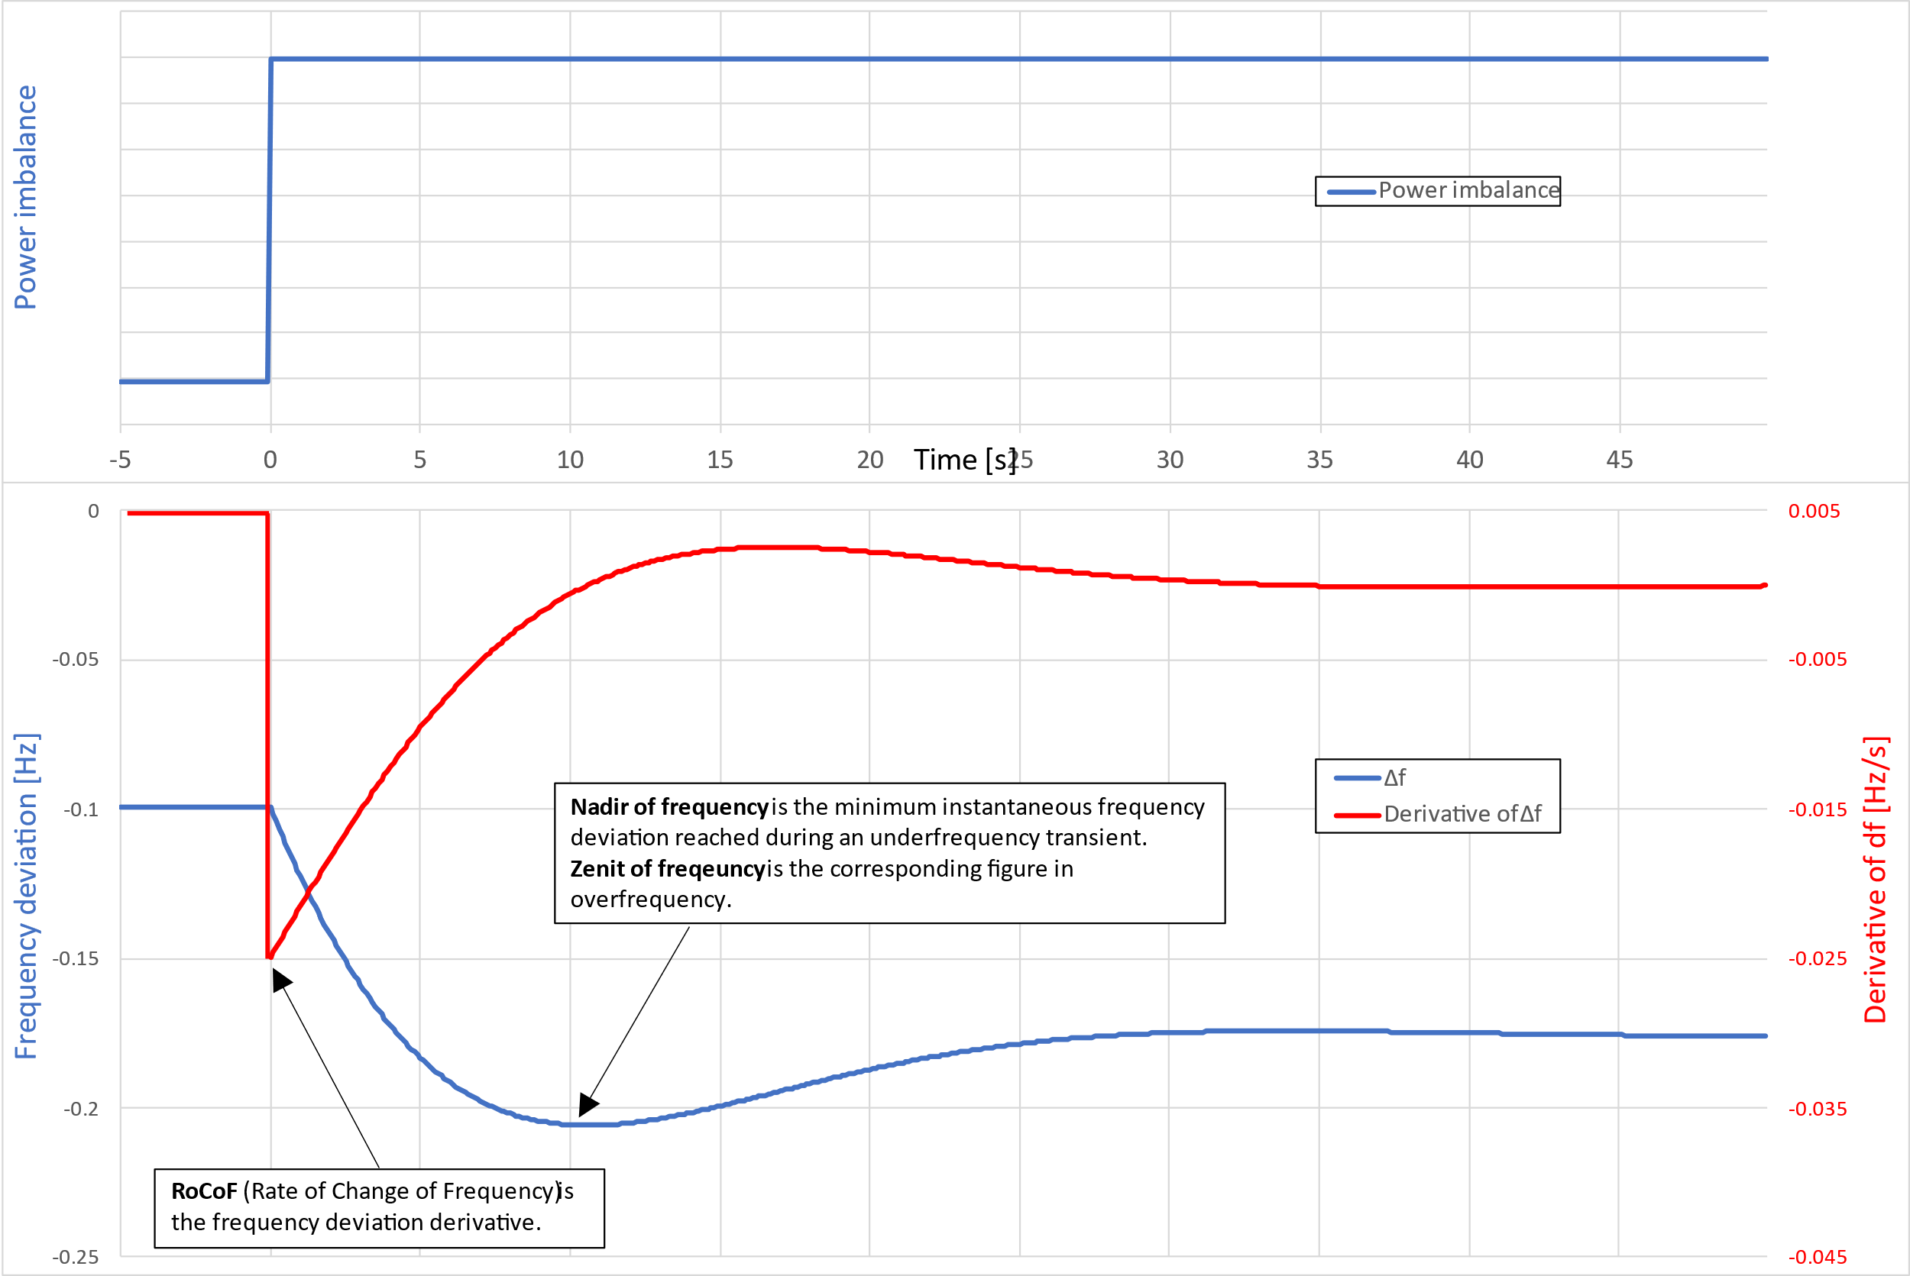
Figure 8: Frequency transient characteristics and main performance indicators: zenit, nadir and RoCoF
The probabilistic model involves the calculation of hundreds of years of system operation with 1-minute granularity. Furthermore, this calculation could be iteratively repeated in order to determine the dimensioned FCR value.
Given such a wide number of transient to be calculated, it appears completely unfeasible to perform an actual dynamic simulation in each single minute. There is therefore the need to adopt an algebraic calculation of Zenit/Nadir and ROCOF starting from the aggregated single-busbar model depicted in Figure 9, based on considerations from [2].

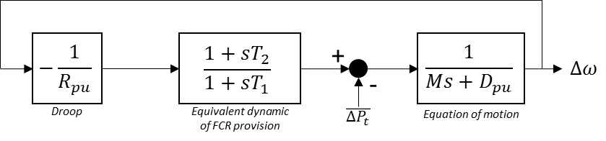
Figure 9: Simplified single-busbar dynamic model of the CE power system
Where:
- Equation of motion: represents the response of the power systems in terms of inertia and self regulation of load;
- Droop: represents the static response of the FCR (see Figure 4);
- Equivalent dynamic of FCR provision: represents the average combined effects of the dynamic responses provided by each FCR providers.
The parameters presented in Figure 8 are thus:

$R_{pu}=\frac{1}{En. Reg.}∙\frac{P_{n}}{f_{n}} \left[{{pu}_{P}/pu}_{∆f}\right]$ Droop in pu ($En. Reg.$ is associated with a certain MW/Hz curve)
$T_{1} [s]$ Pole time constant of average FCR dynamics
$T_{2} [s]$ Zero time constant of average FCR dynamics
$D_{pu}=\frac{D}{f_{n}}[{{pu}_{P}/pu}_{∆f}]$ Self-regulation of load ($D$ is expressend in [pu/Hz])
$M=2∙H [s]$ System equivalent angular momentum (2*Inertia)
$P_{n} [MW]$ Load at SA level

The output of the diagram ($∆ω$) is the frequency deviation in pu.
Considering the actual and complex dynamic model of the SA, with this model significant approximations are introduced since each provider (and each technology) has its own peculiarities when it comes to the FCR deployment dynamic. Such variety of responses is simplified with a single 2nd order dynamic model in order to derive the algebraic formulas for Zenit/Nadir and ROCOF. The ROCOF is evaluated as the initial ROCOF.
Such formulas are derived assuming that a stepwise disturbance is applied on the model presented in Figure 8.
In this way an algebraic relationship between the disturbance and the system parameters can be used within the iterative probabilistic model.
The calculation of dynamic performances of frequency deviations are based on the same 1-minute granularity adopted for the steady state calculations. It means that all the variables (e.g., power imbalance and steady-state frequency deviation) continue to change minute-by-minute.
Both the transient frequency peak (zenit/nadir) and the ROCOF are therefore calculated on a 1-minute basis.

The input of such calculation is the difference of power imbalance between two following minutes.

Assessment of the acceptability criteria on the resulting simulated frequency deviation
According to Art.153(2) of SO GL: “All TSOs of the synchronous area shall have the right to define a probabilistic dimensioning approach for FCR taking into account the pattern of load, generation and inertia, including synthetic inertia as well as the available means to deploy minimum inertia in real-time in accordance with the methodology referred to in Article 39, with the aim of reducing the probability of insufficient FCR to below or equal to once in 20 years”.

A FCR dimensioning shall be considered acceptable if ensures that the FCR is insufficient not more often than once every 20 years. However, the model explores a wider spectrum of phenomena than merely the power imbalance to be counteracted by FCR:
- LER exhausiont leading to the loss of part of FCR provision;
- Dynamic response of FCR during transients.

Hence, the model looks at the simulated frequency (either SSΔf or during transients) as a proxy to dimension the FCR.
The «once in 20 years» criterion needs therefore to be interpreted.

The first step is to assess whether a specific minute is considered an acceptable minute. A minute is considered an acceptable minute if it fulfills all the following three criteria:

- The absolute value of the simulated steady state frequency deviation does not exceed the steady state maximum frequency deviation;
- The absolute value of the maximum/minimum instantaneous frequency deviation doesn’t exceed the Maximum Transient Frequency Deviation;
- The absolute value of the ROCOF calculated does not exceed the Maximum Initial ROCOF.
All the criteria are based on considerations from [1], [2] and [3].
A minute is considered a not acceptable minute if at least one criterion is not fulfilled.

To interpret the «once in 20 years» criterion, the concept of event is then introduced: an event is a series of not acceptable minutes spaced each other not more than 15 minutes.

It should be stressed that a single event could be made by several following minutes with one or more criteria not fulfilled.
The choice of such approach is related to the fact that the combination of disturbances causing a condition where one or more criterion (SSΔf / nadir / ROCOF) are not fulfilled could persists for several minutes.

The «once in 20 years» criterion is applied on the number of events rather than on single minutes.
The FCR dimensioning is thus aimed at ensuring that the number of detected event is less than 1/20 of the number of simulated years.

E.g., if 200 years are simulated by the model, no more than 10 (200/20) events shall occur.

Input to be used for the FCR dimensioning
In this section, the input used to perform the FCR probabilistic dimensioning are presented, based on the target year considered for the dimensioning.

Frequency deviation
The historical frequency deviation data are one of the most important input of the whole procedure. From these data the statistics regarding the DFDs and LLFDs are defined in order to be then combined in the probabilistic calculation.
Since the time granularity of the calculation is one minute, the frequency deviation trend shall have at least one minute sample rate.
The available database for frequency data spans from 01/01/2008 to date.
The historical frequency deviation data are provided by CE TSOs in the form of file having different sample rate (from 1 s to 10 s).
The raw data are validated and elaborated by the procedure in order to:
- Identify potential lack of data and replace them with the nominal frequency (50 Hz);
- Identify potential bad quality data (i.e. tagged with bad quality flag or outside the 48.5÷51.5 Hz band) and replace them with the nominal frequency (50 Hz);
- Calculate the average 1-minute frequency.

Outages

The outages of relevant grid elements are a main source of disturbance used as inputs of the model.

The data input needed for the extractions are:
- the population of potential events to be considered;
- the power imbalance induced in the SA by each considered outage;
- the occurrence statistics.

The population of outages considered in the methodology is made by all the possible events which occurrence lead to a significative instantaneous power imbalance in the SA. This in turn lead to a significative frequency deviation which can be sum with other phenomena (i.e., DFDs and LLFDs).

The outages taken into account are:
- Failure on generation unit.
- Failure on HVDC connection.

The events related to loss of load (due to critical busbar fault or critical substation blackout). are neglected which is reasonable, comparing the actual instantaneous loss of load, with respectto the power imbalances due to the biggest generation units and HVDCs.

Outages on production units

The dataset of generation unit to be considered is derived from the ENTSO-e Transparency Platform (TP), from the «Production and Generation Units» table. The target year for the generation is the most recent year for which information are available.

All technologies besides onshore wind are considered. The choice to neglect wind onshore is due the fact that the occurrence of full instantaneous loss of a whole wind farm is relatively low and comparable to the loss of load (e.g., due to a failure in the step-up transformer of a power park module).

For nuclear and coal plants “partial outages” are considered. A partial outage is an event in which a unit undergoes a rapid but partial loss of power output (without disconnecting from the system). Power loss and failure rate are derived from TP (“Unavailability of Production and generation Units”).

The failure rate for each technology is derived from literature in terms of number of full outage (with instantaneous loss of production) a years for a single unit.
When an outage on a production unit occurs, the power imbalance caused to the system is calculated considering the installed power and a load factor differentiated for technology..Such factor is the average production level for each technology.

Outages on HVDC

The list of HVDCs whose outages are taken into account comprises all non-embedded HVDC links expected to be in service by target year. The power loss taken into account is based on historical power flows on each connection. It means that the power loss depends on the instant in which the outage occurs.
Hourly flows between areas are derived from data recorded in the most recent year for which data are available on TP. If flows are not available, forecasts of power flows on the links can be used.
Failure rate for HVDC is based on [4], where 2012-2021 statistics for Baltic/Nordic HVDCs are used as reference. If a HVDC link is present in the ENTSO-e report, its outage/year statistic is used as failure rate, otherwise the average outage/year statistic is used as failure rate.

Load and inertia

Load and inertia data are used by the algebraic dynamic model.
These data are derived from TP (table:“Actual Generation per Production Type”). In each hour, the latest available historical production from each technology is used to derive the system kinetic energy and the inertia, based on [3].

LER Presence and TminLER
The LER penetration in the FCR procurement on target year (e.g., 2024) as well as their TminLER will be simulated. The values are based on current and foreseen figures of pre-qualified LER in CE.
For these values, it will be considered the current minimum activation time period and the expectable evolutions of the regulatory framework on target year (e.g., 2024).

For the purpose of FCR dimensioning, a 0.5 reduction factor is applied on the standard frequency range. The definition of LLFD is thus: “an event with an average steady state frequency deviation larger than 0.25 mHz over a period longer than the time to restore frequency”.
An alert state is triggered if at least one of the following conditions occurs: - The absolute value of simulated steady state frequency deviation exceeds for 5 consecutive minutes half of the maximum steady state frequency deviation. - The absolute value of simulated steady state frequency deviation exceeds for 15 consecutive minutes the standard frequency range.

