CSA Methodology _ Amendments Article 21 and 27
For public consultation
Explanatory Note
of the Methodology for coordinating operational security analysis
in accordance with Article 75 of Commission Regulation (EU) 2017/1485 of 2 August 2017 establishing a guideline on electricity transmission system operation

Article 21
Remedial actions inclusion in individual grid models

As referred in CGM Methodology, TSOs shall provide the best operational situation forecast in IGMs. IGMs have a reference only for market gate closure schedules, for forced outages or planned outages, and for load and intermittent generation forecasts. Any other steady-state hypothesis or state variable information contained in IGMs (in opposition to stable Equipment information) might not have clear reference, such as a grid topology which depends on many external parameters such as flow exchanges, influencing outages, etc… Therefore, in the first day-ahead IGM no distinction is made between forecast and remedial action for the status or set point of network elements, under the assumption that a remedial action can be defined as such only when a clear reference status can be defined.
Monitoring of topology included in the IGMs shall be performed as a solution for improvement of forecasts and to prevent unfair behaviour of TSOs (such as gaming) that could impact the Cost Sharing. The results of the monitoring should be checked between impacted TSOs, their NRAs and ACER. Escalation to NRAs and ACER should only be a last resort option when situation is deemed inacceptable by one TSO and no solution can be found among the TSOs. Checking between impacted TSOs should usually be the first (and only) step.

Article 27
Overlapping zones, XNEs and XRAs

Paragraph 1
Definition of Overlapping XNEs and Overlapping XRAs is provided in CSA Methodology Article 2. The additional provisions included in paragraph 1 of the original article have been slightly amended to only identify overlapping XNEs based on the activation of XRAs.
Paragraph 2
The whole operational security violations process will be split into two consecutive steps. Within the first step, operational security violations will be addressed at a regional level, and then possible residual violations will be addressed through a cross-regional coordination. Amended Article 27 introduces a new concept which is to request TSOs to optimize an XNE within one and only one CCR for the coordinated regional operational security assessment. Objective of this request is, for the sake of efficiency, not to optimize twice an XNE in two different CCRs.
In day-ahead timeframe, once CCRs have run their regional operational security assessment to solve operational security violations, all agreed XRAs are exchanged. Aggregation of all XRAs agreed during all coordinated regional operational security assessment allows the identification of potential residual operational security violations. Residual operational security violations will be addressed through the cross-regional coordination with TSOs and RSCs of all impacting CCRs.
In Day-ahead, this two-step approach, with at minimum one coordinated regional operational security assessment followed by one cross-regional coordination to solve residual violations is mandatory.
In accordance with CSA Methodology Article 33, and as illustrated in figure 1 below for day-ahead timeframe, RSCs will have the opportunity to initiate the cross-regional coordination once relevant adjacent coordinated regional operational security assessment results are available, before collecting the updated IGMs and CGMs with regional agreed XRAs. Objective is to save time for allowing more time to the cross-regional coordination. It also allows such opportunity for intraday timeframe.
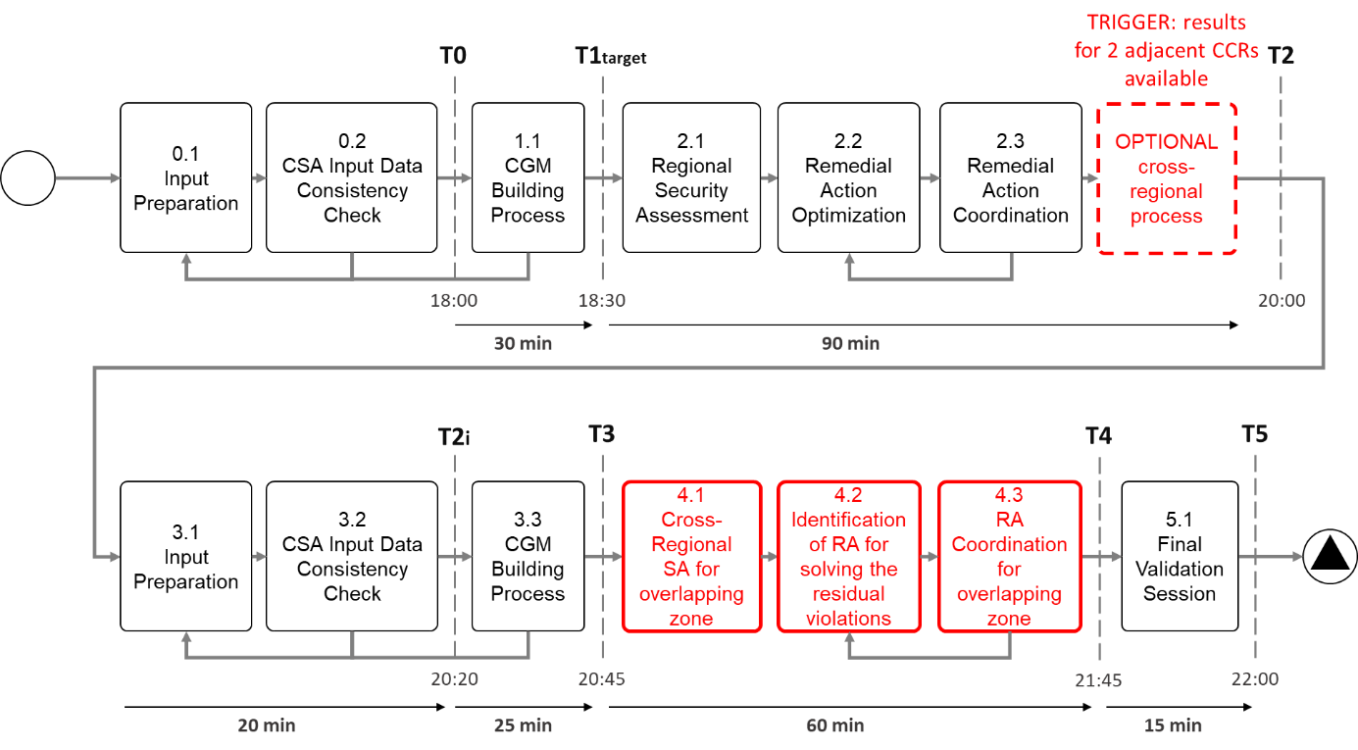
Figure 1 Day-Ahead timeframe Regional and Cross-regional operational security assessment articulation
Paragraph 3
Within Intra-Day timeframe, default approach is to run a cross-regional coordination after a coordinated regional operational security assessment, unless time does not allow it or there is an agreement between adjacent CCRs not to do it. In case a coordinated regional operational security assessment is not followed by a cross-regional coordination process, a conservative approach for coordinated regional operational security assessment applies and shall not increase the loading of overlapping XNEs more than a maximum percentage of the remaining available margin obtained in the CGM, which includes all the agreed XRAs from the previous cross-regional coordination process.
For example: maximum percentage equal to 10%, and Remaining available Margin on a XNE is 5%, (loading of the XNE is 95%), maximum increase for a neighbouring CCR is 0.5%
The maximum percentage value described in Annex II will be provided in the last version. Current value under discussion is around 10%-20%.
In that way more flexibility is left for CCRs when elements are far from their operational limits and it will be unlikely that residual violation occur.
In case the intraday conservative approach is implemented, the XRAs taken into account for cross-regional cost sharing are the sets of XRAs agreed during the last cross-regional coordination.
Paragraph 4
Definition of Overlapping XNE and Overlapping XRA has been provided in Article 33, this paragraph aims at defining a process for assessing the list of Overlapping XNEs. The 5% threshold has been defined as the criteria above which contribution of an impacting CCR is considered as significant following the activation of XRAs.
Point (a) details the process to be repeated every year, or after TSO request, in order to assess the list of Overlapping XNEs. As detailed in paragraph 2, an XNE will be optimized during the coordinated regional operational security coordination process in only one CCR. Consequently, for assessing the list of Overlapping XNE, RSCs in cooperation with TSOs will investigate possible impact of XRAs appointed into a different CCR than the one the XNE is regionally optimized.
When considering a dedicated XNE, located into a TSO belonging to two or more CCRs, the individual Influence Factor of every XRA appointed into one CCR different from the one where the XNE is regionally optimized will be computed. For individual XRAs with an Influence Factor over 1%, sum of these individual XRA absolute values of Influence Factors will be performed. If the sum is higher or equal to 5%, the XNE will be labelled as an Overlapping XNE, if below 5% XNE does not get the label.
The influence factor of generating units and cross-synchronous area HVDC interconnectors is assessed by changing the setpoint of generating unit/HVDC interconnectors and balance over the whole system with a proportional approach.
The range of PST or HVDC taken into account is the maximum/minimum deviation compared to the neutral position, and for redispatching it is the maximum possible operating deviation.
Paragraph 5
This process will be run yearly on Year-Ahead scenarios in accordance with SO Regulation Article 65, and also on TSO request in case of significant changes in their grid using updated year-ahead scenarios in accordance with their significant updates. Requesting TSO shall provide a sound justification for such a reassessment. If an XNE is labelled as Overlapping XNE in at least one of those Year-ahead scenarios, then this XNE will be inserted into the static list of Overlapping XNE.
Paragraph 6
Overlapping list assessment is a pragmatic approach to increase efficiency of the operational process as this Overlapping XNE list will help operators in identifying CCRs impacted in the cross-regional computation, to solve Residual violation and find the best solution.
If a Residual Violation is identified:
- on an Overlapping XNE, use the XRAs of the impacting CCRs on this Overlapping XNE. Those XRAs will be regarded as Overlapping XRAs.
- on a XNE which is not an Overlapping XNE, use the XRAs offered to the CCR the XNE belongs to. In case such XRAs are not enough, additional XRAs from neighbouring CCRs might be used upon coordination with other TSOs. Those XRAs in that case would not trigger cross-regional cost sharing.
This list of Overlapping XNE is also an input for the cross-regional Cost Sharing Methodology, as only XNEs belonging to this list can trigger cross-regional Cost Sharing, in accordance with CSA Methodology Article 27.
Paragraph 7
The principles and rules for consistency between coordinated regional and cross-regional operational security assessment is to use the same list of contingencies as the one used for each coordinated regional operational security assessment. The list of available XRAs is also the same as the one available for coordinated regional operational security assessment, meaning that during the cross-regional coordination, RSCs can propose to activate or deactivate any XRA available or agreed during the coordinated regional operational security assessment. At cross-regional coordination step RSCs goal is to identify residual violations, impacting CCRs and with support of TSOs to solve Residual Violations while not creating new violations.
Paragraph 8
The principles and rules for the identification of economically efficient XRAs to address residual violation shall aim to limit deviation with agreed XRAs within each coordinated regional operational security assessment while:
- Solving the residual overloads
- Not generating new overloads on XNEs
- Minimizing the costs
- Respecting the technical, operational, procedural and legal constraints defined by each TSO.

RSCs are in charge of proposing solutions for solving Residual Violations, and tools available to support RSCs in this task are not detailed at this stage. We know that from today’s perspective one supporting tool is the Remedial Action impact assessment matrix, in order to identify potential XRAs to solve Residual Violations.
Paragraph 9
This paragraph repeats principles already embedded into original CSA Methodology Article 27.
Paragraph 10
This paragraph repeats principles already embedded into original CSA Methodology Article 27.

****************************************************************************
Information about Cost Sharing Methodology

Cross-regional Cost Sharing principles are still under discussion but general concept is:
- the costs of the Overlapping XRAs aiming at solving residual operational security violations on an Overlapping XNE shall be borne by the CCR where the operational security violations on such XNE were not addressed at the regional level.
- this is to avoid that the CCR which has solved operational violation on the XNE during the regional optimization does not pay twice, at regional level and cross-regional level.
The following exceptions apply to the above principles, when considering an Overlapping XNE with a residual operational violation:
- in case regional operational security violations was not fully solved at regional level
- in case not all the XRAs agreed at regional level were consistently included in the CGM used for the cross-regional process
- in case there was remaining available margin in the initial CGM and both CCRs increased burdening flows resulting from regionally agreed XRAs. In that case both CCRs would bear the costs proportionally to their additional burdening flows on this Overlapping XNE. This condition applies if the Overlapping XNE is considered as a Scanned element in the CCR not in charge of optimizing it at regional level.
- in case the agreed XRAs from one CCR have not an impact equal or higher than 5% over another CCR

The costs for solving residual overloads to be borne by TSOs of involved CCR(s) should be shared using the following principles:
- Market flows, internal flows and loop flows from involved CCR(s) should pay for costs for solving the residual overload. For a dedicated Overlapping XNE, for TSOs located in two or more involved CCRs, amount of flow types from those TSOs which have already be paid in the regional cost sharing of the involved CCR should not be paid again.
- The share of internal flows or loop flows should be borne directly by the concerned TSOs.
The rules for Flow Decomposition and the rules for identifying the overlapping XRAs activated to address residual operational security violations on overlapping XNEs and to attribute the related costs to individual overlapping XNEs are also still under discussion.

