Survey on on the change of the number of clearings for the exchange of balancing energy from Replacement Reserves in accordance with Article 19 of Commission Regulation (EU) 2017/2195 of 23 November 2017 establishing a guideline on electricity balancing
29th May 2023

DISCLAIMER
This document is submitted by RR transmission system operators (TSOs) to the RR NRAs for information purposes only. It contains the preliminary feedback of stakeholders on the various options to change the design of the RR process. The result of the consultation shall serve as an input to draft the actual proposal for the 3rd amendment of the implementation framework for the exchange of balancing energy from Replacement Reserves in accordance with Article 19 of Commission Regulation (EU) 2017/2195 of 23 November 2017 establishing a guideline on electricity balancing.

Content
1. Introduction 3
1.1. Reason to change the design of the RR process 3
1.2. Timeline to change the design of the RR process 5
2. Comparison of possible future design of RR process 6
2.1. Current RR process with 24 clearings per day 6
2.2. Option for future RR process with 96 clearings per day #1 6
2.3. Option for future RR process with 96 clearings per day #2 6
2.4. Option for future RR process with 96 clearings per day #3 7
2.5. Comparison of pros and cons 96 clearings options 7
2.6. Impact on cross-border marginal price 9
3. Summary and conclusion of TSOs 10
4. Annex 1- Detailed description of possible future design of RR process 11
4.1. Current RR process with 24 clearings per day 11
4.2. Option #1 for future RR process with 96 clearings per day with current timings 13
4.3. Option #2 for future RR process with 96 clearings per day with reduced timings 14
4.4. Option #3 for future RR process with 96 clearings per day with reduced timings and delivery period of 30 minutes 15
4.5. Infeasible option for future RR process with 48 clearings per day 16
4.6. Details on the bid conversion process for TSOs with central dispatch model 17
4.7. Details on activities during ‘TERRE Process Time’ 23
5. Annex 2- Market participants’ positions and questions received during the public consultation 24
5.1. Is there an impact on your RR offers with the changes proposed in the final option? Please elaborate in detail. 24
5.2. What is your opinion on the conditional linking mentioned in the 96-clearings option? Do you consider it as one of the possible solutions? 24
5.3. Do you perceive an impact of market liquidity with the reduction of the delivery period ? If so, please indicate to what extent for 24
i. the reduction from 60‘ to 30‘ products on the one hand 24
ii. the reduction from 60‘ to 15‘ products on the other hand 24
5.4. For the same MTU: how much time do you need between ID GCT and TERRE GCT (please provide an answer in minutes)? 24
5.5. For the same MTU: how much time do you need between TERRE results and MARI GCT (please provide an answer in minutes)? 24
5.6. For two consecutive MTUs: how much time do you need between TERRE results of the first MTU and TERRE GCT of the second MTU (please provide an answer in minutes)? 24
5.7. Do you have any other comments or proposals on the RRIF or on the RR process in general? 24

Introduction
Today, the replacement reserve (RR) process consists of 24 daily gates with 24 clearings per day. This process will be changed in the future. With the following survey, RR TSOs would like to get the view of stakeholders on the various options that come with an increased number of clearings for the RR process in the future. RR TSOs will consider that feedback, when drafting the proposal for the 3rd amendment of the implementation framework for the exchange of balancing energy from Replacement Reserves in accordance with Article 19 of Commission Regulation (EU) 2017/2195 of 23 November 2017 establishing a guideline on electricity balancing.

Reason to change the design of the RR process
Today, the RR process consists of 24 daily gates with 24 clearings per day. This design was mainly chosen because at the time of the introduction of the RR platform, the cross-border scheduling step was 60 minutes on most borders. According to the current IF, the cross-border scheduling step must be reduced to 15 minutes, on all borders, which would allow to increase the number of daily gates for the RR process.
RR IF Article 11.5:
All RR TSOs shall harmonise number of daily clearings:
(1) At the go-live of the RR-Platform, the number of daily gates will be 24. The RR TSOs will reduce the cross-border scheduling steps to less than 60 minutes for the borders included in the Region. The deadline will be the date required by the EBGL for using the European Platform for exchange of mFRR which is still subject for possible derogation and the date required by the CACM regulation for the intraday cross zonal gate closure frequency definition.
(2) Starting from this deadline, the cross-border scheduling step will be 15 minutes, therefore an increase of the number of daily gates, may be evaluated taking into account the maturity of the European balancing market at that time.

Together with the reduction of the cross-border scheduling step, relevant market regulation also prescribes a combined reduction of the market time unit (MTU) and of the Imbalance Settlement period on both balancing markets and energy markets.
EBGL Article 53(1)
By three years after the entry into force of this Regulation, all TSOs shall apply the imbalance settlement period of 15 minutes in all scheduling areas while ensuring that all boundaries of market time unit shall coincide with boundaries of the imbalance settlement period.

REG.(EU) 2019/943 Article 8
- […]
- NEMOs shall provide market participants with the opportunity to trade in energy in time intervals which are at least as short as the imbalance settlement period for both day-ahead and intraday markets.
- [… ]
- By 1 January 2021, the imbalance settlement period shall be 15 minutes in all scheduling areas, unless regulatory authorities have granted a derogation or an exemption. Derogations may be granted only until 31 December 2024.

The RR platform already allows the use of a 15-minute MTU, while only performing 24 daily clearings. On the other hand, the number of daily gates for the cross-zonal intraday, which is also 24 at the moment, will increase to 96 gates in the future (as per the above Article of Reg.(EU) 2019/943). Also, as set by the following art. 24.2(b) of EBGL, the balancing energy gate closure time shall not be before the intraday cross-zonal gate closure time:
EBGL Article 24(2)
Balancing energy gate closure times shall:
- be as close as possible to real time;
- not be before the intraday cross-zonal gate closure time;
- ensure sufficient time for the necessary balancing processes.

Therefore, the new number of intraday gates necessarily leads to the increase of the number of daily gates for the RR process.

See the following table on the compatibility between number of clearings for cross-zonal intraday gate closure time and the RR process.

 | 24 RR gates | 48 RR gates | 96 RR gates
24 CZ ID gates | Compatible | Compatible | Compatible
96 CZ ID gates | Not compatible | Not compatible with CZ ID or conflict with MARI | Compatible

The constraint is to respect an operational window of one hour and fifteen minutes (time between the intraday cross-zonal gate closure time and the end of TERRE delivery period). More details on the timing between cross-zonal intraday and RR process can be found in the following sections, where the technical options are described.
For the 24 RR gates, this clearly not the case as there is an overlap of the processes with 96 CZ ID gates. For the case with 48 RR gates and 96 RR gates, theoretically there would be a remaining time window for an RR process. Nevertheless, the available time is to short which either creates a conflict with the processes that some TSOs need to perform between CZ ID result communication and RR gate closure, or creates a conflict with the following MARI process. More detailed explanation on these aspects can be found in the following sections.
As a conclusion, only an RR process with 96 clearings is compatible with 96 gates on the cross zonal intraday market.

Timeline to change the design of the RR process
From the last section, it is clear that:
- The number of RR gates can only be increased once all RR TSOs have reduced the Cross-Border Scheduling Step to 15 min. The deadline required by EBGL for this change is on July 24, 2024 (deadline for implementing the mFRR platform);
- The increase of the number of gates in the RR process has to be done before the increase of the number of gates in the CZ ID.
- The overview of current planning and deadlines show that careful alignment is necessary;
- Taking into account all restrictions and preliminary assessment, the change of RR process cannot take place before Q4 2024/Q1 2025.
The exact date for the change can only be fixed once the target design for the RR process is chosen, and following a detailed impact analysis on the LIBRA platform and the local implementations of all RR TSOs and BSPs. Such impact analysis does also need to consider the proper transition from the today’s RR process to the new process without interruption of the RR market.

Comparison of possible future design of RR process

Current RR process with 24 clearings per day
Currently, the RR-Platform has 24 daily gates. A more detailed explanation of the current situation is included in Annex 1, section 1. As a summary, the main characteristics of the current process are:
- 24 Gates per day (one every hour)
- Each clearing is for four MTUs (4x15 min)
- Full Activation Time (FAT) of 30 min
- Balancing Energy Gate Closure Time (BE GCT) at H-55
- Process time for TSOs 15min
- Process time for LIBRA 4 min
- Results communicated to BSPs at the latest at H-25
- Granularity of Cross Border Marginal Price (CBMP) 15 min

Option for future RR process with 96 clearings per day #1
The first option is changing to 96 clearing per day but keeping the current process timings.
In this option, there will be one clearing every 15 minutes with a 15 minutes delivery period and all timings will remain unchanged: the BGCT will remain 55 minutes before delivery and the process will last 20 minutes. Hence, BSPs will not have the results of the first clearing to update the offers for the second clearing. For this purpose, conditional linking amongst clearings is foreseen. With this possibility, BSPs will be able to inform TSOs and the algorithm if their offer is subject to activation depending on the result of the previous clearing.

A more detailed explanation of this option is included in Annex 1, section 2. In summary, the main characteristics of this option are:
- 96 Gates per day (one every 15 min)
- In each clearing, one MTU is computed (15 min)
- FAT of 30 minutes
- BE GCT remains at H-55
- Process time for TSOs remains 15 minutes
- Process time on LIBRA remains 4 minutes
- Results communicated to BSPs at the latest at H-30
- Linking of bids between clearings is necessary

Option for future RR process with 96 clearings per day #2
The second 96 clearings option is to reduce the TSO process timings to avoid introducing conditional linking.
In this option: the BE GCT is moved to 40 minutes before delivery and the process will last 10 minutes. Hence, BSPs will have the results of the last clearing to update the offers for the following clearing.

A more detailed explanation of this option is included in Annex 1, section 3. In summary, the main characteristics of this option are:
- 96 Gates per day (one every 15 min)
- In each clearing, one MTU is computed (15 min)
- FAT of 30 minutes
- BE GCT is moved to H-40
- Process time for TSOs is reduced to 5 minutes
- Process time on LIBRA is reduced to 2 minutes
- Results communicated to BSPs at the latest at H-30

Option for future RR process with 96 clearings per day #3
The third 96 clearings option is to reduce the TSO process timings and to introduce the possibility to have delivery period of 30 minutes.
In this option: the BE GCT is moved to 40 minutes before delivery and the process will last 10 minutes. Besides, although the clearings remain independent, one MTU is cleared twice. This would mean that TSOs and BSPs will submit needs and bids for one MTU once in a first clearing and then, based on the results of the first clearing, they will have the possibility to resubmit needs and bids for the same MTU in a second clearing.

A more detailed explanation of this option is included in Annex 1, section 4. As a summary, the main characteristics of this option are:
- 96 Gates per day (one every 15 min)
- In each clearing, 2 MTUs can be computed (2x15 min) but only some TSOs will submit bids and needs for the second MTU
- Delivery period up to 30 minutes
- FAT of 30 minutes.
- BE GCT is moved to H-40
- Process time for TSOs is reduced to 5 minutes
- Process time on LIBRA is reduced to 2 minutes
- Results communicated to BSPs at the latest at H-30
It must be clarified that this option still has some open questions that should be resolved before selecting it for the evolution of the TERRE project. However, TSOs want to receive feedback from BSPs on whether they are interested or not in this solution.

Comparison of pros and cons 96 clearings options
Increasing the number of clearings implies changes with different impacts which are more or less dimensional for the stakeholders depending on the option chosen. In the table below, the TSOs list the main advantages and disadvantages of each option from their point of view:
Option | Pros | Cons
96 daily gates with current timings | - Aligned with target ID resolution and target XB scheduling step  - Time for process on LIBRA remains the same | - 30min delivery period not possible, will reduce liquidity due to technical constraints  - Very similar process/product compared to MARI Scheduled Activation which allow arbitrage between MARI and TERRE for BSPs and less added value for operators  - BSPs need to make bids of next clearing without results of previous clearing. Does require the introduction of linking between clearings (same as in MARI)
96 daily gates with reduced timings | - Aligned with target ID resolution and target XB scheduling step  - Results of previous clearing are known, when BSP need to submit bids for next clearing. No linking needed. Simplified process.  - Balance energy gate closure is closer to real-time. | - 30min delivery period not possible, will reduce liquidity due to technical constraints  - Very similar process/product compared to MARI Scheduled Activation which allow arbitrage between MARI and TERRE for BSPs and less added value for operators  - Less time for process on TSOs and LIBRA platform sides.
96 daily gates with reduced timings and delivery period up to 30 minutes | - Delivery period up to 30min possible for some TSOs. Increases the liquidity.  - Results of previous clearing are known, when BSP need to submit bids for next clearing. No linking needed.  - Balance energy gate closure is closer to real-time. | - The usage of the RR process is not the same for all TSOs.  - There are two clearings for each MTU with possible arbitrage and reduced transparency.  - More complicated process.  - Less time for process on TSOs and LIBRA platform sides.

All of the presented options are still under feasibility review. Due to the increase in algorithm complexity and reduced timing in presented options, it is necessary to evaluate if the proposed options are technically possible by the platform infrastructure. It is assumed that changes are possible, however, there still needs to be confirmation from the IT supplier.

Impact on cross-border marginal price
From a calculation point of view, no change is foreseen on the CBMP regardless of the chosen option. The AOF will work as today and the market clearing will still produce a CBMP for each 15’-MTU as today.
The following remarks can be made on this topic for the three different options:
- Option #1 and Option #2
Each clearing produces a CBMP for a single MTU; for each MTU and bidding zone a unique CBMP is defined.
- Option #3
Each clearing produces:
  - a CBMP for a single MTU, in bidding zones where only one MTU is cleared at a time: there is no difference with Options #1 and #2.
  - CBMPs for two MTUs, in bidding zones where two consecutive MTUs are cleared at the same time. In this case, each MTU is cleared twice: for each MTU and each bidding zone, for the same product and market, there are up to two separate CBMPs. The implications of such design in terms of transparency and fairness, and any possible mitigation (e.g. define a rule to have only one CBMP per MTU per bidding zone), are still under evaluation among TSOs.
Additionally, all the presented options may have an impact on the liquidity of the RR market and it is to be expected that a relevant change in liquidity in the RR market in one or both directions will lead to a different distribution of market power across market participants (BSPs); therefore, the CBMP will likely be indirectly affected by a change in the bidding strategies resulting from any of the presented options.

Summary and conclusion of TSOs
- The current RR IF prescribes, that all RR TSOs must reduce the cross-border scheduling step to 15 minutes. The deadline for this change is the date required by the EBGL for using the European Platform for exchange of mFRR.
- The reduction of the cross-border scheduling step allows to increase the number of daily RR gates from today’s 24.
- Such an increase of daily gates for the RR process is not only possible, but it is necessary in order to keep the RR process compatible with an increased number of daily gates in the cross zonal intraday market of 96 per day.
- The analysis shows that only an RR process with 96 daily gates is compatible with the 96 gates of the CZ ID.
- This necessary change of the RR process from 24 gates per day to 96 gates per day has to be done before the change on the CZ ID is done.
- TSOs identified three possible designs for an RR process with 96 clearings per day:
  - Option #1: A process with 96 clearings, a maximum delivery period of 15 minutes and the same timing as today. This would require the introduction of linking between clearings
  - Option #2: A process with 96 clearings, a maximum delivery period of 15 minutes and a reduced process timing with no need to introduce a linking between clearings.
  - Option #3: A process with 96 clearings, a maximum delivery period of 30 minutes and a reduced timing. This option would only be available for some TSOs.
- All three possible design options of the RR process have pros and cons. RR TSOs would therefore very much appreciate the feedback of all stakeholders on the options in order to select the more appropriate design for the future RR market. It is important to remind option #3 still has some open questions that should be resolved before selecting it for the evolution of the TERRE project. However, TSOs want to receive feedback from BSPs on whether they are interested or not in this solution.

Annex 1- Detailed description of possible future design of RR process
In this Annex there is discussed what is current RR process and options for the future RR process. There are three working options, how to proceed with the future clearing process.

Current RR process with 24 clearings per day
The current RR process can be divided into the following steps shown in the figure:
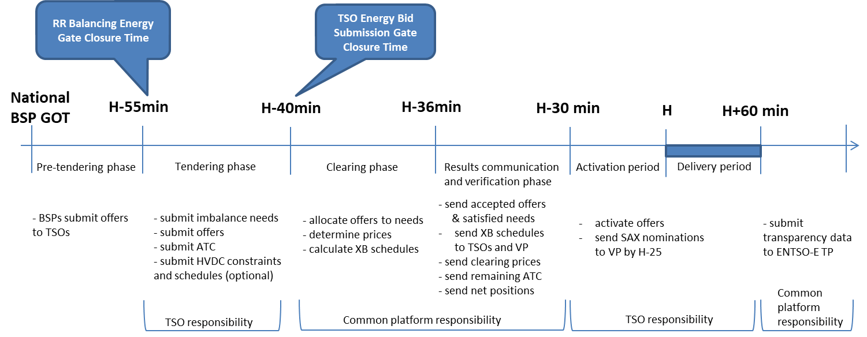

- TSOs receive the bids from the BSPs from their local balancing area/bidding zone
  - Bids are sent from BSPs to TSOs up to 55 minutes before delivery
  - This phase is named: Pre-tendering phase
- TSOs put the valid RR bids on the LIBRA platform
  - Valid BSP bids are sent to Libra from H-55 min to H-40 min
  - This phase is named: Tendering phase
- TSOs send their needs and ATC values to the platform
  - TSOs bids (needs) are sent to Libra from H-55 min to H-40 min
  - This phase is named: Tendering phase
- Platform runs the algorithm with offers and needs
  - From H-40 min to H-36 min Libra runs the algorithm and allocates the offers to satisfy the needs, determines prices and calculates XB schedules.
  - This phase is named: Clearing phase
- Communication of accepted offers, satisfied needs and marginal prices
  - From H-36 min to H-32 min Libra sends accepted offers/satisfied needs, XB schedules, clearing prices, remaining ATC and net positions
  - This phase is named: Results communication and verification phase
- TSO-BSP communication and RR activation
  - From H-32 min to H-30 min TSOs send activation signals to BSPs
  - This phase is named: TSO communication period
- RR activation period
  - RR activation period is from H-30 min to H
- RR delivery period
  - RR activation period is from H to H+60 min
- RR deactivation period
  - After Delivery Period, BSPs deactivate their energy under national regulation constraints.
- Calculation of the bilateral exchanges between balancing areas and TSO-TSO settlement
In the following figure the current process can be seen. A reference to the negotiation of this same energy in the Single IntraDay Coupling and MARI project is also included.

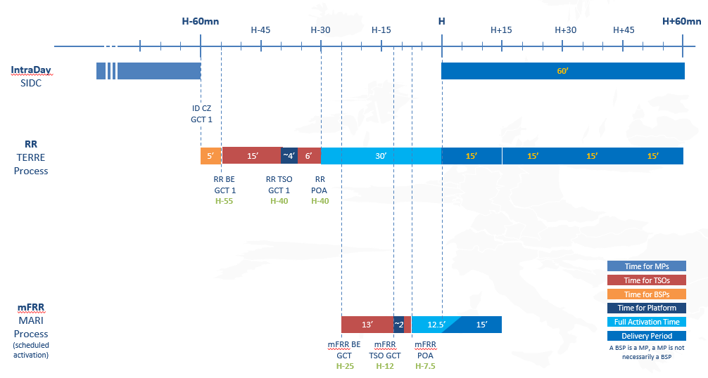

Option #1 for future RR process with 96 clearings per day with current timings
The option for 96 gates foresees a clearing every 15 minutes. This means offers will be activated for delivery periods that will always be 15 minutes long. This will implicate the elimination of 30-minutes and 60-minutes offers, as well as the possibility to link 15-minutes offers over 2, 3 or 4 quarterly hour periods. All other types of bids will remain as a possibility: fully divisible, divisible, indivisible, exclusive and multi-part.
The rest of the process will remain the same. Hence, BSPs will still have until 55 minutes to submit offers to their respective TSO before the beginning of the delivery period. FAT will also remain unchanged, and results will be therefore communicated at least 30 minutes in advance. The time for TSOs to integrate the offers of the BSPs in their national system will remain at 15 minutes, starting the algorithm optimization 40 minutes before the delivery period.

Every clearing will be spaced 15 minutes and the total time for the process will be 25 minutes. Hence, BSPs will need to offer for the next clearing without having the result of the previous one. This will create the need to use conditional linking amongst offers, similar to MARI project. With this new type of complex offers, BSPs will be able to indicate if the offers are available or not depending on the result of the previous clearing, which is an indicator the platform will have in the moment of optimizing this period. The possible linking amongst offers will be as follows:
- If bid in earlier MTU period is activated, the linked bid in following MTU is available.
- If bid in earlier MTU period is activated, the linked bid in following MTU is unavailable.
- If bid in earlier MTU period is not activated, the linked bid in following MTU is available.
- If bid in earlier MTU period is not activated, the linked bid in following MTU is unavailable.

In the following figure, the process for two consecutive clearings can be seen. A reference to the negotiation of this same energy in the Single IntraDay Coupling and MARI project is also included.
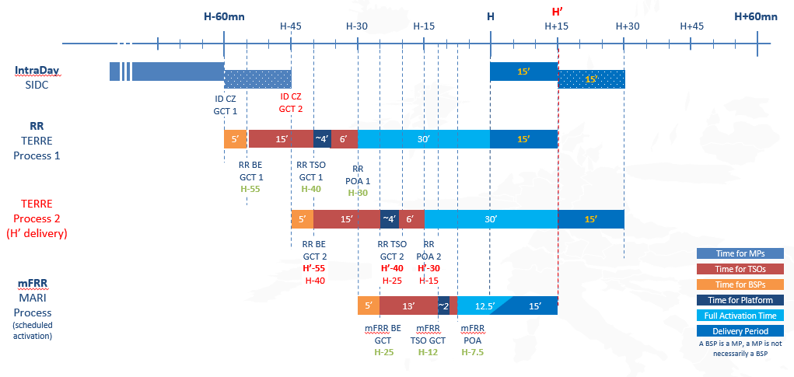

Option #2 for future RR process with 96 clearings per day with reduced timings

This option provides an alternative approach similar to option #1 without linking of bids but with reduced TERRE process time:
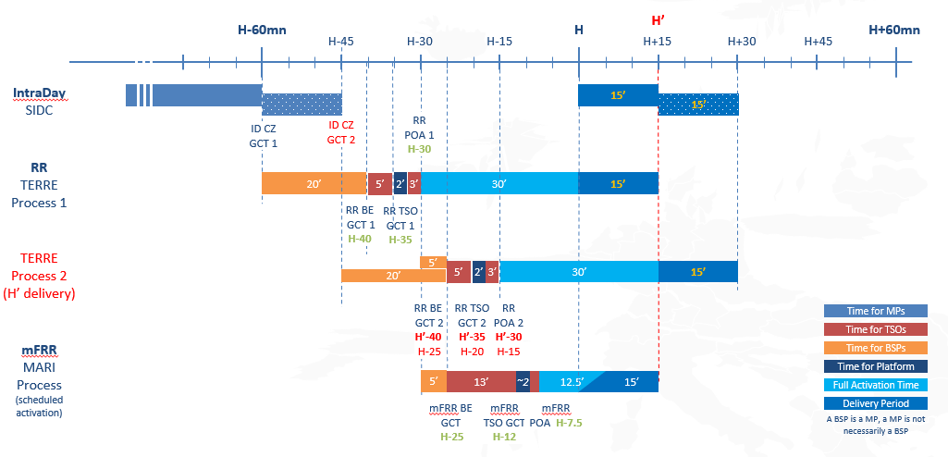
This option requires reducing the TSO process time to 5 minutes. For the first MTU of the hour H, the intraday results will be known at H-60 and results from the previous TERRE clearing will be communicated at H-45. Therefore TSOs propose to set the BE GCT at H-40 to let 5 minutes between two consecutive TERRE clearings.

Option #3 for future RR process with 96 clearings per day with reduced timings and delivery period of 30 minutes

This option #3 includes the same features as option #2 but with the additional possibility for some BSPs to offer products with a 30-minute delivery period. This requires optimizing each MTU twice over two consecutive and independent clearings composed of two MTUs each.

However, this additional possibility would only be available for BSPs connected to CEPS, RTE and Swissgrid. Indeed, BSPs connected to other TSOs would only be able to submit bids for the first MTU (15-minute products) due to some difficulties for TSOs with central dispatch model, explained in detail in section 4.6 and some infeasibilities for other TSOs, explained in section 4.7.
The graph below illustrates the sequence of two consecutive clearings:
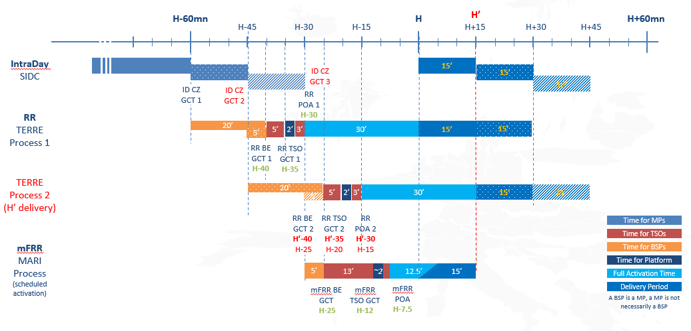
- For TERRE process 1: the first MTU [H; H+15] will be cleared with all bidding zones whereas the second MTU [H+15; H+30] will be cleared only for TSOs and BSPs that can submit needs ands bids for this second quarter hour. Results will be known at H-30 i.e 5 minutes before the beginning of TERRE process 2.
- For TERRE process 2: TSOs and BSPs that have submitted needs and bids for MTU 2 in TERRE process 1 will have to take into account the results in order to resubmit needs and bids for the first MTU of TERRE process 2. As mentioned in section 2.6, there will be up to two different CBMPs for the same MTU but the rules to link these two clearings have not yet been decided.
Without prejudging the feasibility of this complex scenario nor the compatibility with the regulations, the TSOs would like to collect feedback from stakeholders to see whether it needs further investigations.

Alternative option for future RR process with 48 clearings per day

An alternative option would be changing to 48 clearing per day. This would mean having one clearing every 30 minutes and that those clearings will be considering a delivery period of two MTUs (30 min).
In this option, the BGCT is moved to 45 minutes before delivery and the process will last 10 minutes. Hence, BSPs will have the results of the last clearing to update the offers for the following clearing. As a summary, the main characteristics of this option are:
- 48 Gates per day (one every 30 min)
- Each clearing is for two MTUs (2 x 15 min)
- FAT remains 30 min
- BE GCT is moved to H-40
- Process time for TSOs is reduced to 5 min
- Granularity of the CBMP is 15 min
- Process time on LIBRA is reduced to 5 min

This option for 48 gates foresees a clearing every 30 minutes. This means offers can be activated for delivery periods either 15 or 30 minutes long. This will implicate the elimination of 60-minutes offers, as well as the possibility to link 15-minutes offers over 3 or 4 quarterly hour periods. All other types of bids will remain as a possibility: fully divisible, divisible, indivisible, exclusive and multi-part.
Some parts of the process will have to run on shorter periods. BSPs will still have 5 minutes to submit offers to their respective TSO after the closure of the second quarter hour in the CZ ID market. For the first quarter hour, the time to update the offer will increase to 20 minutes. FAT will remain at 30 minutes and the time for TSOs to validate offers and calculate needs and ATCs will be reduced to 5 minutes, starting the algorithm optimization 35 minutes before delivery period.
Every clearing will be spaced 30 minutes and the total time for the process will be 15 minutes. Hence, BSPs will not need to offer for the next clearing without having the result of the previous one.
In the following figure the process for two consecutive clearings can be seen. A reference to the negotiation of this same energy in the Single IntraDay Coupling and MARI project is also included:

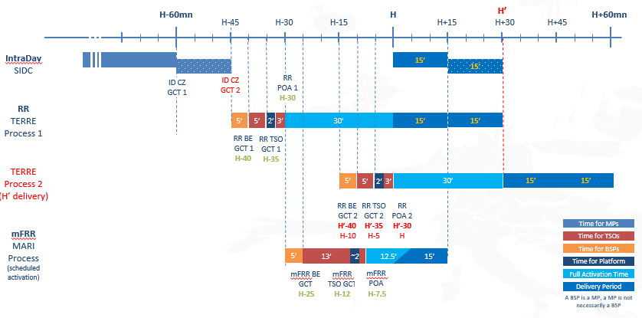
It must be noted that this option presents some difficulties for TSOs with central dispatch model, explained in detail in section 4.6 and some infeasibilities for other TSOs, explained in section 4.7. Hence, this option is not present in previous sections and should not be considered as consulted. It is only included in the annex for BSPs information on other possible options discarded.

Details on the bid conversion process for TSOs with central dispatch model
This section is intended to clarify both the complexity of a 48 clearings framework and the reason why central dispatch countries would technically be able to participate only in the first MTU in option #3
Below provided details on the bid conversion process for central dispatch TSOs, with a particular focus on the opportunity of performing the conversion of two subsequent MTUs, but it is important to be noted that the complexities identified by central dispatch TSOs are the same that would be faced by the BSPs themselves in self-dispatch countries.
It has been mentioned in previous sections that the option with 48 daily clearings is not compatible with the bid conversion process for TSOs with a central dispatch model. This section provides the details on that process. Focus is provided on the bid conversion process for Italian bids, from the Integrated Scheduling Product bids into standard RR bid, and how this process would be impacted by the increase in the number of clearings. Among RR countries, a similar situation would occur for the bid conversion process in Poland.
In the Italian power system all generators that are able to provide the RR service are obligated to participate to the RR market with their whole leftover capacity from previous markets.
This obligation is enforced by the conversion of the bids performed by Terna: Terna must calculate the RR bid quantity, making sure that all available capacity is considered and that the resulting scheduling will be feasible, considering all technical constraints of the power plants (ramping, time to start-up & shut down, minimum off-time & up-time, etc.) and of the system (line overload risk, etc.).
The calculation for a MTU needs at least the following inputs, together with all technical data of power plants:
- ID scheduling for the MTU,
- RR scheduling for the previous MTU.
In a framework of ISP=15’ and 96 clearings, the same calculation approach as today can be used. Therefore, the conversion process with 96 clearings would be as follows:
- Calculation of the maximum upward and minimum downward schedule for MTU1, based on the RR schedule of MTU0 and on the technical requirements of the power plant (in the example only the ramping constraint is taken into account, for simplicity of representation);
- Calculation of the total upward offered quantity ($δP^{+}$) as the difference between the maximum upward schedule (calculated in the previous step) and the ID schedule of MTU1, and calculation of the total downward offered quantity ($δP^{-}$) as the difference between the ID schedule of MTU1 and the minimum downward schedule of MTU1 (calculated in the previous step).
- Determination of the families of exclusive bids, in order to account for the multiple functioning bands of each generator.

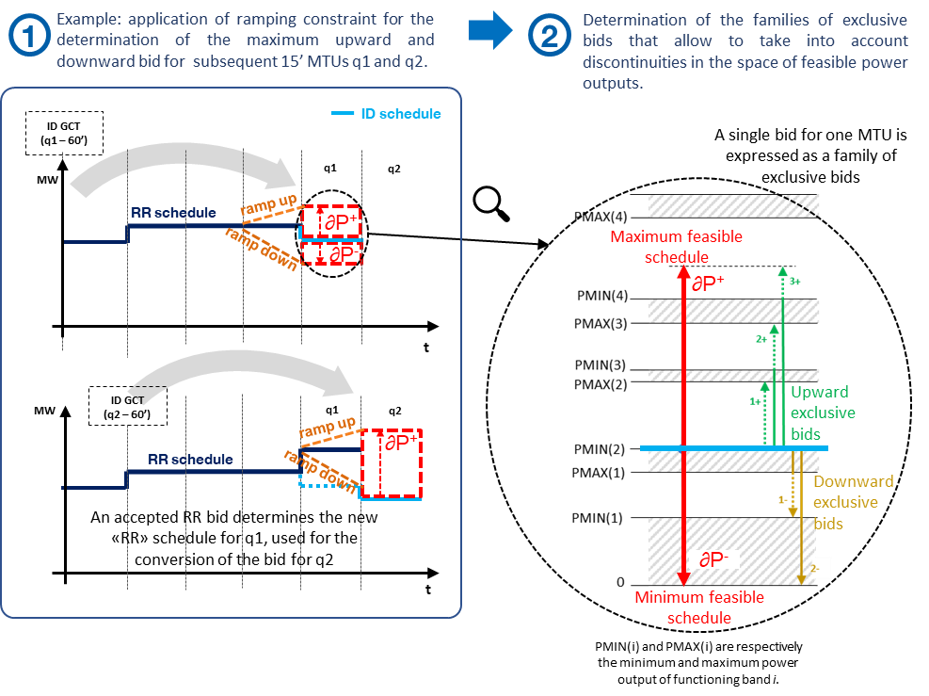

On the other hand, in a framework of ISP=15’ and 48 clearings (or any other clearing of more than one MTU) the solution for the conversion process would not be as straightforward, because it would require a simultaneous bid conversion for two subsequent MTUs.
As a matter of fact, when ISP moves to 15’ BSPs must be allowed to submit 15’ bids (according to EBGL). Therefore, bids for two or more MTUs cannot be linked in time a priori the same as it is done today with a 60’ ISP/MTU.
Terna analysed the available options for converting two bids together without linking them in time, with a focus on the application of only the ramping constraint (which is a relatively simple constraint), following the principle that the conversion must be performed in such a way that any possible level of acceptance of the submitted standard RR bids results in a feasible schedule for the power plants.
Option 1: Possible scenarios for the acceptance are taken into account by exclusive bids spanning the two MTUs.
The first of the evaluated options is to use the structure of exclusive bids to create multiple combinations that can cover all possible acceptance rates of both MTUs included in each clearing.
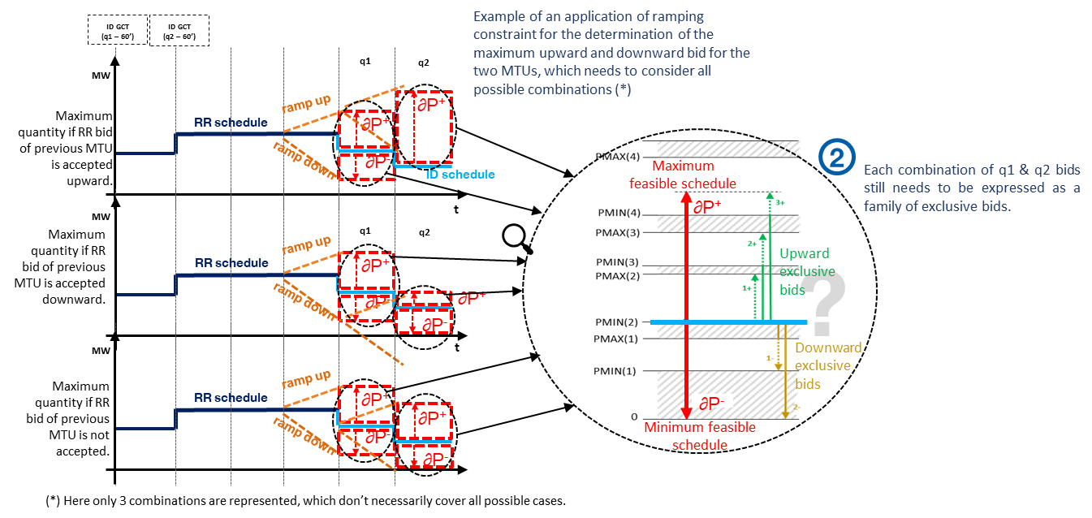
In the example above, it is shown how the complexity increases together with the number of situations that will be covered. Moreover, it is yet to be assessed whether all of the technical constraints used today can actually be simulated with a limited number of acceptance scenarios.
The already presented 3-step conversion process would change as follows, with an exponential increase in complexity:
- Calculation of the maximum upward and minimum downward schedule for MTU1, based on the RR schedule of MTU0 and on the technical requirements of the power plant (in the example only the ramping constraint is taken into account, for simplicity of representation);
- Calculation of the maximum upward and minimum downward schedule for MTU2, based on the possible RR schedules of MTU1 and on the technical requirements of the power plant (in the example only the ramping constraint is taken into account, for simplicity of representation), for each acceptance scenario for MTU1 (in the example only 3 scenarios taken into account, for simplicity of representation);
- For each scenario, calculation of the total upward offered quantity ($δP^{+}$) as the difference between the maximum upward schedule (calculated in the previous step) and the ID schedule of MTU1, and calculation of the total downward offered quantity ($δP^{-}$) as the difference between the ID schedule of MTU1 and the minimum downward schedule of MTU1 (calculated in the previous step).
- For each scenario, determination of the families of exclusive bids, in order to account for the multiple functioning bands of each generator.
- Determination of the families of exclusive bids to enforce the alternative acceptance of the combinations that were identified.
In conclusion, the RR bid conversion becomes a combinatorial problem of unjustifiable complexity, that may result in tens of exclusive bids per generator (for 200+ generators). This increased complexity would have an impact (impossible to quantify at this time) both on the time needed for the conversion and on the clearing itself.
Option 2: Limitation of offered capacity in both MTUs.
In the second option, the underlying uncertainties of clearing two unlinked MTUs are dealt with by limiting the offered capacity to the extent that any possible acceptance rate is feasible.
The conversion process would be similar to the previous option, with the difference that the scenarios are used to limit the offered quantity of one (or both) MTUs (instead of determining families of exclusive bids). The process would be as follows if the acceptance scenarios of MTU1 are used to limit the offered quantity of MTU2:
- Calculation of the maximum upward and minimum downward schedule for MTU1, based on the RR schedule of MTU0 and on the technical requirements of the power plant (in the example only the ramping constraint is taken into account, for simplicity of representation);
- Calculation of the maximum upward and minimum downward schedule for MTU2, based on the possible RR schedules of MTU1 and on the technical requirements of the power plant (in the example only the ramping constraint is taken into account, for simplicity of representation), for each acceptance scenario for MTU1 (in the example only 3 scenarios taken into account, for simplicity of representation);
- Calculate the minimum of the maximum upward schedule for MTU2 among all scenarios; calculate the maximum of the minimum downward schedule for MTU2 among all scenarios.
- Calculation of the total upward offered quantity ($δP^{+}$) as the difference between the upward schedule (calculated in the previous step) and the ID schedule of MTU1, and calculation of the total downward offered quantity ($δP^{-}$) as the difference between the ID schedule of MTU1 and the downward schedule of MTU1 (calculated in the previous step).
- Determination of the families of exclusive bids, in order to account for the multiple functioning bands of each generator.
It would also be possible, in order to limit the total loss of liquidity, to optimally select the minimum and maximum schedules of MTU1 and MTU2 so that any acceptance rate of both MTUs is feasible; this approach would allow to save some liquidity but would probably increase the time required for the conversion process.
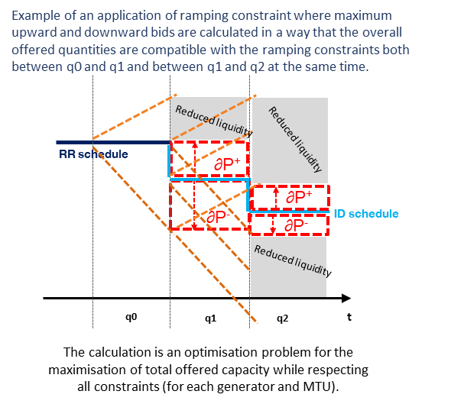
This option may result in a conversion process as complex as the previous one in terms of the evaluation of possible acceptance rates of MTU1 (or even more complex if the bands are selected optimally on both MTU1 and MTU2), but it wouldn’t have an impact on the performance of the clearing.
The main downside of this option, together with the increased complexity (and time required) of the conversion process, would be the extreme loss of RR liquidity in the Italian power system.

Evaluation of the 48 gates options from a central dispatch perspective
No option was identified for an implementation of a process with 48 daily clearings that would still respect the current criteria and timings for the conversion of bids.
Also, central dispatch systems would not be able to submit bids for both MTUs that would be cleared in 96 clearings option #3.
The current procedure for RR bid conversion is described in the Italian network code and was object of a public consultation; the possibility of amending such procedure, especially if against operational constraints of market parties or system liquidity, is a regulatory and system-wide decision.

Details on infeasibilities for the alternative options with 30’ delivery period
Both the option with 96 clearings per day with reduced timings and delivery period of 30 minutes explained in section 4.4 and the option with 48 gates explained in section 4.5 would not allow time for current processes carried out by Iberian Peninsula TSOs (calculation of system needs and validation of RR offers for their submission to LIBRA platform) currently taking into account intraday market results. The implementation of both options would require adaptations in the calculation of system needs and simplifications in the offers vaildation process.

Annex 2- Market participants’ positions and questions received during the public survey

A public survey of the proposed options is proposed in the period 29th May until 30th June 2023. Received positions and questions including TSOs answers will be found in the following sections.

Option preference:

Which option is your preferred one? Please explain, in detail, your selection.

Impact on liquidity:

Is there an impact on your RR bids with the changes proposed in the final option? Please elaborate in detail.

Do you consider conditional linking necessary for option #1? Please elaborate why.

Will your availability to provide RR be affected with the reduction of the delivery period ? If so, please indicate to what extent for

Option #1 and #2 (reduction of maximum delivery period from 60 to 15 minutes)

Option #3 (reduction of maximum delivery period from 60 to 30 minutes)

Flexibility on timings:

Currently there are 5 minutes between ID GCT and TERRE GCT, would it be possible to shorten this timing (please provide an answer in minutes)?

Currently there are 5 minutes between TERRE results and MARI GCT, would it be possible to shorten this timing (please provide an answer in minutes)?
Other:

Do you have any other comments or proposals on the RRIF or on the RR process in general?

