TSOs highlight that this consultation is conducted only on the tracked changes performed to the existing methodology, and that the full text of the methodology is provided for transparency and for facilitating the stakeholders in their review.

The final submission will be performed only on the changes to the existing methodology.

Explanatory document to all TSOs’ proposal for a harmonised methodology for the allocation process of cross-zonal capacity for the exchange of balancing capacity or sharing of reserves per timeframe in accordance with Article 38(3) of Commission Regulation (EU) 2017/2195 of 23 November 2017 establishing a guideline on electricity balancing

[For Public Consultation]

22 March 2024

DISCLAIMER
This document is released on behalf of the all transmission system operators (“TSOs”) for the purposes of approval of the proposal for methodology for a harmonised allocation process of cross-zonal capacity for the exchange of balancing capacity or sharing of reserves per timeframe (hereafter referred to as “methodology for a harmonised allocation process per timeframe”) in accordance with Article 38(3) of the Commission Regulation (EU) 2017/2195 of 23 November 2017 establishing a guideline on electricity balancing (“EB Regulation”).

Table of Contents

Table of Contents 2
List of Figures 3
Definitions and Abbreviations 5
1 Introduction 12
1.1 EB Regulation and the scope of the Harmonised Methodology 13
1.2 Cross-zonal capacity for balancing capacity purpose 13
1.3 Competition on cross-zonal capacity between day-ahead and balancing capacity markets 14
2 EB Regulation requirements for the HCZCAM for the allocation process of cross-zonal capacity 16
2.1 Co-optimised allocation process: Article 40 of the EB Regulation 16
2.3 Principles from Articles 38 and 39 of the EB Regulation 18
2.4 Other relevant information from the EB Regulation 20
3 Background information 22
3.1 Balancing capacity market 22
3.1.1 Balancing capacity auctioning 22
3.1.2 Exchange of balancing capacity 22
3.1.3 Sharing of reserves 24
3.1.4 Limitations to the CZC allocated to the balancing capacity market 25
4 Market value of cross-zonal capacity 26
4.1 Actual Market Value of cross-zonal capacity for the Exchange of Energy 27
4.1.1 The market value of cross-zonal capacity 27
4.1.2 Isolated energy markets cleared independently 27
4.1.3 Coupled energy markets with congestion 28
4.2 Actual Market Value of cross-zonal capacity for the exchange of balancing capacity or sharing of reserves 29
4.2.1 The market value of CZC is independent of the pricing method for balancing capacity 29
4.2.2 Isolated markets for balancing capacity with pay-as-bid pricing 30
4.2.3 Coupled balancing capacity markets with pay-as-bid pricing 30
4.2.4 Non-convexities in balancing capacity markets 31
5 Methods for the calculation of market value of cross-zonal capacity 33
5.1 Process Steps of CZC allocation 34
5.1.1 Flow-Based Computation 34
5.1.2 Bid Submission & Collection 35
5.1.3 Bids Preparation 35
5.1.4 Cross-Zonal Capacity Allocation 36
5.1.5 Market Clearing 36
5.1.5.1 Balancing Capacity Market Clearing 37
5.1.5.2 Day-Ahead-Market Clearing 37
5.1.6 Notification and Settlement 37
5.2 Co-optimised allocation process 38
5.2.1 One-step/ two-step implementation 38
5.2.2 One-step co-optimised allocation process 39
5.2.2.1 Two-step co-optimised allocation process 41
5.2.3 Cross-product linking of bids 41
5.3 Market-based allocation process 43
5.3.1 Market-based allocation process 44
5.3.2 Forecasting of the market value of CZC for DAM purposes 45
5.3.3 One forecast process and one forecast validation process per BC platform 48
5.4 Forecasting Methods 48
5.5 Fallback procedures 50
6 The establishment of the BC platform in the market-based allocation process 51
6.1 Steps required for the establishment of the BC platform 51
6.2 CZCAOF blueprint definition 52
6.3 Decentralized approach 53
6.4 Organisation of the co-operation of Application TSOs in a market-based allocation process 54
6.5 Firmness regime for the allocation of cross-zonal capacity 55
7 Cost sharing of the BC platform establishment 57
7.1 Cost-sharing: Step B. Building the CZCAOF blueprint 58
7.2 Cost-sharing: Step C. Technical Implementation of the CZCAOF Software 58
7.3 Cost-sharing: Step D. Technical Implementation of the forecast validation process by RCCs 59
7.4 Cost-sharing: Step E. Technical Implementation of the forecast process 59
8 Governance 61
9 Provisions referring to specific topics in the HCZCAM document 63
10 Annex - Structure of applications, CPOF and CZCAOF 69

List of Figures
Figure 1: Principle of optimal capacity allocation to different purposes 15
Figure 2: How to allocate available cross-zonal capacity 15
Figure 3: Exchange of reserves – illustrative example. Source: LFCR supporting document 2013 23
Figure 4: Sharing of Reserves – simple example. Source: LFCR supporting document 2013 24
Figure 5: Market value of CZC is defined as the total economic surplus 27
Figure 6: Economic surplus in two energy markets cleared in isolation 28
Figure 7: Economic surplus in coupled energy markets with congestion 28
Figure 8: Economic surplus in isolated markets with pay-as-bid pricing 30
Figure 9: Economic surplus in coupled balancing markets with pay-as-bid pricing 31
Figure 10: The six main process steps of CZC allocation 33
Figure 11: Process graph of the DACC flow-based computation 34
Figure 12: Process graph of the bid preparation and provision of BC and DAM bids 35
Figure 13: Process graph of the bid preparation by TSOs and NEMOs 35
Figure 14: Process graph of the CZCAOF 36
Figure 15: Process graph of the market clearings of the DAMs and BCMs 37
Figure 16: Process graph of the notification and settlement process 37
Figure 17: Process Overview One-Step Co-optimised Allocation 39
Figure 18: Process Overview Two-Step Co-optimised Allocation 41
Figure 19: Outline of cross-product linking of bids using the multilateral approach within the BCM and the unilateral approach between the BCM and the DAM 42
Figure 20: Process Overview Market-Based Allocation 44
Figure 22: steps required for the Figure 22: steps required for the BC platform 54
Figure 23: Harmonisation of the Figure 23: Harmonisation of the BC platform 56
Figure 21: Organisation of the co-operation of Application TSOs 55
Figure 24: Cost sharing of the Figure 24: Cost sharing of the BC platform 58
Figure 25: Cost sharing for Building the CZCAOF Software 59
Figure 26: cost sharing for the Technical Implementation of the CZCAOF Software 60
Figure 27: cost sharing for the Technical Implementation of the forecast process 61

Definitions and Abbreviations
Definitions | Description
Application of a timeframe of CZCA | One or more TSOs applying one or more cross-zonal capacity allocation processes of this methodology for a harmonised allocation process per timeframe on one or more bidding zone borders. The application shall have an approved methodology of Article 38(1) of EB Regulation in place.
Co-optimisation method | Methodology to allocate CZC for the exchange of balancing capacity or sharing of reserves that is based on a comparison of the actual market value of CZC for the exchange of balancing capacity or sharing of reserves and the actual market value of CZC for the exchange of energy.
Cross-Zonal Capacity Allocation Optimisation Function | The functionality that determines the allocation of cross-zonal capacity for the exchange of energy and for the exchange of balancing capacity or sharing of reserves and determines the marginal clearing prices and volumes of balancing capacity for each application and per participating TSO.
Day-ahead Market timeframe | The timeframe of the electricity market until the day-ahead market gate closure time, where, for each market time unit, products are traded the day prior to delivery.
Duration of application | The period for which balancing capacity cooperation applies one of the methodologies over one or more bidding zone borders to allocate CZC for the exchange of balancing capacity or sharing of reserves according to Article 38(2) of the EB Regulation.
Economic surplus from the exchange of balancing capacity or sharing of reserves | The sum for the relevant time period of (i) the TSOs’ surplus for the exchange of balancing capacity or sharing of reserves, (ii) the balancing service providers’ surplus for the exchange of balancing capacity or sharing of reserves, and (iii) the congestion income. Surplus for balancing service providers is being the difference between the price of the accepted bids and the clearing price per capacity unit multiplied by the accepted capacity volume of the bid. Surplus for TSOs for the exchange of balancing capacity is being the difference between the maximum possible clearing price and the actual clearing price per capacity unit multiplied by the volume of balancing capacity demand. Surplus for TSOs for sharing of reserves is being the sum of multiplying the quantities and prices of all balancing capacity bids rejected due to sharing of reserves if pay-as-bid pricing is applied and being the highest price of the balancing capacity bid multiplied with the capacity volume of the bids that are not cleared any more due to the sharing of reserves if marginal pricing is applied. Surplus for congestion income being the price of cross-zonal capacity as determined by Article 21 of this methodology multiplied by the allocated volume of cross-zonal capacity.
Exchange of balancing capacity | As defined in Article 2(30) of Commission Regulation (EU) 2017/2195 of 23 November 2017 establishing a guideline on electricity balancing.
Intraday market timeframe | As defined in Article 2(37) of Commission Regulation (EU) 2015/1222 of 24 July 2015 establishing a guideline on capacity allocation and congestion management.
Market coupling operator | As defined in Article 2(30) of Commission Regulation (EU) 2015/1222 of 24 July 2015 establishing a guideline on capacity allocation and congestion management.
Market Operator | As defined in Article 2(7) of Commission Regulation (EU) 2019/943 of the European Parliament and of the Council of 5 June 2019 on the internal market for electricity (recast).
Market time unit | The time unit for the aFRR, the mFRR, and RR balancing capacity bids or the day-ahead market time unit (i.e., the period for which the balancing capacity bid price or the market price is established).
Market value function | Function to relate the market-related economic surplus to the CZC which is available for the exchange of bids.
Market value of cross-zonal capacity | The economic surplus of CZC allocation, which is the sum of the producer surplus, consumer surplus and congestion income from the exchange of energy (1) for the purpose of exchange of Day-ahead market energy or (2) for the purpose of the exchange of balancing capacity or sharing of reserves.
Forecast error | The deviation of the forecasted market value from the actual market value in percent per day-ahead market time unit for the exchange of energy when applying the market-based allocation. A positive deviation of the forecast error means a forecasted market value for the exchange of balancing capacity or sharing of reserves larger than the actual market value for the exchange of balancing capacity or sharing of reserves.
Procurement of balancing capacity | A range of processes during a certain time period comprising a balancing capacity auction, the selection of balancing capacity bids at the gate closure time (the Contracting of balancing capacity) and informing the balancing service providers about their selected bids.
Release of cross-zonal capacity | CZC allocated for the exchange of balancing capacity or sharing of reserves that are no longer needed and is released as soon as possible and returned in the subsequent capacity allocation timeframes.
Sharing of reserves | A mechanism in which more than one TSO takes the same balancing capacity, being, FRR or RR, into account to fulfil their respective reserve requirements resulting from their reserve dimensioning processes.
Single day-ahead coupling | As defined in Article 2(27) of Commission Regulation (EU) 2015/1222 of 24 July 2015 establishing a guideline on capacity allocation and congestion management.
Single intraday coupling | As defined in Article 2(27) of Commission Regulation (EU) 2015/1222 of 24 July 2015 establishing a guideline on capacity allocation and congestion management.
TSO BC demand | The balancing capacity volume to be procured for own purposes resulting from the TSO’s dimensioning process within the scope of the methodology pursuant to Article 33(1) of the EB Regulation and defined per scheduling area and bidding zone in accordance with Article 32(1) of the EB Regulation.
TSO BC sensitive demand | A part of the TSO BC demand defined by the respective TSO to be volume sensitive for the purpose of reserve sharing, bid indivisibility, and substitution of reserves for cost minimisation and volume shortage.
TSO procurement volume | The balancing capacity volume to be procured by the respective TSO in its own area determined by the Cross-Zonal Capacity Allocation Optimisation Function.
Use of cross-zonal capacity for the exchange of balancing capacity or sharing of reserves’ | The physical use of CZC with an actual transfer of balancing energy.

Abbreviations
The list of abbreviations used in this document:

AC Alternating current
ACER Agency for the Cooperation of Energy Regulators
aFRR Frequency restoration reserves with automatic activation
ATC Available Transfer Capacity
BC Balancing capacity
BCM Balancing capacity market
BEC Bilateral Exchange Computation
BSP Balancing service provider
CA Control area
CACM Commission Regulation (EU) 2015/1222 of 24 July 2015 establishing a guideline on capacity allocation and congestion management
CB Critical branch
CCR Capacity Coordination Region
CZC Cross-zonal capacity
CZCA Cross-zonal capacity allocation
CZCAOF Cross-Zonal Capacity Allocation Optimisation Function
D Day of realisation
D2CF Two-days ahead congestion forecast
DACC Day-ahead capacity calculation
DAM Day-ahead market
DC Direct current
EB Regulation Commission Regulation (EU) 2017/2195 of 23 November 2017 a establishing a guideline on electricity balancing
ECC European Commodity Clearing
ENTSO-E European Network of Transmission System Operators for Electricity
EU European Union
FB Flow-based
FCR Frequency containment reserves
FRR Frequency restoration reserves
GCT Gate closure time
GSK Generation shift key
H Hour
JAO Joint Allocation Office
LFC Load-frequency control
LFCR Load-frequency control and reserves
LT Long-term
LTTR Long-term transmission right
mFRR Frequency restoration reserves with manual activation
MC Market coupling
MP Market party
MW Megawatt
NEMO Nominated electricity market operator
NRA National regulatory authority
NTC Net Transfer Capacity
RCC Regional coordination centre
RR Replacement reserve
SA Synchronous area
SDAC Single day-ahead coupling
SIDC Single intraday coupling
SO Regulation Commission Regulation (EU) 2017/2195 of 23 November 2017 establishing a guideline on electricity transmission system operation
TSO Transmission system operator
- Introduction
The Commission Regulation (EU) 2017/2015 establishing a guideline on electricity balancing (EB Regulation) proposes the application of cross-zonal capacity allocation (CZCA) for the balancing process to improve competition and increase welfare by means of cross-zonal balancing exchanges. This implies that TSOs may allocate cross-zonal capacity (CZC) available for the single day-ahead coupling (SDAC) to the same timeframe in which the balancing capacity (BC) procurement is organised. To yield the largest benefit through CZCA in a market-based environment, the EB Regulation introduces four CZCA processes:
- Article 40 to develop a methodology based on the co-optimised allocation process;
- Article 41 to develop a methodology based on the market-based allocation and/or the inverted market-based allocation;
- Article 42 to develop a methodology based on economic efficiency analysis.
This document gives background information and rationale for the Methodology for a harmonised allocation process of cross-zonal capacity for the exchange of balancing capacity or sharing of reserves per timeframe (Harmonised Methodology - HCZCAM) for the exchange of balancing capacity or sharing of reserves as required by EB Regulation Article 38(3).
The HCZCAM shall include three timeframes which all focus on day-ahead procurement according to the Clean Energy Package, consequently excluding the timeframe of economic efficiency analysis.
- The co-optimised allocation process is mandatory as part of the HCZCAM.
- The market-based allocation is the timeframe that finds the most interest for application across Europe by interested future application TSOs.
- The inverted market-based allocation is a potential method for cross-border procurement.
An elaboration of the inverted market-based allocation is not covered in this explanatory document. ACER has decided to not further elaborate the inverted market-based allocation in the HCZCAM. In the case in future there is an interest in an application, all TSOs may propose an amendment of this harmonised cross-zonal capacity allocation methodology to determine the requirements of such process. However, currently, there is no intention to define the rules for the inverted market-based allocation for the following reasoning:
- The inverted market-based allocation process shall be based on the co-optimised allocation process, with the difference that forecasted SBCP offers are used instead of actual SBCP offers. Since it is unclear when the co-optimised allocation process is expected to be operational, the introduction of the Inverted market-based allocation is at this time not possible.
- The inverted market-based allocation process is currently not the interest of an application but remains an option for the future.
- It is seen as a clear benefit to gain experience with cross-zonal capacity procurement through the market-based allocation, before moving to the inverted market-based allocation. This includes experience with the forecasting process and forecast validation process of the market-based allocation.

In case the inverted market-based allocation becomes a favoured and possible option for one or more application TSOs, the experiences gained from the market-based allocation process shall lay the foundation for amending Title 3 of the methodology for a harmonised allocation process per timeframe and defining the market rules of the inverted market-based allocation.

For higher legibility, the document is structured as follows:
- Chapters 1 and 2 give a general presentation of the EB Regulation requirement and the co-optimised allocation process and the market-based allocation process;
- Chapter 3 provides background information regarding balancing capacity markets and cross-border exchange of balancing capacity;
- Chapter 4 covers the assessment of the market value of CZC for day-ahead market purposes and for balancing capacity market purposes. The principles of the required CZCA optimisation (cost-benefit analysis) are provided;
- Chapter 5 introduces a comprehensive description of the harmonised allocation process, where co-optimized and market-based allocation processes as explained in chapters 1 and 2 are described. This also includes the forecast and the forecast validation processes for market-based allocation;
- Chapter 6 describes the details of establishing the BC platform in the market-based allocation process including the required steps, harmonisation, and cooperation between application TSOs;
- Chapter 7 is dedicated to cost sharing of the BC platform in the market-based allocation process;
- Chapter 8 is dedicated to specific topics in the methodology for a harmonised allocation process per timeframe.

  - EB Regulation and the scope of the Harmonised Methodology
The EB Regulation established an EU-wide set of technical, operational and market rules to govern the functioning of electricity balancing markets.
The main purpose of this guideline is the integration of balancing markets to enhance the efficiency of the European balancing processes. The integration should be done in a way that avoids undue market distortion. This requires harmonisation of both technical requirements and market rules. To provide this level of harmonisation, the EB Regulation sets out requirements for the development of harmonised methodologies for CZCA for balancing purposes.
  - Cross-zonal capacity for balancing capacity purpose
TSOs procure ahead of real-time BC for automatic and manual frequency restoration reserves (FRR) and/or replacement reserves (RR).
The cross-border cooperation for the BC procurement could be implemented by two different schemes:
- Exchange of balancing capacity refers to the BC provision to a TSO in a different scheduling area or LFC area, where a LFC area consists of more than one monitoring area, than the one in which the offering balancing service provider (BSP) is connected. Exchange of balancing capacity between balancing areas may lead to a deviating geographical BC procurement location than the dimensioning results for each area to increase efficiency, competition and cost savings. The total BC procured in all scheduling areas is equal to the total dimensioned volumes.
- Sharing of reserves refers to a mechanism in which more than one TSO take the same reserve capacity into account to fulfil the respective reserve requirements as required from the reserve dimensioning processes. This is possible between two or more TSOs which from experience do not need the same procured BC unit at the same time. TSOs can therefore share their reserves and reduce the procurement of the total BC while still meeting their individual system security requirements and saving procurement costs.
Article 38(1) of the EB Regulation allows two or more TSOs to allocate a part of the CZC for the cross-border exchange of balancing capacity or sharing of reserves. Such an allocation may:
- enable TSOs to procure and use BC in an efficient, economic and market-based manner;
- improve competition for BC markets;
- improve competition between different markets; and
- facilitate regional BC procurement.
  - Competition on cross-zonal capacity between day-ahead and balancing capacity markets
The CZC between two bidding zones is limited. Therefore, this limitation requires the implementation of a mechanism to allocate the scarce CZC in an economically efficient way. The CZC allocated to the SDAC decreases the available CZC for BC purposes and vice versa. In other words, CZC allocation to one market increases its economic surplus but decreases the economic surplus of another and vice versa. The DA and BC markets therefore directly compete for the available CZC of the day-ahead timeframe. By establishing a CZCA methodology, the equal treatment of both markets shall be ensured.
The allocation process implies CZCA for the BC market at D-1 for the 24 hours of the next day together with and at the same market time unit (MTU) as the CZCA to the SDAC.
For the co-optimised allocation process, firm energy supply and demand bids, together with firm balancing capacity bids, therefore, compete for the available CZC for each MTU of the next day, as calculated and published by the TSOs before the GCT of the SDAC.
The classical economic concept to optimally allocate CZC to different purposes (also called the optimal capacity split problem) is to express the marginal economic surplus for an increment of CZC used for each purpose, and then find the capacity split where the marginal value for each purpose is equal (or the difference in marginal value is minimal if the lines do not cross). This principle is shown in Figure 1 below.
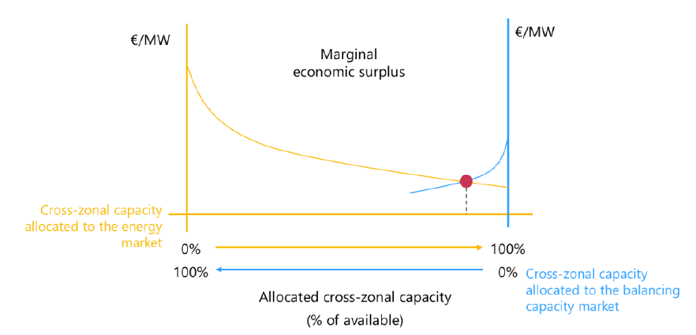
Figure 1: Principle of optimal capacity allocation to different purposes
CZC allocation across all borders, all MTUs and all allocation purposes give maximum market welfare if and only if it is not possible (i.e., without violating constraints) to reduce the difference in marginal economic surplus between allocation purposes for any hour on any border any further, while the summed effect of resulting increases of the difference in marginal economic surplus on any other border, hour and allocation purpose is lower. This is called a Pareto optimum.
The objective of the co-optimisation function is to maximise the sum of the economic surplus of the balancing capacity market and the SDAC while minimising BC procurement costs.
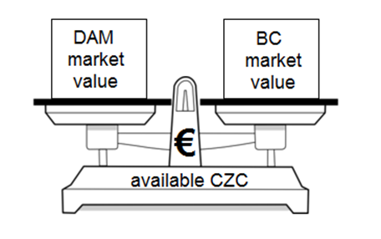
Figure 2: How to allocate available cross-zonal capacity
As a result, one unit of CZC may be allocated for the exchange of balancing capacity or sharing of reserves if the corresponding market value of CZC is higher than the market value for the same CZC unit allocated to SDAC.

- EB Regulation requirements for the HCZCAM for the allocation process of cross-zonal capacity
Article 38(3) of the EB Regulation requires all TSOs to develop a proposal for a harmonised methodology for the CZCA processes for the exchange of balancing capacity or sharing of reserves according to Articles 40 and 41. This chapter provides a summary of the EB Regulation requirements for the aforementioned allocation processes.
  - Co-optimised allocation process: Article 40 of the EB Regulation
Article 40(1) of the EB Regulation states the requirement to develop “a proposal for a methodology for a co-optimised allocation process of cross-zonal capacity for the exchange of balancing capacity or sharing of reserves.”
Besides the obligation to develop a proposal, Article 40 defines boundary conditions and specific requirements for this methodology.
In the words of the EB Regulation, such a methodology shall:
a) apply for the exchange of balancing capacity or sharing of reserves with a contracting period of not more than one day and where the contracting is done not more than one day in advance of the provision of the balancing capacity;
This means that the entire process of the co-optimised CZCA methodology takes place after D-1 BC market gate closure time (GCT) and DAM GCT, i.e. when all bids are firm. This means that according to the EB Regulation, co-optimisation allocation is done during the SDAC auction.
(b) include the notification process for the use of the co-optimised allocation process;
(c) include a detailed description of how cross-zonal capacity shall be allocated to bids for the exchange of energy and bids for the exchange of balancing capacity or sharing of reserves in a single optimisation process performed for both implicit and explicit auctions;
In the CZCA processes, there is direct competition between (at least) two different products for the same CZC: bids for energy and bids for balancing capacity. The inputs of the single optimisation process are both balancing capacity bids and energy bids, submitted per scheduling area and per bidding zone, respectively. The result is an optimal allocation of the CZC to both products.
(d) include a detailed description of the pricing method, the firmness regime and the sharing of congestion income for the cross-zonal capacity that has been allocated to bids for the exchange of balancing capacity or sharing of reserves via the co-optimised allocation process;
Pricing methods are, for example, pay-as-bid and pay-as-cleared. The objective function of the co-optimised allocation process is completely independent of the method for the TSO-BSP pricing, which is applied ex-post to the selected balancing capacity bids (see section 4.2).
Nonetheless, it is required to describe the allowed pricing methods for the cross-zonal capacity allocation processes in order to calculate and determine exactly the allocation of CZC to the exchange of balancing capacity or sharing of reserves based on the objective of welfare maximisation.
It is also required to describe in detail when the CZC is considered to be firmly allocated to the matched bids for the exchange of balancing capacity or sharing of reserves.
The congestion income is part of the total economic welfare. It can appear whenever there is a price difference between bidding zones. The congestion income on a border, if any, must be shared between the network owners who share that border: it is required that the HCZCAM contains the principles for sharing the congestion income for all timeframes.
Article 40(3) of the EB Regulation requires that the definitions of the pricing method of CZC, the firmness regime of CZC, and the sharing of congestion income from CZC for which the co-optimised allocation process is applied to ensure equal treatment between balancing capacity bids and energy bids.
(e) include the process to define the maximum volume of allocated cross-zonal capacity for the exchange of balancing capacity or sharing of reserves;
Article 40 poses no a priori limitation for the co-optimised allocation of CZC for the exchange of balancing capacity or sharing of reserves, but limits can arise from technical or economic reasons.
(f) be based on a comparison of the actual market value of cross-zonal capacity for the exchange of balancing capacity or sharing of reserves and the actual market value of cross-zonal capacity for the exchange of energy;
Actual bids, which represent the actual market value, are used for all products. This means that:
- the GCT is the same for balancing capacity and energy markets;
- TSOs (balancing) and NEMOs (trading energy) have the same timeslot to send data to the market coupling operator.
It is stated in Article 40(4) of the EB Regulation that CZC allocated for the exchange of balancing capacity or sharing of reserves via the co-optimised allocation process shall be used only for the exchange of balancing capacity or sharing of reserves and the associated exchange of balancing energy.
  - Market-based proposal: article 41 of the EB Regulation
Article 41(1) of the EB Regulation states the requirements to develop “a methodology for a market-based allocation process of cross zonal capacity for the exchange of balancing capacity or sharing of reserves.”
Besides the obligation to develop a proposal, article 41 of the EB Regulation defines boundary conditions and specific requirements for this methodology.
In the words of the EB Regulation, such a methodology shall:
- apply for the exchange of balancing capacity or sharing of reserves with a contracting period of not more than one day and where the contracting is done not more than one week in advance of the provision of the balancing capacity;
- include the notification process for the use of the market-based allocation process;
- include a detailed description of how to determine the actual market value of cross zonal capacity for the exchange of balancing capacity or sharing of reserves, and the forecasted market value of cross zonal capacity for exchanges of energy and the forecasted market value of cross zonal capacity for the exchange of balancing capacity or sharing of reserves;
- include a detailed description of the pricing method, the firmness regime and the sharing of congestion income for the cross zonal capacity that has been allocated to bids for the exchange of balancing capacity or sharing of reserves via the market-based allocation process;
Pricing methods are, for example, pay-as-bid and pay-as-cleared. It is required to describe in detail when the CZC is considered to be firmly allocated to the matched bids for the exchange of balancing capacity or sharing of reserves, in other words, to identify the time interval during which this CZC is not available for any other allocation processes.
In general, the congestion income is part of the total economic welfare and its value can change due to the allocation of CZC for the exchange of balancing capacity or sharing of reserves. It appears whenever there is a price difference between bidding zones and it can also take into account the cost of using CZC (in case a third party owns transmission rights). The congestion income on a border, if any, must be shared between the TSOs who share that border: it is required that the market-based (MB) CZCA methodology contains the principles for sharing the congestion income.
Article 41(4) of the EB Regulation requires that the definitions of the pricing method of CZC, the firmness regime of CZC, and the sharing of congestion income from CZC for which the MB CZCA methodology is applied to ensure equal treatment between balancing capacity bids and energy bids.
(e) include the process to define the maximum volume of allocated cross zonal capacity for the exchange of balancing capacity or sharing of reserves pursuant to paragraph 2;
Article 41 poses no a priori limitation for the market-based allocation of CZC for the exchange of balancing capacity or sharing of reserves, but limits can arise from technical or economic reasons.
(f) be based on a comparison of the actual market value of cross zonal capacity for the exchange of balancing capacity or sharing of reserves and the forecasted market value of cross zonal capacity for the exchange of energy;
Moreover, it is stated in Article 41(5) of the EB Regulation that CZC allocated for the exchange of balancing capacity or sharing of reserves via the market-based allocation process shall be used exclusively for the exchange of balancing capacity or sharing of reserves and the associated exchange of balancing energy, otherwise, it shall be released.
  - Principles from Articles 38 and 39 of the EB Regulation
Article 38 of the EB Regulation – General requirements
The co-optimised CZCA methodology is based on general requirements set out in Article 38 of the EB Regulation:
Article 38(1) of the EB Regulation states that two or more TSOs are allowed to allocate parts of CZC for the use of balancing, based on three different allocation methodologies, co-optimised allocation being one of them.
Article 38(2) of the EB Regulation lists the information that any CZCA proposal needs to specify regarding its scope of application: bidding zone borders, market timeframe, duration, and methodology.
Article 38(3) of the EB Regulation stipulates that, where relevant, all TSOs shall develop a proposal to harmonise the different proposals for each of the three allocation methodologies by 5 years after the EB Regulation entered into force. This is implemented with HCZCAM for the allocation process of cross-zonal capacity for the exchange of balancing capacity or sharing of reserves per timeframe.
Article 38(4) of the EB Regulation mentions that CZC which is allocated to the exchange of balancing capacity or sharing of reserves can only be used for the standard products of mFRR, aFRR and RR for both AC and DC interconnections. On DC interconnectors, CZC may also be allocated for operating and exchanging FCR. The reliability margin of AC interconnectors shall be used for operating and exchanging FCR and shall not be used for the exchange of balancing capacity or sharing of reserves.
Article 38(5) of the EB Regulation forbids the CZCA for balancing purposes when the capacity calculation is not performed according to capacity calculation methodologies developed pursuant to Commission Regulation (EU) 2015/1222 and pursuant to Commission Regulation (EU) 2016/1719. However, the TSOs believe this requirement shall not prevent TSOs to establish an early market-based integrated balancing capacity markets and applying allocation of cross-zonal capacity.
Article 38(8) of the EB Regulation requires that:
- on a regular basis it is assessed whether the allocated CZC is needed for the purpose of balancing;
- when CZC is no longer needed for balancing, it shall be released as soon as possible and returned in the subsequent capacity allocation timeframes, where it shall no longer appear as already allocated CZC in the calculations of CZC.
According to Article 38(9) of the EB Regulation, allocated CZC shall be released when it has not been used for the associated exchange of balancing energy, meaning that the RR, mFRR and aFRR quantities affecting CZC have not been activated in their relevant timeframes. Releasing CZC means that it becomes available for the exchange of balancing energy with shorter activation times (e.g., allocated CZC for mFRR, when released, is available for aFRR/imbalance netting).
Article 39 of the EB Regulation – Calculation of the market value of cross-zonal capacity
Article 39 of the EB Regulation defines the principles for the calculation of the market value of CZC.
Article 39(1) of the EB Regulation states that for the co-optimised CZCA methodology, the market value of CZC is determined based on the actual market values of CZC.
Article 39(2) of the EB Regulation says that the actual market value of CZC for the exchange of energy is calculated based on actual bids from the SDAC and its calculation should take into account, where relevant and possible, expected bids from SIDC.
Article 39(3) of the EB Regulation says that the actual market value of CZC for the exchange of balancing capacity shall be calculated based on balancing capacity bids submitted to the capacity procurement optimisation function.
Article 39(4) of the EB Regulation says that the actual market value of CZC for sharing of reserves shall be calculated based on the avoided costs of procuring balancing capacity. This is implicitly taken into account in the co-optimised CZCA methodology because sharing of reserves means that the total demand for balancing capacity of the TSOs in the sharing agreement is lower; therefore, the benefit of allocating CZC is the avoided cost of procurement.
  - Other relevant information from the EB Regulation
Article 33 of the EB Regulation – Exchange of balancing capacity
According to Article 33(2) of the EB Regulation, “except in cases where the TSO-BSP model is applied pursuant to Article 35, the exchange of balancing capacity shall always be performed based on a TSO-TSO model whereby two or more TSOs establish a method for the common procurement of balancing capacity taking into account the available cross-zonal capacity and the operational limits defined in Chapters 1 and 2 of Part IV Title VIII of Regulation (EU) 2017/1485.”
Article 33(3) of the EB Regulation states that, apart from the exceptions in Articles 26 and 27 of the EB Regulation, “all TSOs exchanging balancing capacity shall submit all balancing capacity bids from standard products to the capacity procurement optimisation function”, without modifying or withholding any balancing capacity bids which shall be included in the procurement process.
Article 33(4) of the EB Regulation requires that all TSOs exchanging balancing capacity ensure the (secure) availability of CZC, either by a probabilistic approach (described in Article 33(6) of the EB Regulation) or by the CZCA methodologies pursuant to Articles 38 to 42 of the EB Regulation.
Article 36 of the EB Regulation – Use of cross-zonal capacity
According to Article 36(2) of the EB Regulation, “two or more TSOs exchanging balancing capacity may use cross-zonal capacity for the exchange of balancing energy when cross-zonal capacity is:
a) available pursuant to Article 33(6); i.e. it is calculated with the probabilistic approach,
b) released pursuant to paragraphs 8 and 9 of Article 38; meaning that CZC was allocated according to one of the methodologies in Articles 40, 41 and 42 of the EB Regulation and then either not used for the associated exchange of balancing energy or deemed too high in a re-evaluation,
c) allocated pursuant to Articles 40, 41 and 42. meaning that CZC was allocated according to one of the processes according to Articles 40 and 41 of the EB Regulation and can, therefore, be used for the associated exchange of balancing energy.

Article 58 of the EB Regulation – Balancing algorithms
Following Article 58(3) of the EB Regulation, in the proposal pursuant to Article 33, two or more TSOs exchanging balancing capacity shall develop algorithms to be operated by the capacity procurement optimisation functions for the procurement of balancing capacity bids. Those algorithms shall:
(a) minimise the overall procurement costs of all jointly procured balancing capacity;
(b) if applicable, take into account the availability of cross-zonal capacity including possible costs for its provision.
According to Article 58(3)(a), the price formation of balancing capacity markets has to comply with the cost minimisation principle, taking into account all TSO BC demand of all standard balancing capacity products that are exchanged or shared, of all TSO members of an application. The cost minimisation entails that in terms of price formation, is based on the BSP bids exactly.

Article 56 and 57 of the EB Regulation – Settlement rules for the procurement
According to Articles 56 and 57, applications shall establish harmonised rules for all standard balancing capacity bids, the TSO BC demand and congestion income of any application. The requirements shall be respected in the development of the capacity procurement optimisation as an integral part of the Cross-Zonal Capacity Allocation Optimisation Function of each timeframe according to Article 58(3).
- Background information
  - Balancing capacity market
According to Article 32 of the EB Regulation, all TSOs of an LFC Block shall regularly and at least once a year review and define the reserve capacity requirements for the LFC Block or scheduling areas of the LFC Block pursuant to the dimensioning rules as required in the SO Regulation. Reserve capacity can be provided by:
- procurement of balancing capacity within the scheduling area (CA) and exchange of balancing capacity with neighbouring TSOs;
- sharing of reserves;
- the volume of non-contracted balancing energy bids which are expected to be available both within their scheduling area and within the European platforms taking into account the available CZC.
    - Balancing capacity auctioning
Each TSO procuring balancing capacity shall define the rules for the procurement of balancing capacity. These rules shall comply with the following principles, according to Article 32(2) of the EB Regulation:
- the procurement method shall be market-based for at least the frequency restoration reserves and the replacement reserves;
- the procurement process shall be performed on a short-term basis to the extent possible and where economically efficient;
- the contracted volume of balancing capacity may be divided into several contracting periods; and
- the procurement of upward and downward balancing capacity for at least the frequency restoration reserves and the replacement reserves shall be carried out separately.
Co-optimised allocation and market-based allocation require a BC auction at D-1. However, each balancing capacity application consisting of one or more TSOs can choose if the auction at D-1 has a contracting period of 24 hours, is smaller or even consists of multiple contracting periods, within 24 hours, as long as harmonised within the application.
    - Exchange of balancing capacity
The exchange of reserves allows TSOs to organise and ensure the availability of reserve capacity resulting from the dimensioning by relying on BSPs that are connected to an area operated by a different contracting TSO within a synchronous area or between two synchronous areas.
Two or more TSOs exchanging or mutually willing to exchange balancing capacity shall develop a proposal for the establishment of common and harmonised rules and processes for the exchange and procurement of balancing capacity while respecting the requirements set by EB Regulation for procurement for balancing capacity.
Except in cases where the TSO-BSP model is applied, the exchange of balancing capacity shall always be performed based on a TSO-TSO model whereby two or more TSOs establish a method for the common procurement of balancing capacity taking into account the available CZC and the operational limits defined by SO Regulation.
All TSOs participating in the same exchange of FCR, FRR or RR shall specify an exchange agreement as defined by SO Regulation.
The exchange of reserves between two areas may lead to a different geographical location of the balancing capacity from the dimensioning results for each area; however, the total amount of balancing capacity within the two areas is still equivalent to the total amount without the exchange of reserves.
Figure 3 illustrates the exchange of 200 MW of balancing capacity from Area B to Area A.
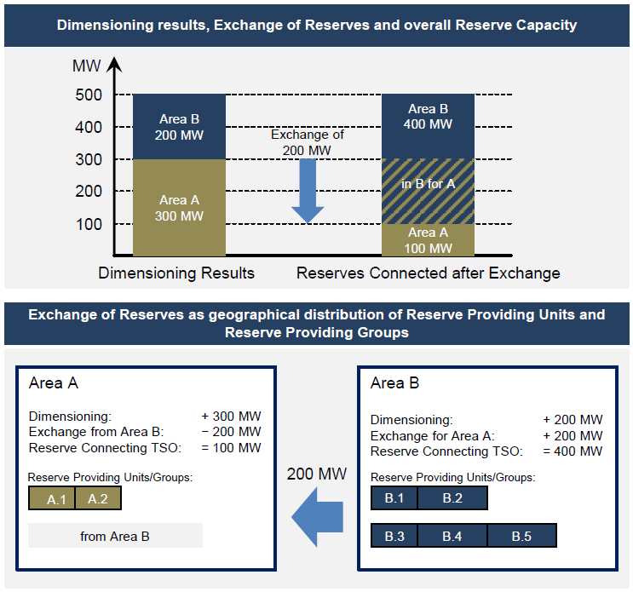
Figure 3: Exchange of reserves – illustrative example. Source: LFCR supporting document 2013
Suppose that the dimensioning rules result in the need for 300 MW for Area A and 200 MW for Area B. Without the exchange of reserves the respective reserve capacity has to be provided by reserve-providing units or reserve-providing groups connected to the Area which means that 300 MW have to be connected in Area A and 200 MW in Area B.
As a result of the exchange of reserves of 200 MW from Area B to Area A, 200 MW of reserve capacity needed for Area A is now located within Area B, whereas Area A still ensures, besides, the availability of the full amount of its reserve capacity.
Although the geographical location of the reserve capacity is different from the dimensioning results for each area, the total amount of reserve capacity within Area A and B is still 500 MW which is equivalent to the total amount without the exchange.
    - Sharing of reserves
The sharing of reserves agreement allows two or more TSOs to organise and ensure the availability of balancing capacity that is required by dimensioning rules by relying on the same reserves inside a synchronous area and between two synchronous areas.
The roles and responsibilities of the reserve connecting TSO, the reserve receiving TSO and the affected TSO for the exchange of reserves between synchronous areas, shall be described in the synchronous area operational agreement and a sharing agreement as defined by SO Regulation.
In contrast to the exchange of reserves, sharing of reserves changes the total amount of procured balancing capacity by the connecting TSOs, with an impact on the geographical distribution as an additional implicit effect. The sharing of reserves agreement defines priority rights to the shared reserves in the situation where either two or more TSOs have a simultaneous need.
Figure 4 illustrates the sharing of 100 MW balancing capacity between two areas with a possible relocation of 100 MW of reserves from Area A to Area B.

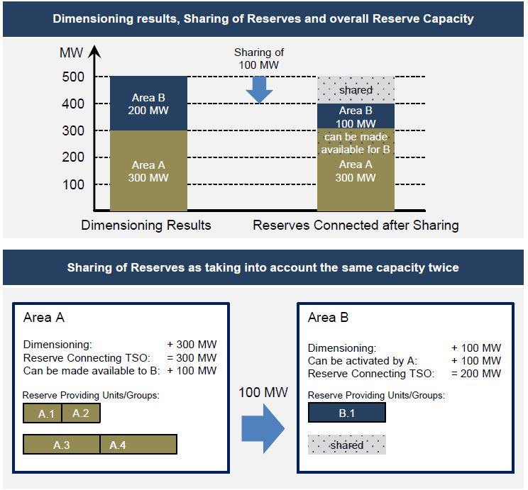
Figure 4: Sharing of Reserves – simple example. Source: LFCR supporting document 2013
Suppose that the dimensioning rules for area A and area B result in the need for 300 MW for area A and 200 MW for area B. Without the sharing of reserves, the TSOs of area A and area B have to ensure the availability of respectively 300 MW and 200 MW.
However, assuming that in some cases it might be very unlikely that both TSOs need to activate the full amount of reserve capacity at the same time, the TSOs of area A and area B can ‘share’ part of their reserve capacity. In practice, this means that the TSOs of area B can make use of, e.g., 100 MW of the reserve capacity of the TSOs in area A.
As a result, the TSOs of area A and area B now need to ensure the availability of 300 MW and 100 MW. The TSOs of area A now make 100 MW of their reserve capacity also available to the TSOs of area B. The total amount of the reserve capacity within the system is now 400 MW, whereas it was 500 MW without the sharing agreement (i.e., leading in this example to a reduction of 100 MW of reserve capacity in the total system).

    - Limitations to the CZC allocated to the balancing capacity market
Due to its criticality for system adequacy, and its possible interference with the SDAC processes, the allocation of CZC to the balancing capacity market may be subject to additional limitations, beyond the capacity calculation processes that are in place for the allocation of CZC to the energy market.
Relevant NRAs and TSOs within a balancing capacity cooperation may decide to limit CZC allocation to the balancing capacity market:
- in case it is necessary to comply with the SO Regulation limits for local procurement (Articles 167 and 169 and Annexes),
- as a way to avoid market distortions and safeguard the effective execution of the SDAC,
- as a measure for market power mitigation, or
- in case of an already reduced CZC due to planned or unplanned outages, wherein the allocation to the balancing capacity market would excessively constrain the execution of the SDAC.
Such additional limits would then be entered as an input to the Cross-Zonal Capacity Allocation Optimisation Function (CZCAOF) and be enforced as an additional constraint to the optimisation itself.
- Market value of cross-zonal capacity
The decision to optimally allocate CZC for DAM purposes or BC exchange or sharing of reserves shall be based on a comparison of the corresponding market value of CZC for the exchange of energy following actual or forecasted day-ahead energy bids and the market value of CZC for the exchange of balancing capacity or sharing of reserves following actual TSO balancing capacity demand and actual or forecasted BSP SPBC bids. Depending on the allocation method, underlying information for the market value of CZC calculation differs:
- Co-optimisation: EB Regulation Article 40(2) requires the comparison of actual market values of CZC based on firm day-ahead energy bids and firm BC bids and TSO BC demand.
- Market-Based Approach: EB Regulation Article 41(3) requires the comparison of forecasted market values of CZC for day-ahead energy exchange purposes but actual market values of CZC as based on firm BC bids and TSO BC demand.
EB Regulation Articles 39(2) to 39(4) specify how the actual market value of CZC shall be derived: with regard to the exchange of energy the bids of market participants in the DAM shall be used, also taking into account bids in the intraday market where relevant and possible; and balancing capacity bids submitted to the capacity procurement function pursuant to EB Regulation Article 33(3) of the EB Regulation shall be used with regard to the BC exchange. When CZC is used for sharing of reserves, the market value of CZC shall be based on the avoided costs of procuring balancing capacity to calculate the consumer surplus for the balancing capacity market. The actual market value of CZC for the exchange of energy between bidding zones and for the BC exchange is calculated per day-ahead market time unit.
EB Regulation Article 39 (5-6) further specifies how the forecasted market value of CZC shall be derived.
The economic concept to optimally allocate CZC to different purposes (also called the optimal capacity split problem) is to express the marginal market value for an increment of CZC used for each purpose and then find the capacity split where the marginal values are equal (or the difference in marginal values is minimal if the lines do not cross).
The maximisation of the economic surplus is achieved by allocating CZC on all borders, all hours and for all allocation purposes such that the Pareto optimum is reached, i.e.:
      - it is not possible (without violating constraints) to reduce the difference in marginal market values of CZC on any border for any hour of the day; or
      - without increasing marginal market value difference more of one other border or a sum of other borders during the same day.
However, this concept assumes that the economic surplus optimisation problem must be convex. This assumption may not hold for BCMs, and the consequences of applying this method are further described in section 4.2.4.
  - Actual Market Value of cross-zonal capacity for the Exchange of Energy
    - The market value of cross-zonal capacity
In the co-optimised allocation process as well as in this Explanatory Document, the market value of CZC for the exchange of energy between all bidding zones of the SDAC is defined as the economic surplus (change/incremental) of the SDAC resulting from the additional CZC allocated for the energy market. It is calculated based on the sum of producer surplus, consumer surplus and congestion income, and it is defined per day-ahead market time unit.

Figure 5: Market value of CZC is defined as the total economic surplus
Note that:
- the important measure for the market value is the economic surplus of allocating one additional MW of CZC for either purpose, not the absolute values of this economic surplus.
- only the implicit allocation of CZC (Flow-Based or cNTC-based) is relevant for the calculation since the final allocation of CZC is based on co-optimisation; any explicit allocation of CZC which may take place, e.g., monthly or yearly only affects and determines the upper limit of CZC that may be allocated via co-optimisation.
In the following, the principles of the cross-border exchange of energy are explained.
    - Isolated energy markets cleared independently
Figure 6 shows the base case of isolated energy markets which are cleared independently, i.e. no CZC is allocated or used for the exchange of energy and the market-clearing prices (will) differ. In this example, the market-clearing price in zone C is lower than in zone B. The consumer and producer surpluses are highlighted in blue and red, respectively, and the total sum of the areas represents the total economic surplus.
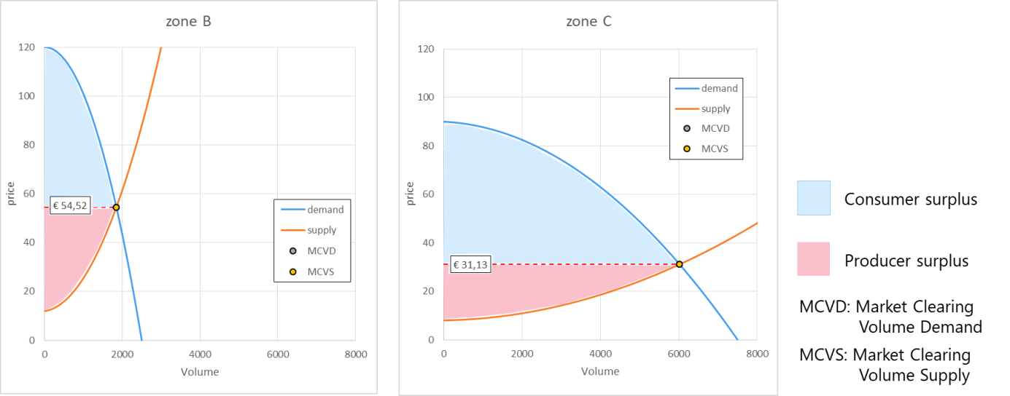
Figure 6: Economic surplus in two energy markets cleared in isolation

    - Coupled energy markets with congestion
When CZC is allocated and may be used for the exchange of energy, market participants may trade across the border. If the amount of available CZC is large enough, this may even lead to full price convergence between the two bidding zones. Once prices have converged, any additional CZC would then have a value of 0.

Figure 7 depicts a situation where the allocated CZC only allows for a partial price convergence: the market-clearing price in zone C remains lower than in zone B. In addition to buyer and seller surpluses, the remaining price difference creates a positive congestion rent which is also part of the total economic surplus (the green area between the red dotted lines in zone B). With full price convergence, the congestion rent distributions would cancel out and disappear.
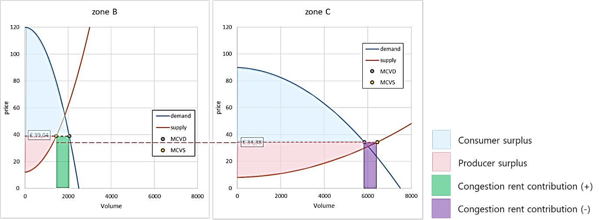
Figure 7: Economic surplus in coupled energy markets with congestion
The same logic may be applied to multiple markets and bidding zones; it is thus possible to calculate the value of CZC for each border for which co-optimisation applies. The general calculation of economic surplus is shown in the equation below and consists of the sum of consumer buyer/surplus, producer/seller surplus and congestion rent over all markets. The congestion rent for a market or bidding zone is calculated based on the market-clearing price and the market net position, where the market net position equals the sum of exchanges in both directions (positive for export, negative for import) on all borders with other markets. The market net position also equals the difference in supply and demand volumes cleared.
$$\sum_{all markets}{\{Consumer/buyer surplus+Producer/seller surplus-Market Net Position *Market Clearing Price\}}$$
Equation: Calculation of the economic surplus when supply and demand are matched to an equilibrium clearing point
The absolute market value of CZC may now be calculated as the difference between the total economic surplus when CZC is allocated for the exchange of energy and the situation of isolated markets. The marginal market value of CZC at a specific border is equal to the price difference at the border.
  - Actual Market Value of cross-zonal capacity for the exchange of balancing capacity or sharing of reserves
The market value of CZC for the exchange of balancing capacity or sharing of reserves is defined as the additional total economic surplus in the balancing market resulting from the additional CZC allocated for the balancing capacity market. It is calculated based on consumer surplus (TSO) and on producer surplus (BSP) as well as on congestion income (transmission capacity owner) from BC exchange and sharing of reserves.
The underlying data are upward and downward balancing capacity bids which have been submitted and accepted by the CZCAOF for capacity procurement pursuant to Article 33(3) of the EB Regulation.
Following Article 32(3) of the EB Regulation, the procurement of upward and downward balancing capacity for at least the frequency restoration reserves and the replacement reserves shall be carried out separately.
Sharing of reserves means a reduction of TSO BC demand. The additional market value of CZC of sharing of reserves is therefore based on the avoided costs of procuring according to Article 39(4) of the EB Regulation and assigned as the consumer surplus.
    - The market value of CZC is independent of the pricing method for balancing capacity
The calculation of the market value of CZC is based on the maximisation of economic surplus. Hence it is independent of the pricing method for balancing capacity, i.e., pay-as-bid or marginal pricing. While the principle of economic surplus determination is in general the same, the allocation of CZC may differ if one applies pay-as-bid or marginal pricing but this is also subject to the prices and volumes of the bids. Subject to the chosen pricing method, market parties will prepare prices and volumes of the bids accordingly.
    - Isolated markets for balancing capacity with pay-as-bid pricing
Figure 8 depicts the base case of two isolated markets for balancing capacity with pay-as-bid pricing. In this example, it is assumed that the supply curves for balancing capacity are monotonously non-decreasing in both markets, and the demand for balancing capacity in both areas is fixed and perfectly inelastic. In case the local TSO BC demand exceeds the available amount of locally submitted BC bids, the market value of CZC for the exchange of balancing capacity or sharing of reserves is calculated for the unsatisfied bids based on the local balancing capacity bid price cap.
In this example, the price for the last accepted bid for TSO A is higher than the respective price for TSO B. The red arrow indicates available CZC for the exchange of balancing capacity or sharing of reserves if the markets were coupled.
As indicated in the Figure, with pay-as-bid pricing the producer surplus is 0. The welfare in this case is equal to the consumer surplus and is calculated as the difference between the accepted bid prices and the balancing capacity price cap.

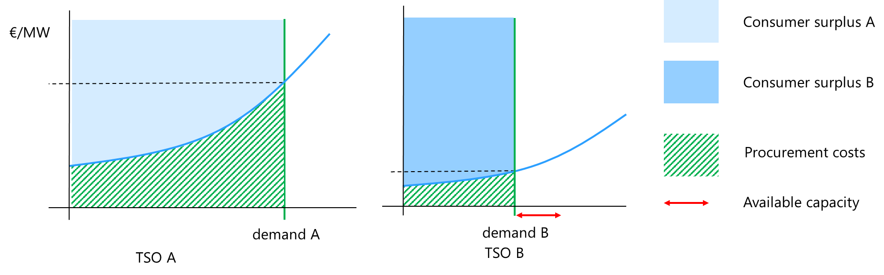
Figure 8: Economic surplus in isolated markets with pay-as-bid pricing
    - Coupled balancing capacity markets with pay-as-bid pricing
When the two markets are coupled, and CZC is allocated, TSO A will be able to procure part of its balancing capacity in the area of TSO B. As a result, the marginal price in market A will decrease, and that in market B will increase. Figure 9 shows the situation where available CZC is not enough to reach full price convergence. A part of the procurement of TSO A is now done at TSO B, which means that TSO A can now procure cheaper balancing capacity in market B compared to the isolated situation. This means that the consumer surplus for TSO A is increasing. As is shown on the left-hand side of Figure 9, the difference in economic surplus is the area (yellow) below the supply curve of area A, above the shifted supply curve of area B (dashed blue line) and between the supply clearing volume in the coupled situation and the original demand A. This is the market value of the allocated CZC in this particular situation. To derive the marginal market value, these results must be compared to incremental changes of CZC, i.e., for each additional MW of CZC allocated to the balancing capacity market.
As there is no natural congestion income for pay-as-bid markets, a different solution is necessary to remunerate transmission right holders for their scarce good of cross-zonal capacity. The methodology defines that for this case, the price of cross-zonal capacity shall be equal to the price of cross-zonal capacity in the day-ahead energy market. This ensures that transmission rights holders always get their fair share of the overall welfare generated, even if pay-as-bid pricing is used for balancing capacity. In the example below this would mean, that a part of the yellow area, namely the price spread between the day-ahead market areas multiplied by the volume of allocated cross-zonal capacity for balancing, shall be transferred to the congestion income distribution process.

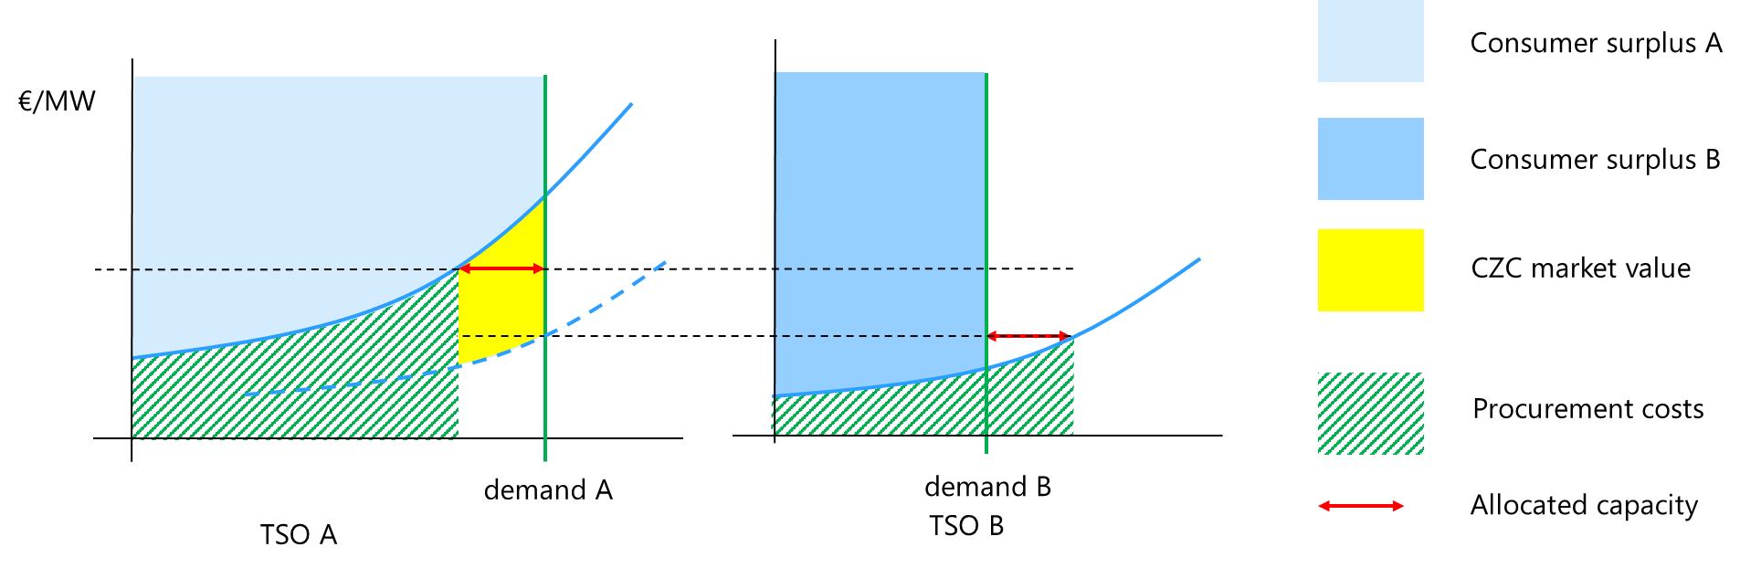
Figure 9: Economic surplus in coupled balancing markets with pay-as-bid pricing
    - Non-convexities in balancing capacity markets
The balancing capacity market is directly linked to the energy market, i.e., the BSPs' expectation of the market-clearing in the energy market will be reflected in their bidding behaviour for balancing capacity. The alternative costs for the provision of reserves instead of energy are lowest for the market participants that are almost indifferent to delivering energy, i.e., their marginal costs are near the spot price. For reserves to be offered, some market participants can lower their energy output, and others can start energy production at a moderate economic loss. The former has a variable cost, and the latter has a fixed cost.
This dependency between the two markets makes it difficult to apply the market coupling principles presented in section 4.2.3. For this to be true, there must be no externalities, no transaction costs and perfect information. Additionally, the economic surplus optimisation problem must be convex. This includes the absence of discrete variables. Discrete variables mean combinatorial problems that are hard to solve. Balancing capacity bids that reflect fundamental costs cannot be organised as a monotonously increasing "merit order list".
Non-convexities include start-up and shut-down costs along with minimum output requirements (which state that if a plant is running, it must produce at least a certain amount). Due to this combinatorial problem, there does not exist a "market-clearing price" in spinning reserve markets that clear a balancing capacity market efficiently, nor a "marginal price". The market price conveys little or no information on which reserve offers were accepted.
The non-convex effects in the balancing capacity market can be tackled through discrete variables (block bids and combinatorial constraints), and by maximising the economic surplus integer programming. The efficiency of the allocation would be the highest if the energy and balancing capacity market were integrated into one single auction, where the economic surplus is maximised over all matched energy market bids and balancing capacity market bids subject to system constraints.
The combinatorial difficulties can be overcome by restricting reserve bids to a simple format (price, volume). This would render a "merit order" of bids, but the bids would not reflect underlying costs, and the auction would not deliver economic surplus optimisation. This will, on the other hand, reduce the efficiency of the CZCA and increase the procurement cost of balancing capacity, since BSPs must include a higher risk in their price determination or abstain from participating in the market, which will reduce liquidity.

- Methods for the calculation of market value of cross-zonal capacity
As already elaborated in chapter 2, the three allocation processes differ in the availability of firm information and, consequently, the requirement of forecasting the market value of CZC.
While an allocation process based on economic efficiency analysis is not foreseen as a relevant allocation process by TSOs, co-optimised allocation and market-based allocation will be further elaborated on in this chapter.
The following graph provides a generic overview of the six main steps of the CZC allocation process and how they interfere:

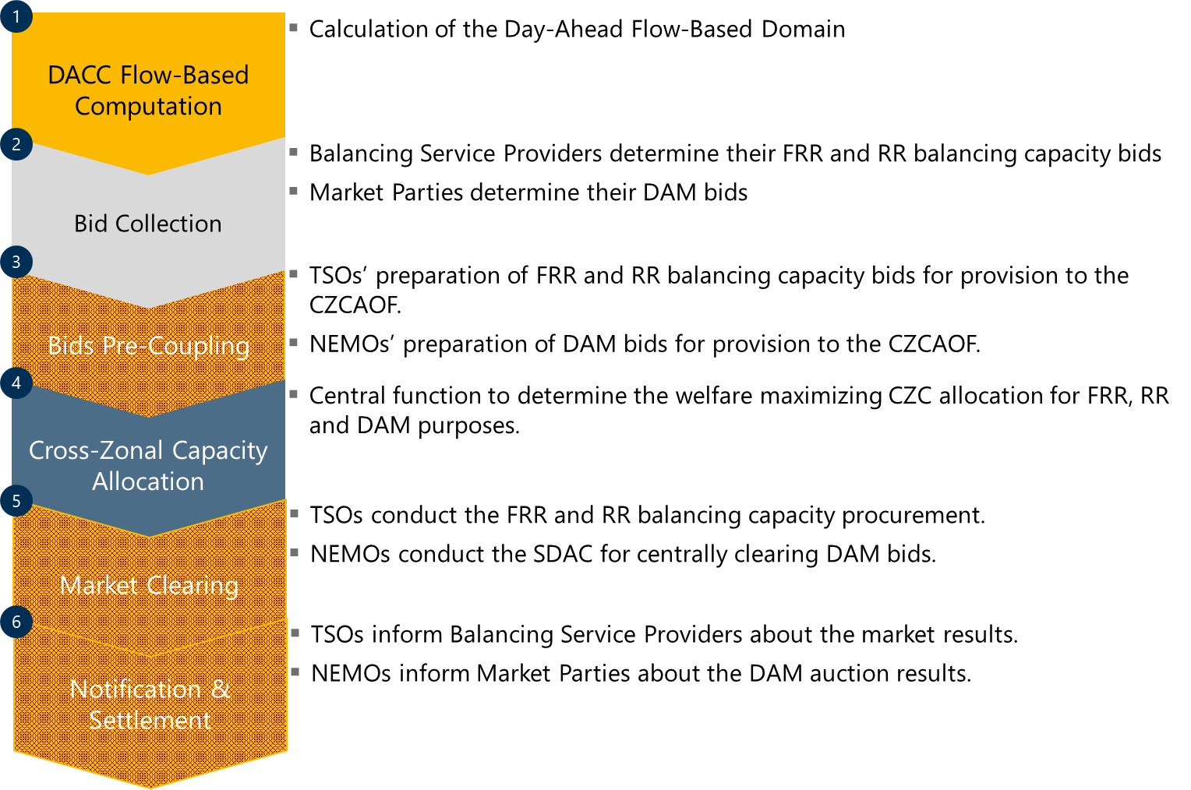
Figure 10: The six main process steps of CZC allocation
- In the Day-Ahead Capacity Calculation (DACC), the CZC for the DAMs and the BCMs are determined.
- In the Bid Collection process, BSPs determine their BC bids as do MPs for DA. Bids are then provided to TSOs and NEMOs.
- TSOs and NEMOs prepare the bids for providing them to the CZCAOF. They pseudonymise the bids and build individual merit orders, if applicable, taking into account links in the bid preparation process.
- The central process of co-optimisation is the CZCAOF. The CZCAOF determines the total welfare maximising allocation of CZC for DAM purposes and for BCM purposes.
- Based on the CZCAOF outcome, the DAMs can be cleared and BCM bids can be procured from BSPs.
- In the notification and settlement process, MPs are informed about their matched bids and results are published. TSOs inform their BSPs and settle the procured BC offers. NEMOs inform MPs about cleared bids.
These six steps are individual sub-processes of the allocation process and will be further elaborated in the following:
  - Process Steps of CZC allocation
    - Flow-Based Computation
The DACC is implemented per capacity calculation region (CCR). The following process graph summarises inputs, processing and outputs.

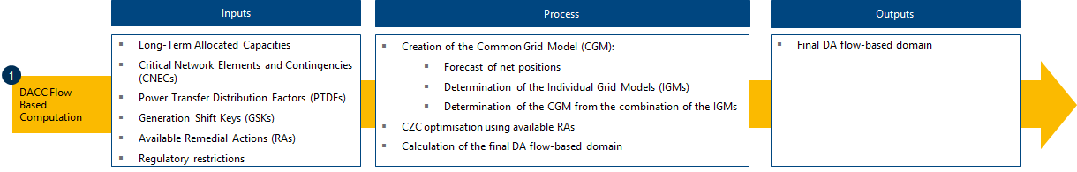
Figure 11: Process graph of the DACC flow-based computation
The flow-based computation determines the flow-based domain, both, for the DAMs and the BCMs on D-1 for the next day. This requires the long-term allocated CZCs, the information about critical network elements and contingencies (CNECs) as well as Power Transfer Distribution Factors (PTDFs), Generation Shift Keys (GSKs) and available remedial actions (RAs). Beyond, regulatory restrictions need to be taken into account.
From this information, the final DA flow-based domain is determined. This is done in a multi-step process. First, the net positions are forecasted together with the DC flows in the Common Grid Model Alignment and provided to each CCR. TSOs develop scenarios for each Market Time Unit (MTU) and determine their Individual Grid Models (IGMs). The IGMs are merged to obtain the Common Grid Model (CGM) for each MTU. Subsequently, CZCs are optimised taking into account RAs and the final DA flow-based domain is calculated.
    - Bid Submission & Collection
BSPs and MPs optimise their portfolios based on the available market and system information. Therefore, they split their production capacities into offers to the DAM and the BCMs. The according bid preparation and provision are shown in the following graph.

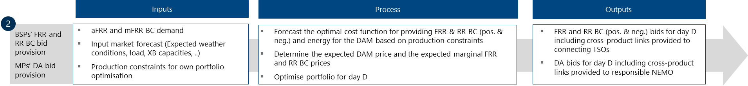
Figure 12: Process graph of the bid preparation and provision of BC and DAM bids
When BSPs determine their offers to the BCM and MPs their provisions to the DAM, they know the total demand from their TSO as well as external market, system and weather conditions and their own production constraints.
With these inputs, BSPs and MPs forecast their optimal production function and cost function for providing BC and energy bids. In combination with the external conditions, BSPs determine their expectations for the DAM price and the marginal BCM prices. By bringing price expectations and cost functions together, BSPs and MPs optimise their portfolio for day D and their offers to the DAM and the BCMs.
The output of the individual portfolio optimisation is the bids to the DAM and the BCMs. These bids are provided to NEMOs and TSOs.
    - Bids Preparation
In the bid preparation process, NEMOs and TSOs separately prepare the bids provided by MPs and BSPs for further processing in the CZCAOF, EUPHEMIA and the CPOF. This is shown in the following graph.

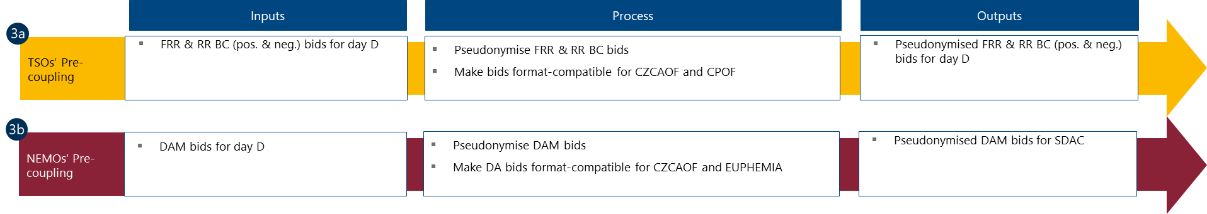
Figure 13: Process graph of the bid preparation by TSOs and NEMOs
TSOs pseudonymise bids and make them format-compatible for the CZCAOF and the CPOF. Pseudonymised bids for each BCM are combined in BCM bids order books.
BC demand per product and direction has been determined in the TSOs’ (individual) dimensioning process including possible reserve sharing potential and an indication of substitution of reserves. TSOs provide this demand information including tolerance bands for sharing of reserves, the substitution of reserves and bid indivisibility to the CPOF.
NEMOs take the DAM bids from MPs and make them format-compatible for the CZCAOF.
Pseudonymised DAM bids are then provided as DA order books to the CZCAOF and EUPHEMIA.
    - Cross-Zonal Capacity Allocation
Depending on the CZC allocation process, the CZC allocation is determined from
- the provided DA order books and TSOs’ BCM bids order books and demand and tolerance bands for sharing and substitution of reserves and bid indivisibility (co-optimised allocation process).
- the forecasted DA bidding curves, TSOs’ BCM bids order books and demand and tolerance bands for sharing and substitution of reserves and bid indivisibility and CZCA limitations for BC use (market-based allocation process).
The total available CZC is provided from the flow-based computation. The CZCAOF also takes into account CZC allocation constraints per border or per product and minimum local reserve requirements. CZC allocation applies a Europe-wide total economic surplus maximising algorithm. CZC is allocated to DAM if the DA market value from the next Megawatt (MW) of CZC allocated to the DAM is equal to or higher than the market value from the next MW of CZC allocated to any BCMs. The high-level CZCAOF process is shown in the following graph.

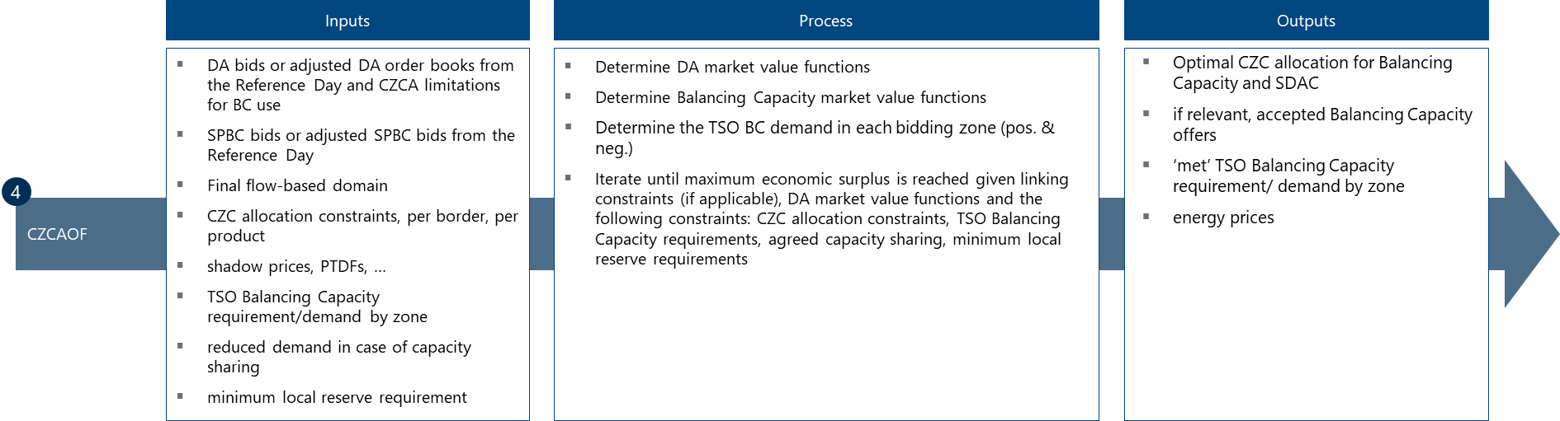
Figure 14: Process graph of the CZCAOF
In an optimisation process, the CZCAOF determines the optimal CZC allocation for BCMs and for the SDAC, taking into account cross-product linking between the different markets, if applicable.
    - Market Clearing
After or together with CZC allocation, depending on the implementation option, the DAMs and the BCMs are separately cleared. The market clearing processes for DAMs and BCMs are displayed in the following figure and explained thereafter.

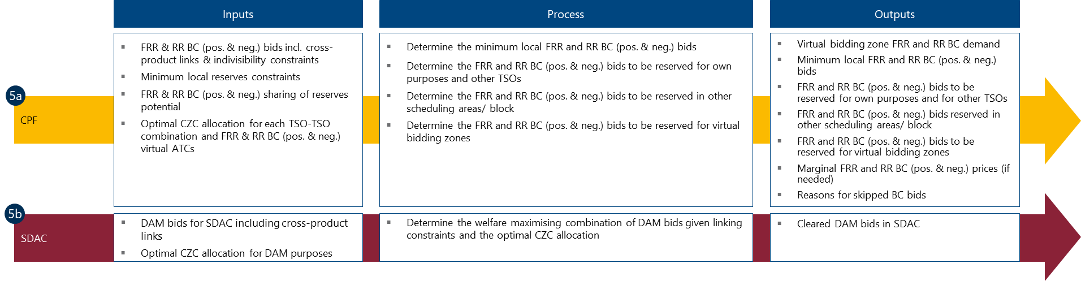
Figure 15: Process graph of the market clearings of the DAMs and BCMs
      - Balancing Capacity Market Clearing
The clearing of the BCMs (also named the procurement of BC) is conducted by the CPFs. Therefore, the outcomes of the CZCAOF relevant to BC products are provided directly to each CPF. Beyond, outputs from prior functions and technical or regulatory requirements are inputs to the CPF. From these inputs, the CPF determines the most beneficial distribution of BC procurement for control areas considered in the CPF given the actual CZC allocation. Thus, the CZCOF determines the bids to be reserved for TSOs’ own purposes, for other TSOs and also for each virtual bidding zone in one TSO’s control area. In line with this, it also determines for each TSO of the application the BC to be reserved abroad.

      - Day-Ahead-Market Clearing
NEMOs have already installed an algorithm to clear the DAM (EUPHEMIA). For the SDAC, EUPHEMIA requires the allocated CZC for DAM purposes and the DAM bids including cross-product links. It also determines the Europe-wide welfare maximising matching of bids, taking into account cross-product links and finally provides the cleared DAM bids.
    - Notification and Settlement
The notification and settlement process informs MPs and BSPs about matched bids, exact volume and prices. The process is organised as shown in the graph.

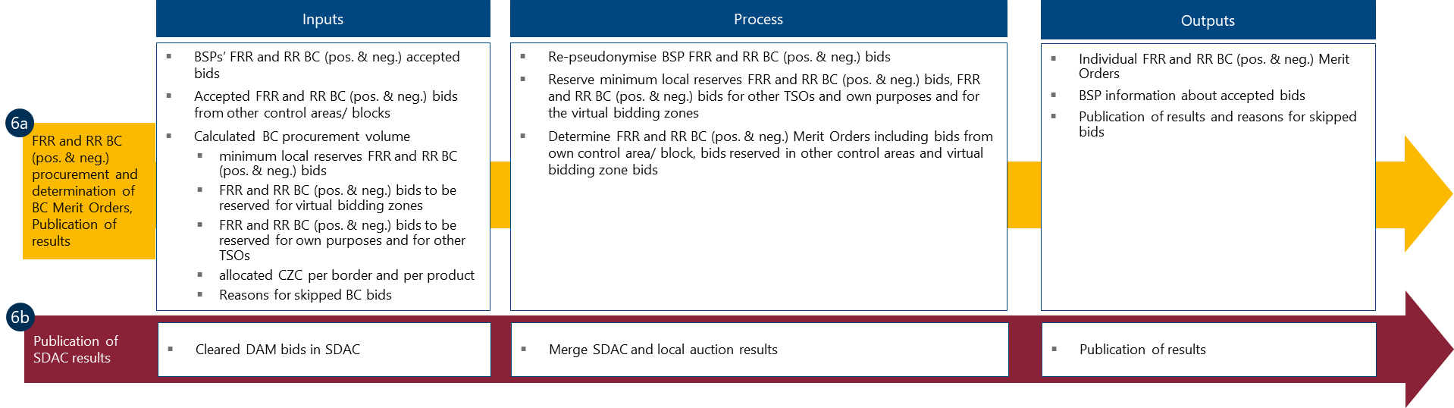
Figure 16: Process graph of the notification and settlement process
Notification and settlement are done separately by individual TSOs and NEMOs for BSPs and MPs in their scheduling areas or their bidding areas. Therefore, the outputs of the CPF and of the SDAC process enter the notification and settlement process.
TSOs re-pseudonymise the settled bids and calculate the surplus for each of their BSPs, network owners and themselves. Subsequently, they inform BSPs about accepted bids and publish results and reasons for skipped bids. As further outcomes, TSOs determine the congestion revenues and the inter-TSO compensation. Finally, TSOs settle the accepted BC bids with BSPs and inter-TSO-TSO settlement.
NEMOs re-pseudonymise cleared DAM bids, publish the results and settle the matched DAM bids.

In the remainder of this chapter, this generic CZC allocation process will be adapted to the specific context of the two allocation processes. The key differences arise from the point in time when either DAM bids or BC bids are firm. When determining the CZC allocation for BC purposes and energy purposes:
- in the co-optimised allocation process, DAM bids and BC bids are firm.
- in the market-based allocation process, BC bids are firm but DAM bids are not firm.
Consequently, actual DAM bids need to be forecasted in the market-based allocation process before step 4.
  - Co-optimised allocation process
The co-optimised allocation process performs the CZC allocation based on joint optimisation of the BCMs and the DAMs. The CZC split can be determined from the market values of CZC for BCMs and DAMs based on firm bids. This CZC allocation process provides the most efficient solution for CZC allocation for balancing capacity and for energy purposes. On the other hand, it requires BSPs and MPs to optimise their portfolio without having any information on the acceptance of their bids and, consequently, on production requirements. As BSPs and MPs are exposed to a high level of market uncertainty, they would add risk mark-ups to their bid prices resulting in inefficiently higher prices. To mitigate this inefficiency, cross-product linking allows BSPs/MPs to connect bids from different markets in the co-optimised allocation process in the sense that if a bid is accepted for one market, it cannot be accepted for another.
The ENTSO-E project team Co-optimisation Implementation Impact Assessment has elaborated requirements for a feasible implementation of a co-optimised allocation process pursuant to EB Regulation Article 40.
    - One-step/ two-step implementation
Two alternative implementation options are currently discussed which are a one-step implementation and a two-step implementation. The one-step implementation defines co-optimisation as an integral process in which the CZCAOF, the DAM clearing and the virtual clearing of the BCMs are integrated as much as possible. This integration enables a joint optimisation of the SDAC, the BCMs and the CZC allocation providing the most efficient and welfare-maximising outcome.
On the other hand, the integrated optimisation process requires the iterative solution of a complex mathematical problem. Time issues for solving this mathematical problem might run the overall problem intractable. With the two-step implementation, only BCMs are cleared jointly with the CZCAOF. DAMs shall use the remaining CZC and clear after the CZCAOF sub-process. Therefore, the CPOF is conducted with the CZCAOF in step 1 and DAM clearing is implemented by EUPHEMIA using the outcome of the first step in step 2. The CZC split requires an exact market result. This is guaranteed only by the joint optimisation of the CZCAOF with the CPOF for the BCMs as balancing capacity must be available to fulfil TSOs' demand if possible. Joint optimisation of CZCAOF together with the SDAC in the first step and CPOF in step 2 might result in too little balancing capacity.
The two implementation options are explained in more detail in the following.

    - One-step co-optimised allocation process
Figure 17 provides a process overview of the one-step co-optimised allocation process.

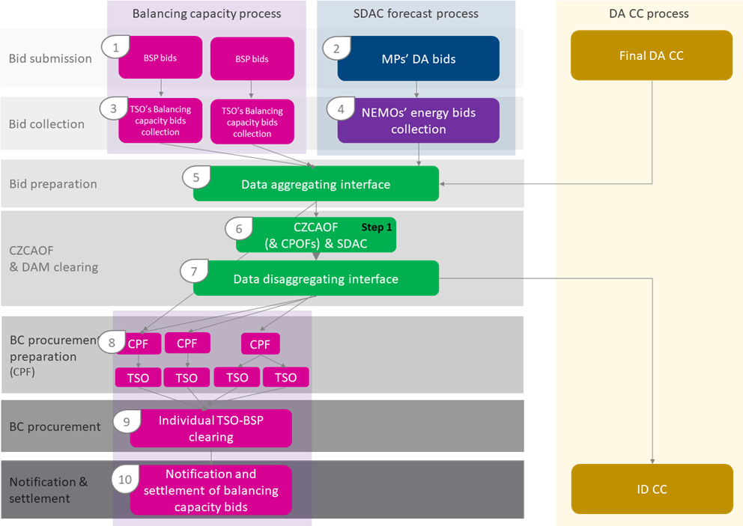

Figure 17: Process Overview One-Step Co-optimised Allocation
In 1 and 2, BSPs and MPs submit bids (including a linking code) to TSOs and NEMOs respectively. In 3 and 4, TSOs and NEMOs collect BC and DAM bids, respectively. In 3, TSOs define their demands and in 4, NEMOs perform validations and conversions of bids provided by MPs. TSOs/ NEMOs send the pseudonymised set of BC/ DA bids to the data aggregating interface. In 5, the data aggregating interface prepares all bids for the CZCAOF. In 6, the CZCAOF together with EUPHEMIA provides the first-best solution for CZC allocation and DAM clearing. This implicitly also results in the allocation of CZC for BCMs and, therefore, the determination of BC volumes to be procured in each BCM. In 7, the data from the CZCAOF is provided to relevant TSOs and applications in charge by the data disaggregating interface. In step 8, the CPFs per country prepare the BC procurement using the information of allocated CZC and the CPOF (per product and direction). Each TSO re-pseudonymises the BC bids. In 9, each TSO separately procures the BC volumes based on the accepted BC bids. Finally, in 10, TSOs publish the procurement results.

      - Two-step co-optimised allocation process
Figure 18 shows the differences which come along with the two-step co-optimised allocation process.

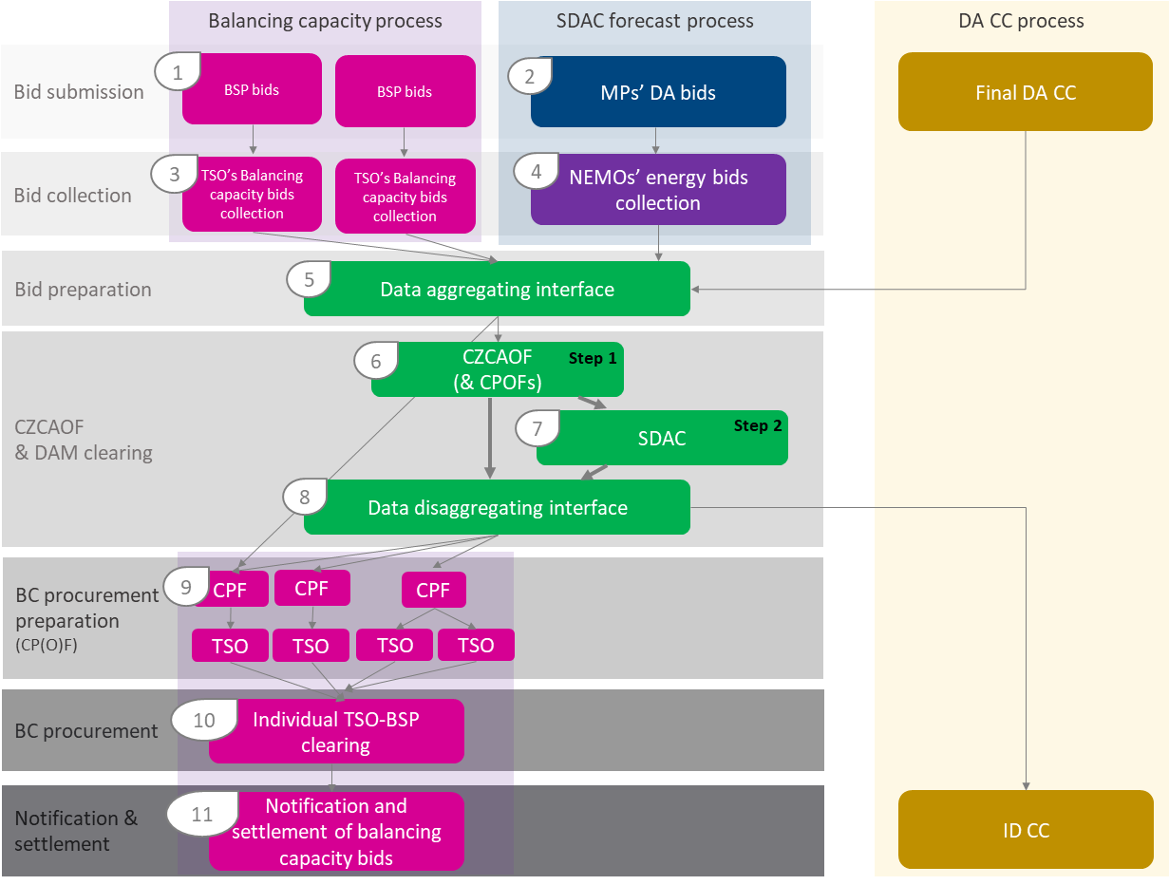
Figure 18: Process Overview Two-Step Co-optimised Allocation
The individual sub-processes of the two-step implementation are almost identical to the sub-processes of the one-step implementation. The difference between the two implementation options is the coordination between the CZCAOF and EUPHEMIA for the matching of DAM bids in the SDAC. In 6, the CZCAOF is optimised together with the CPOFs (and DAMOF) providing accepted BCM bids and revised PTDFs/ATCs/BC order books. This is step 1 of the two-step approach. The CZCAOF provides the revised PTDFs/ATCs to EUPHEMIA. In 7, EUPHEMIA performs the SDAC of the DAM bids based on the provided revised PTDFs/ATCs resulting in the matched DAM bids as an outcome of step 2. After the provision of the outcomes by the data disaggregating interface, the CPFs per country prepare the procurement in step 9.
In contrast to the one-step implementation there is only a one-directional exchange from the CZCAOF to EUPHEMIA but not in the opposite direction.
    - Cross-product linking of bids
Cross-product linking is a linking-of-bids type by which bids of different products are connected, e.g., a positive aFRR BC order is linked with a DAM supply bid order. Since one GCT for all products disables submission of bids of unsettled generation capacities, liquidity is decreased in less attractive markets. The aim of cross-product linking in a co-optimised allocation process is to prevent the choice to be made by BSPs or MPs to engage in one single market. Cross-product linking allows BSPs/ MPs to combine bids to different markets in the sense that the same generation capacity can be used either in one market or the other but not in both within the same MTU.
This type of cross-product linking between different BC products or between BC products and the DAM is called exclusive bid linking.
Cross-product linking can be applied to the following conditions:
- Bids with exclusive acceptance of one bid among a set of bids. Exclusive group bids link offers from which only one can be accepted.
The acceptance of one offer of the exclusive group has ex ante the same economic value for the BSP/ MP as the acceptance of any other offer within the exclusive group. Disclaimer: the actual surplus for the MP shall be determined by the clearing price of the market where the bid is accepted.
- Bids which link products of the same or of different quality for the same MTU.
If one offer of the linked bids is accepted, the other offer cannot be accepted or must be accepted. This is relevant for BSPs which offer one and the same share of a generation capacity e.g., as negative aFRR BC and as a DAM supply bid in the same MTU. If the bid is not accepted in the DAM, the production unit cannot be used in the same MTU for a negative aFRR provision. This is an example of so-called linking families.
The CPOF will then select the offer or combination of offers whose acceptance provides the highest economic welfare.
Cross-product linking can be implemented in two different ways:
- unilateral cross-product linking of bids; and
- multilateral cross-product linking of bids.
The linked bids can vary between the markets both in price and volume.

The following implementation could be implemented in the two-step co-optimised allocation: BCM bids (like aFRR, mFRR and RR bids) are linked multilaterally while unselected bids are transferred unilaterally to the DAM. This is illustrated in Figure 19.

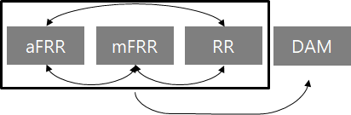
Figure 19: Outline of cross-product linking of bids using the multilateral approach within the BCM and the unilateral approach between the BCM and the DAM
By doing so, BCMs as a whole are prioritised above the DAM in regard to bid usage. This corresponds to sequential markets as currently organised in Austria, Germany, the Netherlands and Nordic systems. It minimises the risk of unsatisfied demand since liquidity is first offered and used for BC before leftovers are offered to DAM clearing.
Within the BCMs, prioritisation can be made, like performing the auction of the higher quality product aFRR before the lower quality mFRR BC auction and the lower quality RR BC auction, such that MPs can re-optimise the bids of the second auction based on the results of the first auction. The DA market clearing is performed with pure DAM bids and the linked bids that were not in the money in the BCMs.
  - Market-based allocation process
The market-based allocation process differs from the co-optimised allocation process in the sense that BCM bids are firm whereas DAM bids are not. In preparation for the CZC allocation, the DAM bidding curves for the determination of the DA market value function of CZC allocated for DAM purposes must be forecasted. A market value function relates the market-related economic surplus to the CZC which is available for the exchange of bids. The more CZC is available for the exchange of a product, the higher the market value of CZC. The intersection of the market value functions of CZC for BCMs and DAMs determines the optimal CZC split. At this point, the marginal market value of CZC for the exchange of balancing capacity or sharing of reserves equals the marginal market value of CZC for the exchange of energy.
The forecast process and the forecast validation process will be elaborated in more detail after the description of the general market-based allocation process overview.
While the CZCAOF in the co-optimised allocation process is a joint function for all TSOs, the DAM bids being not firm causes some differences in the market-based allocation process and the functionalities:
- The DAM bidding curves need to be forecasted. The forecasted DAM bidding curves are used by the DAMOF in the CZCAOF to form the market value function of CZC for the DAM from the forecasted bidding curves.
- The forecast is a separate set of process steps which replace the DAM bid provision and processing steps in preparation for the CZC allocation.
- The market value function of CZC for the DAM determined from the forecasted DAM bidding curves can deviate from the actual DAM bidding curves. Although the forecast should provide the best fit to the actual DAM bidding curves, there is a so-called forecast error (the deviation from the market value based on forecasts to the actual market value). This forecast error is to be evaluated by RCCs.
- The CZCAOF determines the CZC split. The CPF determines the procurement of BCM bids per SBCP and direction per MTU.
In the following, the market-based allocation process is described in more detail. Roles and responsibilities and the difference with the co-optimisation allocation process will be explained.

    - Market-based allocation process
The following Figure 20 shows the sub-processes of the market-based allocation process.

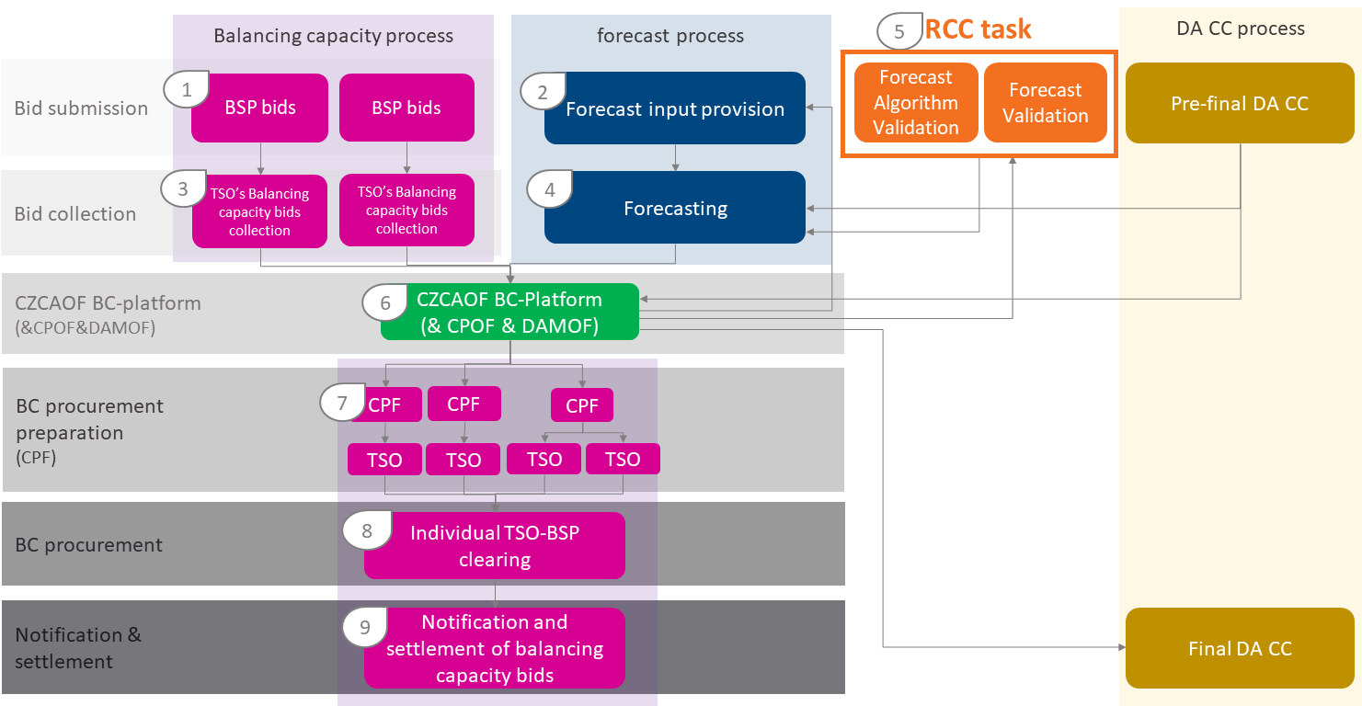
Figure 20: Process Overview Market-Based Allocation
In step 1, BSPs submit bids to TSOs. As MPs’ bids for the DAM are not yet firm, they are forecasted by applying information from the past. As described in more detail in subsection 5.3.2, the major input is the latest available DAM bidding curves which are submitted in line with step 2. In step 3, TSOs define their demands and collect and prepare and pseudonymise the bids from BSPs. The forecasting of the market value of CZC is conducted in step 4. In step 5, RCCs validate the forecast and determine the forecast error. When the forecast method or the forecast algorithm has changed or when RCCs find it beneficial to indicate improvements to the forecast algorithm, RCCs shall validate the forecast algorithm and provide a recommendation on aspects to be considered during the actual forecasting performed in step 4. Together with resulting forecasted DAM bidding curves, actual balancing capacity bids and the balancing capacity demand is provided to the CZCAOF. The CZCAOF employs the BCM bids and demand and determines the market value functions of CZC for all SBCPs of the BC platform jointly in the CPOF of the CZCAOF. The DAMOF of the CZCAOF determines the market value function of CZC for the DAMs from all forecasted DA supply and demand bidding curves of the bidding zones of the BC platform region. Based on the resulting market value functions of CZC for the DAMs and the BCMS the CZCAOF determines the optimal CZC split of the BC platform region. The corresponding CZC allocations for the BCM and the DAM are provided to EUPHEMIA for running the SDAC. Also, these CZC allocations are provided to the CPF. In step 7, the CPFs per country prepare the BC procurement using the information of allocated CZC (per SBCP, direction and MTU). Each TSO re-pseudonymises the BC bids. In step 8, each TSO separately procures the BC volumes based on the accepted BC bids. Finally, in step 9, TSOs publish the procurement results.
    - Forecasting of the market value of CZC for DAM purposes
This subsection explains the forecasting of the market value of CZC for DAM purposes, which consists of a static process step (process step 0), the forecast input provision (process step 1), the forecasting (process step 2), the forecast validation (process step 3), the mandatory CZC limitations for BC (process step 4) and the algorithm validation (process step 5). Although the validation process steps are strongly related to the other steps of the forecasting, they are understood as a separate part. Process steps 0, 1, 2 and 4 belong to the forecast process and process steps 3 and 5 to the forecast validation process. The following process descriptions demonstrate how the processes interact.

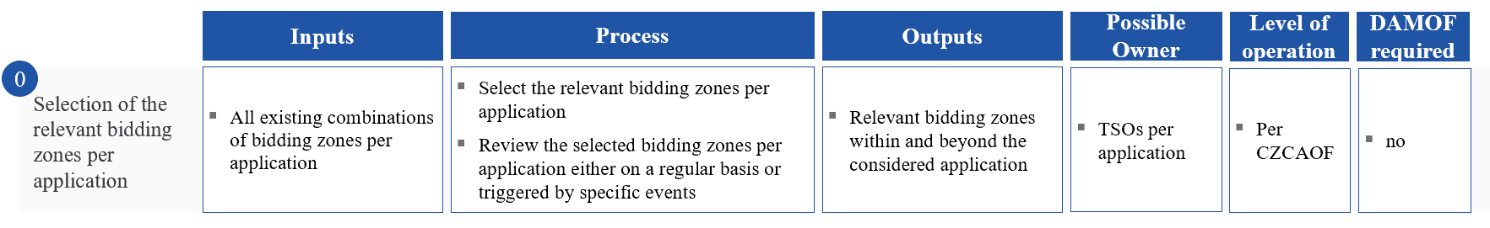

The static process step 0 determines the relevant bidding zones to be considered during the subsequent forecast process steps. TSOs per application evaluate which bidding zones affect the available CZC of their bidding zones. This could be BC exchanges or sharing of reserves or SDAC outcomes in general from directly involved bidding zones or from bidding zones outside the application which affect CZCs of the application. TSOs review the set of relevant bidding zones either on a regular basis or triggered by specific events.

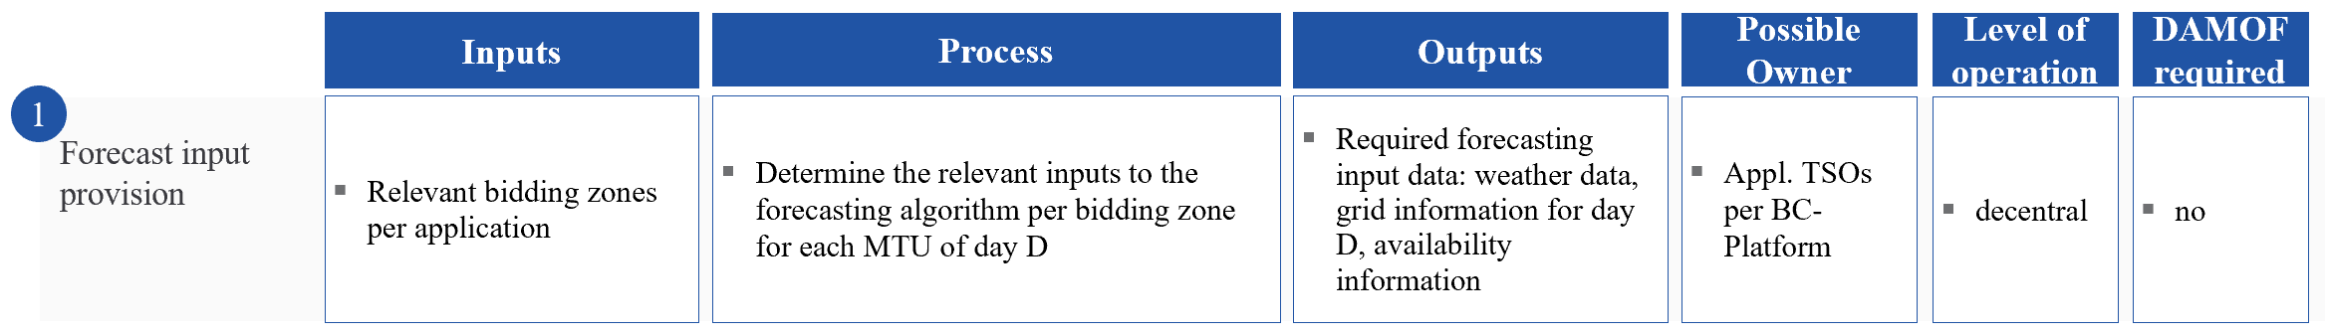

In the forecast input provision step all application TSOs of a BC platform collect and provide the relevant inputs to the forecast algorithm per bidding zone and MTU of day D. Depending on the forecast algorithm input data can differ. Input data could be weather information and grid information but also information on the production and consumption situation.

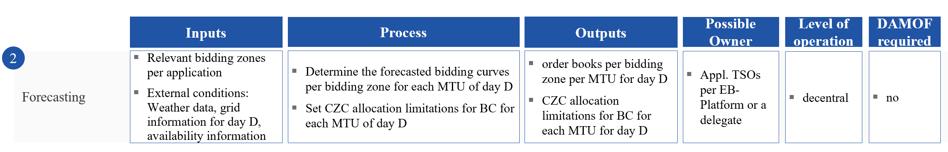

Application TSOs of one BC platform need to decide which forecast method best meets the forecast requirements of the BC platform region. As described in subsection 5.4, different types of forecast methods exist. The selection of a forecast method depends on the regional situation and requires an evaluation of the best fit of forecast methods’ outcomes over a testing period (“applicability”). It is not only relevant to reach the highest accuracy on average. A forecast method also needs to depict an adequate level of accuracy in specific circumstances such as weather fluctuations or generation shortages. Thus, a forecast method should be able to provide a good indication of accuracy in the sense of trueness and precision based on the available information about the situation on day D. Beyond, the forecasting outcome must be replicable and the forecasting approach must be understandable also for market participants and BSPs. Therefore, a most comprehensive level of transparency must be reached by selecting a forecast method and calibrating the underlying algorithm by a forecast entity. The selected forecast method is to predict bidding curves per bidding zone per MTU for day D. In addition, the Application TSOs of one BC platform can also provide CZC limitations for BC for each MTU of day D. The forecast entity takes this limitation into account. It is useful when day D is expected to be difficult to predict due to unusual external circumstances or other conditions. By limiting the CZC allocation for BC, a positive forecast error can be prevented. The allocation limitations can be made in such a way that (1) the maximum volume of allocated CZC for BC is reduced or (2) the CZC for BC as allocated by the CZCAOF is reduced. Therefore, the second approach always reduces the allocated CZC for BC based on the resulting CZC split of the CZCAOF. The first approach, on the other hand, only reduces the allocated CZC for BC if the CZC for BC as allocated by the CZCAOF is above the reduced maximum volume of allocated CZC for BC.

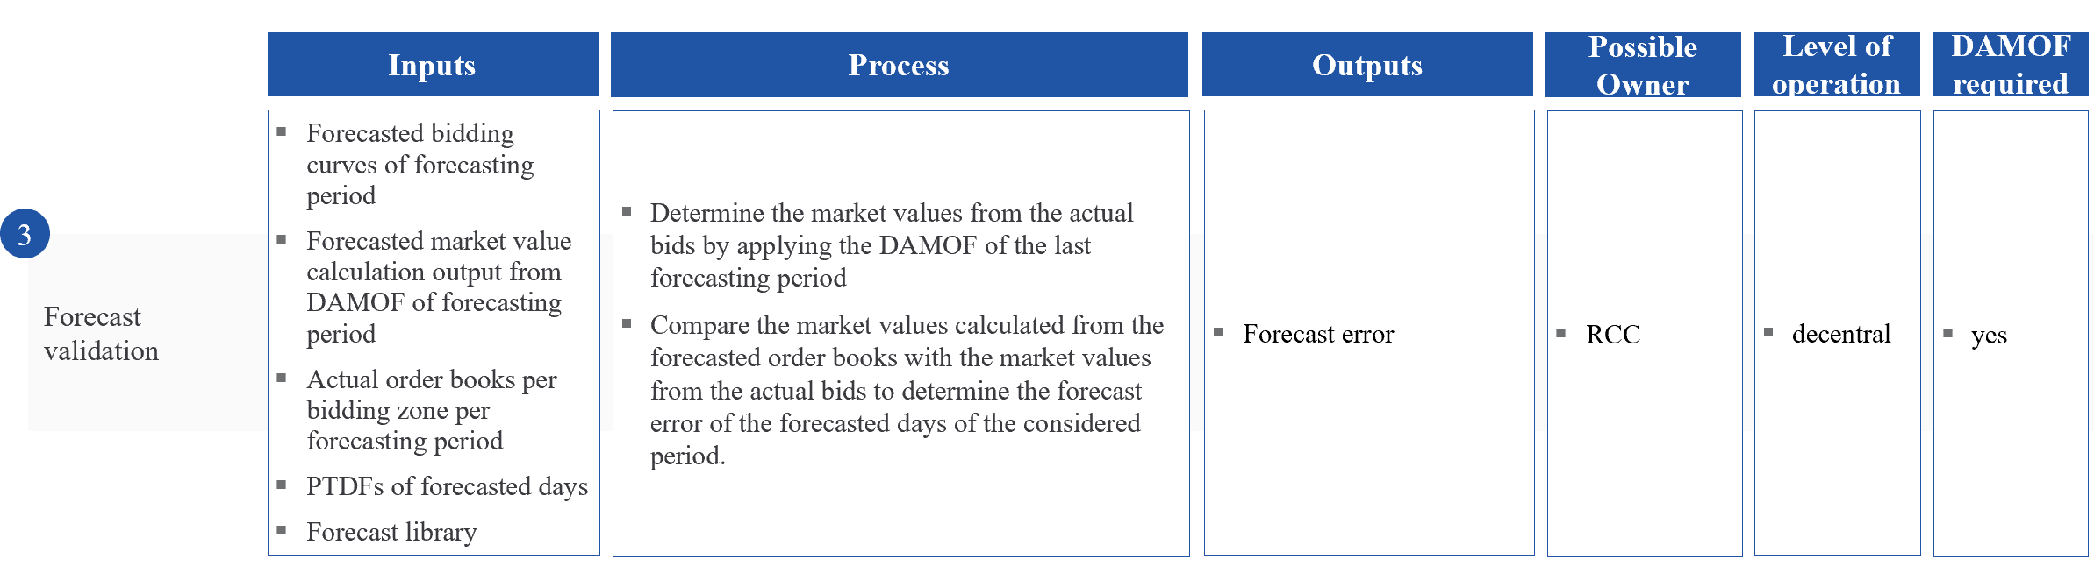

In the forecast validation, RCCs review former forecast results in the preparation of the upcoming forecast of day D. Therefore, they compare the market values of CZC calculated from forecasted bidding curves taking into account CZC allocation limitations for BC with the actual market values of CZC as output from SDAC. The difference is the forecast error. It provides indications of (1) the forecast accuracy and (2) if forecasts in the past were based on a systematic bias. The forecast validation process could be run on a day-by-day basis up to (at most) monthly depending on the frequency of forecasting. Process step 4 shows the consequences of positive forecast errors.
In addition to providing the forecast error, RCCs can provide non-binding recommendations for improvement of the forecast process. The Application TSOs of a BC platform decide on the implementations of these recommendations.

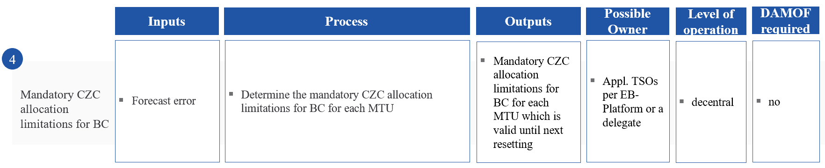

In step 4, the application TSOs of a BC platform have to determine the CZC allocation limitations for BC for each MTU as a consequence of the forecast errors calculated in the forecast validation. The application TSOs of the BC platform shall agree on the rules for determining the mandatory CZC allocation limitations for BC. Also for this mandatory CZC allocation limitations, the application TSOs of the BC platform have to agree if they want to apply the possibility of reducing the maximum volume of CZC for BC or if they want to apply the possibility of reducing the CZC for BC as described above. Limitations shall be based on the average forecast error of the last forecast validation period and are valid for the current forecast validation period. The following table shows an example of a limitation scheme:

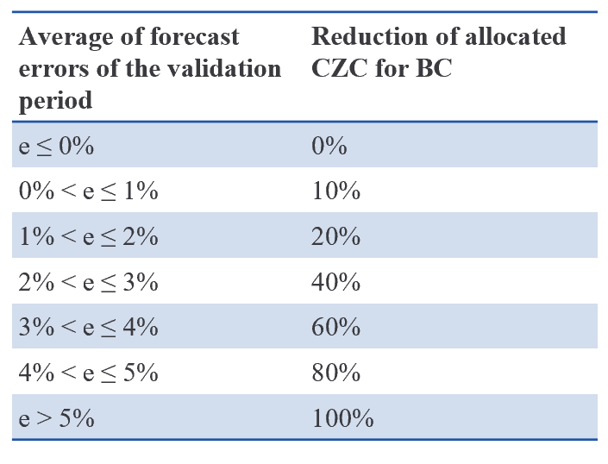
If the average forecast error during the validation period is 0, the reduction of allocated CZC for the exchange of BC or sharing of reserves of the current validation period shall be set to 0 percent. Similarly, if the average forecast error is between 0 and 1 percent, the reduction of allocated CZC for the exchange of BC or sharing of reserves shall be set to 10 percent and so on. If the average forecast error is above 5 percent, no CZC shall be allocated for the exchange of BC or sharing of reserves. The limitation of CZC allocation for the exchange of BC or sharing of reserves shall be for the period until the next validation is conducted.

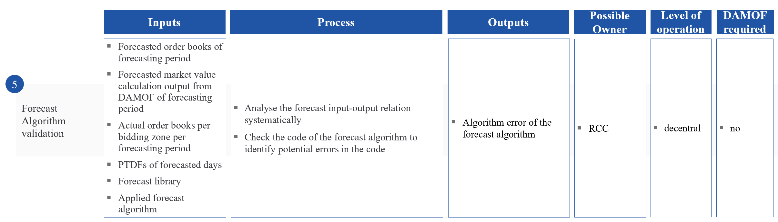

The forecast error describes the deviation of the result of the market-based allocation process based on the outcome of the forecast process and the result which is achieved by using actual order books. Market values are compared as the forecasted bidding curves are per bidding zone whereas the forecast error is determined for the whole BC platform region. Depending on the forecast method, this deviation depends on the inputs to and the calibration of a forecast algorithm. Anyhow, the forecast error describes erratic deviations from the actual situation. In contrast, a systematic deviation is a relative or absolute deviation which occurs with any forecast independently of the input or calibration of a forecast algorithm. This systematic deviation is due to an error in functional implementation. Consequently, it should be healed by an amendment in the algorithm. The detection of a forecast algorithm error is much more complex than the detection of a forecast error as the RCC needs to disentangle the systematic from the non-systematic error based on the input data, the forecast algorithm and the comparison of the forecast with the actual order books. If the RCC finds an indication of a systematic deviation, it needs access to the code of the forecast algorithm to retrace if and where an error might come from. While the forecast validation points to a possibility of improvement, an algorithm error requires a change in the algorithm.

Consequently, RCCs have three tasks:
- RCCs run the forecast validation process;
- Based on the outcome in 1, RCCs provide the forecast error to the Application TSOs of the BC platform in order to adjust the mandatory CZC allocation limitation for BC. RCCs could provide a recommendation for improving the forecast algorithm; and
- dependent on changes made to the forecast algorithm, RCCs perform a forecast algorithm check in order to detect any potential systematic errors.
    - One forecast process and one forecast validation process per BC platform
The CZCAOF optimises the CZC allocation for all applications belonging to the particular BC platform at once. The forecast process provides the DA bidding curves of all relevant DAMs for the applications of the BC platform as one major input to the CZCAOF. To avoid deviations between forecasts due to diverging inputs to forecast processes for subsets of regions within one BC platform the relevant DAMs in the forecast process should be identical to the DAMs of the CZCAOF. Therefore, there should be one forecast process per BC platform. With one forecast process also one forecast validation process per BC platform should be implemented.

  - Forecasting Methods
The previous sections 5.3.2 and 5.3.3 describe the forecast process in the market-based allocation process. The forecast method can be selected by the application TSOs of one BC platform jointly.
The forecast method describes the approach to how the forecasting should be conducted. The approach to be selected should be the most transparent so that market participants and BSPs understand and can take into account the forecast approach in their process of portfolio optimisation. In the following, four main approaches out of a potential range of options will be described from which application TSOs of a BC platform together with the forecast entity may choose one which best meets the regional requirements:
- Market indicators;
- Persistence methods;
- Advanced statistical methods;
- Methods applying artificial intelligence.
Market indicators provide short-term information on bids and volumes. Depending on the timing of the forecast, some market indicators carry full information on the actual situation as they will not change anymore before real-time. This is why there is more actual information the closer the CZC allocation takes place to real-time. On the other hand, forecasts from individual market indicators take the market environment as a fix. When only applying market indicators for the same market at an earlier point in time as predictors for the current situation, no background information is taken into account which has driven the market value function of CZC of the earlier market situation such as weather conditions or unplanned unavailability of generation units.
Persistence methods rely on a set of base scenarios such as Reference Days describing specific situations in the past. These base scenarios can be combined and updated by external information to reach a most appropriate representation of the expected actual situation, e.g., by adjusting the order books of a Reference Day to best meet the situation of the specific MTU of day D. In this sense, persistence methods are an improvement of market indicators as they can be applied to allocation options with a longer lead time.
Market indicators and persistence methods rely on the experience of experts calibrating the weights of the indicators to meet the actual situation and, thus, reach the best estimators for actual bidding curves and, thus, the actual market value function of CZC.
Advanced statistical methods rely on a longer time range of available information. External factors are directly integrated into the problem definition together with indicators and control variables. By employing a time series estimation function for these inputs, influences for each of the inputs are determined. Information on the actual market situation can be used to derive the best estimator for the order books. If the statistical method relies on longer-term information from the past, a time-series approach can be applied. In contrast, if more actual information is provided by indicators used in the forecast algorithm, a so-called cross-sectional estimation approach can be used. Here, current information is used to derive a forecast for the same period in time.
Methods applying artificial intelligence are an advancement of statistical methods where the underlying functional form in statistical methods is replaced by a set of options. The method itself determines intrinsically the relation of parameters by analyzing coherences in historical data. Artificial intelligence-based approaches are the most complex but also the least transparent forecast approaches as it is difficult to determine underlying coherences in the dataset. On the other hand, an adequate artificial intelligence-based algorithm might find coherences which are ignored in statistical methods or also not seen with more expert involvement.
Besides applying forecast methods in their original form, a forecast entity could combine them to better meet regional requirements. In particular, if the most recent information of market indicators or grid indicators has limited significance for the order books to be forecasted, historical developments and, thus, more advanced statistical approaches can be combined with market indicators to provide more insights. In any case, a forecast algorithm is driven by regional influences which drive the forecast result. For example, the river situation has a more direct impact on the production situation in the Nordics than in Eastern Europe as generation is more water-dependent in the Nordics whereas more combustible-related in Eastern Europe.
Beyond, the introduction of forecast methods requires a continuous learning process. From experience, they need to be adapted more in the period directly after the introduction which turns to finetune the longer they are in use. Consequently, also boundaries and forecast error thresholds can be finetuned the longer a forecast algorithm is in use.
  - Fallback procedures
The CZC allocation processes described in the previous sections require the exchange of data between different entities, a forecast process (in the market-based allocation process) and optimisation of CZC allocation. Due to the complexity of the process, issues could happen which might cause delays or non-provision of data to subsequent process steps. This section describes the required countermeasures in these situations.
      - Input data to the CZCAOF is not provided in due time or provided in a format which cannot be processed.
If single TSO or NEMO data is not provided, the CZCAOF will be run ignoring the particular bidding zone or scheduling area. When the correct data is provided for a subsequent MTU, the bidding zone or scheduling area will be considered again in the CZC allocation process. If a bidding zone or scheduling area is excluded from the CZC allocation process, the corresponding TSO/ NEMO have to conduct the BC procurement or DA market clearing locally.
In case forecast data is provided, the CZCAOF should replace the missing forecast data with forecast data from the prior MTU.
      - Input data to the SDAC is not provided in due time.
If the CZCAOF does not provide the CZCAOF outcome or does not provide it in due time to EUPHEMIA, EUPHEMIA cannot optimize the DAM. NEMOs, therefore, have to conduct the DA market clearing locally.
      - Output data of the CPF is not provided in due time.
If the CPF does not provide the CPF outcome or does not provide it in due time, TSOs receive no procurement recommendation. TSOs, therefore, have to conduct the BC procurement locally.

- The establishment of the BC platform in the market-based allocation process
This chapter explains the technical implementation process of building and operating the BC platform. First, an overview is given of the entire process required for the BC platform, from preparation and development to implantation and operation. Secondly, the definition of the CZCAOF blueprint is explained. Finally, the arguments for the decentralised approach for establishing the BC platforms and the cooperation of application TSOs in a market-based allocation process are outlined.
  - Steps required for the establishment of the BC platform
The complete process of building the BC platform for the market-based allocation process is shown in Figure 21 and is divided into three steps: Implementation Preparation, Technical Implementation, and Operation. Each step has a different colour, which means it is the responsibility of either All TSOs, All Application TSOs, or per Application/ set of Application TSOs of one BC platform.

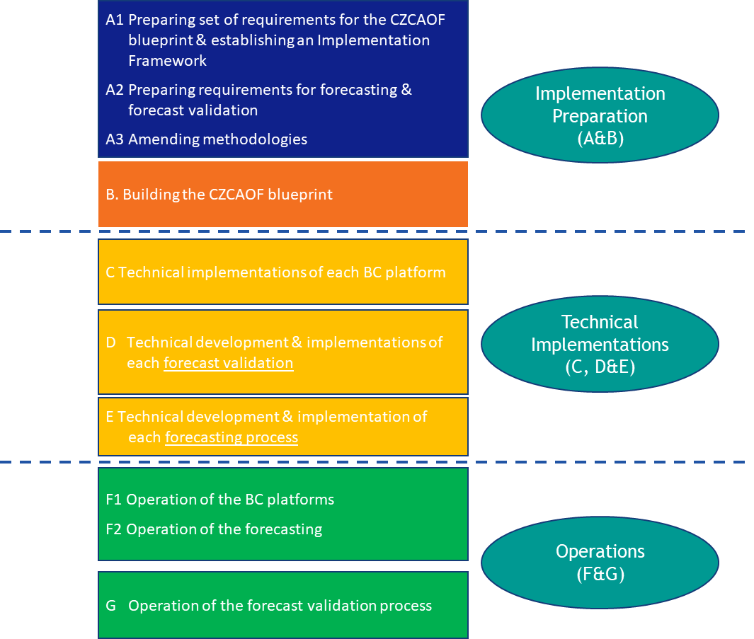
Figure 21: steps required for the BC platform establishment in the market-based allocation process
The Implementation Preparation step includes two main phases. The first phase, shown by the blue box, includes
- the processing of the requirements for the CZCAOF software (also called the “CZCAOF Blueprint”) including CPOF and DAMOF (A1), to be developed by all TSOs and incorporating the CZCAOF requirements of all TSOs for the allocation process of cross-zonal capacity for balancing capacity exchange or reserve sharing. Section 6.2 further elaborates on the definition of the CZCAOF blueprint.
- the preparation of requirements for the forecast process and the forecast validation process (A2): All TSOs shall draft the requirements for forecasting and forecast validation, which shall include the requirements for the forecast process and forecast validation as further elaborated in subsection 5.3.2
- Amending methodologies (A3): Once A1 and A2 are completed, all TSOs may amend the set of requirements of the CZCAOF software and the requirements of the forecast process and the forecast validation process and update the documents accordingly, if necessary.
Although the drafting of the set of requirements for the CZCAOF software and the drafting of the requirements for the forecast process and the forecast validation process should be done jointly by the Application and by Non-Application TSOs to establish common boundaries for implementations, they should be implemented only by the Application TSOs of each BC platform (technical implementation steps C, D, and E).
Step B comprises the preparation of the CZCAOF software by all Application TSOs, taking into account the set of requirements for the CZCAOF software prepared in A2, the orange box in Figure 21. In this step, mainly the mathematical model and the algorithm methodology of the CZCAOF are developed resulting in the software, a programming algorithm coded in a computer programming language.
In the Technical Implementation Phase (yellow boxes), the CZCAOF software is configured for each particular BC platform by the Application TSOs (C) and the forecast process and the forecast validation process are developed and implemented by the Application TSOs of each BC platform (D and E). The technical implementation of the CZCAOF is based on both the set of requirements drafted by all TSOs as developed in step A1 and the CZCAOF software built by all TSOs in step B. The technical implementation of the forecast validation process requires the development and implementation based on the CZCAOF software. RCCs conducting the forecast validation process require specific user access to the CZCAOF as the forecast validation should be conducted on the CZCAOF software of each BC platform individually. Finally, the technical implementation of the forecast process (E) requires both development and implementation based on the forecasting requirements drafted by all TSOs in A2 and the CZCAOF software built by all TSOs in B.
The Operation Phase comprises of the operation of the market-based CZC allocation (F1), the operation of the forecast process by a forecast entity (F2), and the operation of the forecast validation process by an RCC (G). The Application TSOs of a BC platform should be responsible for these steps. They can select a forecast entity (one TSO or another entity) for conducting the forecast process and should select an RCC for conducting the forecast validation process. The operation steps are all based on the technical development and implementation outputs in C, D and E.
  - CZCAOF blueprint definition
In the description of the technical process for the construction of the BC platform, the requirements and constraints of the CZCAOF software (the “CZCAOF blueprint”) are defined by all TSOs and later built by all Application TSOs. The CZCAOF blueprint is the software which conducts the CZC allocation. This comprises of:
- the software for the determination of the optimal CZC allocation based on the outcome of
- the simplified DAM optimisation function (the “DAMOF”) and
- the balancing capacity procurement optimisation function (the “CPOF”).
As previously explained in section 5.3., each BC platform will use the same CZCAOF software. The CZCAOF software will be run on each BC platform’s software infrastructure. The Application TSOs of one BC platform jointly configure the individual requirements of their bidding zones, scheduling areas and bidding zone borders in their CZCAOF software.
Each BC platform should calculate and provide the following information for its Application TSOs:
- the forecasted DAM bidding curves as the output of the DAM forecast process and, therefore, as input to the CZCAOF;
- the actual BCM bids and TSO BC demand as input to the CZCAOF;
- the DAMOF as part of the CZCAOF determines the forecasted market value function of CZC for DAMs;
- the CZCAOF determines the market values of CZC for BCMs and the balancing capacity to be procured by each TSO; and
- The CZCAOF compares the market values of CZC for DAMs and the market values of CZC for BCMs to determine the optimal CZC split.
Inputs, the functional form of the DAM forecast tool and the parametrisation of the DAM forecast tool may differ per BC platform as they account for regional specificities. However, providing the same inputs, functional form and parametrisation to any BC platform, the CZCAOF software guarantees an identical output.
  - Decentralized approach
In contrast to the implementation of the European Balancing Energy platforms PICASSO, MARI and TERRE, EB Regulation does not require TSOs to develop one single CZC allocation platform for Europe. This provides flexibility to balancing capacity markets and facilitates the due consideration of technical grid, generation and consumption specificities. This said, TSOs nevertheless see the need to harmonise processes and the implementation as much as possible where this enables the creation of additional overall European socioeconomic welfare. Consequently, the implementation proposals provided in the HCZCAM and explained in more detail in this Explanatory Document motivate a strong alignment of the market-based allocation process across Europe by the requirement of one and the same CZCAOF software for all BC platforms for all SBCPs.
Based on Figure 21 the understanding of harmonisation is further elaborated in the following Figure 22. There are basically two layers of harmonisation: The Europewide Harmonisation and the BC platform Harmonisation. The Europewide Harmonisation takes place in the Implementation Preparation Step, where one unique CZCAOF software is specified by All TSOs, independently of willingness to become an Application TSO or not. All TSOs jointly prepare the set of requirements which defines the details for the implementation of the CZCAOF software by a software developer (either a TSO or a delegate).
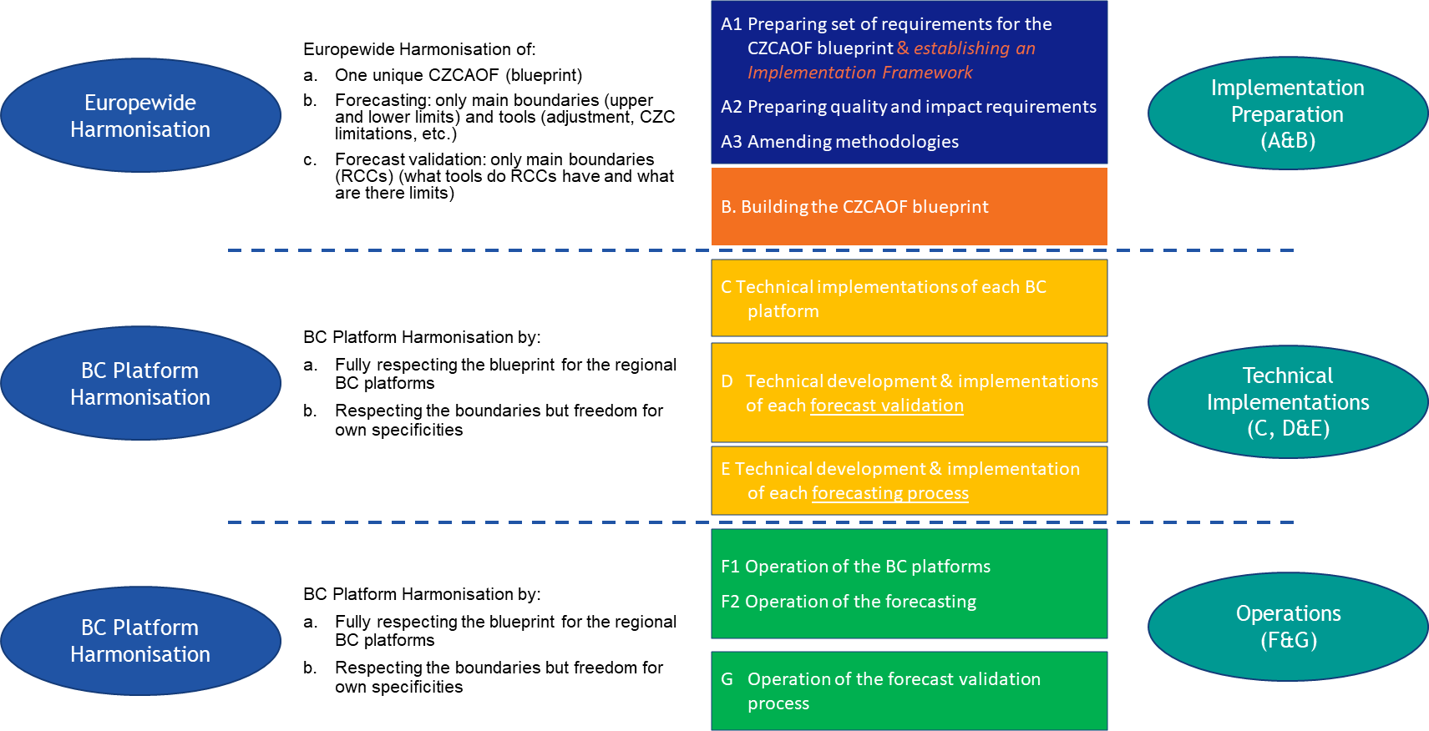
Figure 22: Harmonisation of the BC platform establishment in the market-based allocation process

All TSOs define the general understanding of the forecast process and the forecast validation process for all BC platforms. In contrast to the CZCAOF software, these two processes cannot be further detailed as a set of requirements as regional differences have already shown in the past that a particular forecasting technique better meets the requirements of one region whereas another is more convenient in another region. Consequently, All TSOs can define main boundaries (upper and lower limits) and harmonise tools for the forecast process and forecast validation process but leave the detailed preparation of the forecast process and the forecast validation process for the Application TSOs of each BC platform.
The BC platform Harmonisation guarantees a fully harmonised technical implementation and operation of all functionalities and processes per BC platform. Application TSOs of each BC platform need to fully respect the requirements for the CZCAOF, the forecast process and the forecast validation process as provided in the HCZCAM and this Explanatory Document and the derived set of requirements. Application TSOs of each BC platform apply the CZCAOF software jointly developed by All TSOs for the CZC split.
Application TSOs of one BC platform may adopt the inputs to the CZCAOF and the forecast as well as technically develop and implement their forecast process and their forecast validation process jointly while taking into account the freedom for their own specificities. Application TSOs of one BC platform may operate the CZCAOF and the forecast process by applying measures which best reflect their regional situation.
  - Organisation of the co-operation of Application TSOs in a market-based allocation process
Figure 23 demonstrates the interrelation between Applications, the CPF and the CZCAOF. Figure 21 demonstrates the interrelation between Applications, the CPF and the CZCAOF.
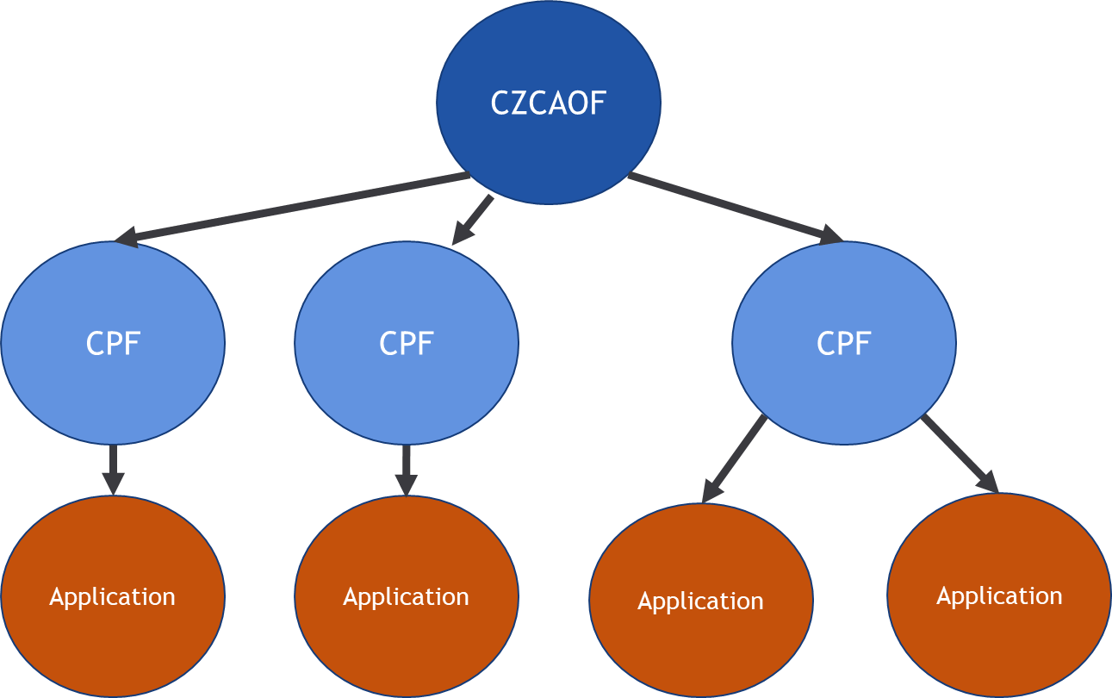
Figure 23: Organisation of the co-operation of Application TSOs
Application TSOs, which want to jointly allocate CZC for BC exchange or sharing of BC reserves of one SBCP and direction, need to jointly establish one BC platform. Each application must belong to one CZCAOF which provides the optimal CZC allocation as the outcome of the CZC allocation procedure. Multiple applications can belong to the same CZCAOF. Consequently, the CZC for each SBCP in each direction is optimised by one CZCAOF. One CZCAOF can also be used to optimise the CZC allocation of more than one SBCP in one direction, for one SBCP in two directions or for more than one SBCPs in two directions. The BC platform is the organisation of all Application TSOs applying one CZCAOF.
The allocated CZC from the CZCA optimisation, the marginal prices and BC volumes as provided by the CZCAOF is the input to a CPF. Based on this, the CPF provides the procurement information of balancing capacity and sharing of reserves for the Application TSOs and from other Application TSOs of the BC platform.
  - Firmness regime for the allocation of cross-zonal capacity
Allocated CZC for the exchange of balancing capacity or sharing of reserves after the co-optimisation process is firm after the selection of upward balancing capacity bids or downward balancing capacity bids by the capacity procurement optimisation function pursuant to Article 33(3) of the EB Regulation.
According to Article 38(9) of the EB Regulation, when CZC allocated for the exchange of balancing capacity or sharing of reserves has not been used for the associated exchange of balancing energy, it shall be released for the exchange of balancing energy with shorter activation times or for operating the imbalance netting process.
The costs of ensuring firmness or in the case of curtailment of firm CZC in the event of force majeure or emergency situations are borne by the relevant TSOs sharing the CZC. These costs include the additional costs from the procurement of balancing capacity due to the non-availability of the balancing capacity given the curtailment of CZC.
Additional costs of the procurement of balancing capacity relate to additional (local) procurement of balancing capacity by means of a second auction, in order to respect reserve compliance, based on the dimensioning process.
- Cost sharing of the BC platform establishment

Figure 24 shows the approach for sharing responsibilities and associated costs for each step of establishing the BC platform in the market-based allocation process comprising the implementation costs and operational costs.
Step A1-A3, the first phase of the Implementation Preparation step, is the responsibility of All TSOs with no implementation or operational cost; its cost mainly includes the time and resources spent by All TSOs on it. Step B, Building the CZCAOF software is the responsibility of All Application TSOs. Its cost is the implementation cost including one-shot costs or capital expenditure for building and releasing the CZCAOF software and should be shared between all countries of All Application TSOs.
The Technical Implementation in steps C, D and E are the responsibility of the Application TSOs per BC platform, and the costs of this phase are implementation costs including one-shot costs or capital expenditure for the technical development and the technical implementation of the CZCAOF on each BC platform and the technical development and the technical implementation of the forecast process and the forecast validation process. The Operations steps F1, F2 and G are in the responsibility of the Application TSOs per BC platform and lead to operational costs including operational expenses for the Application TSOs per BC platform.

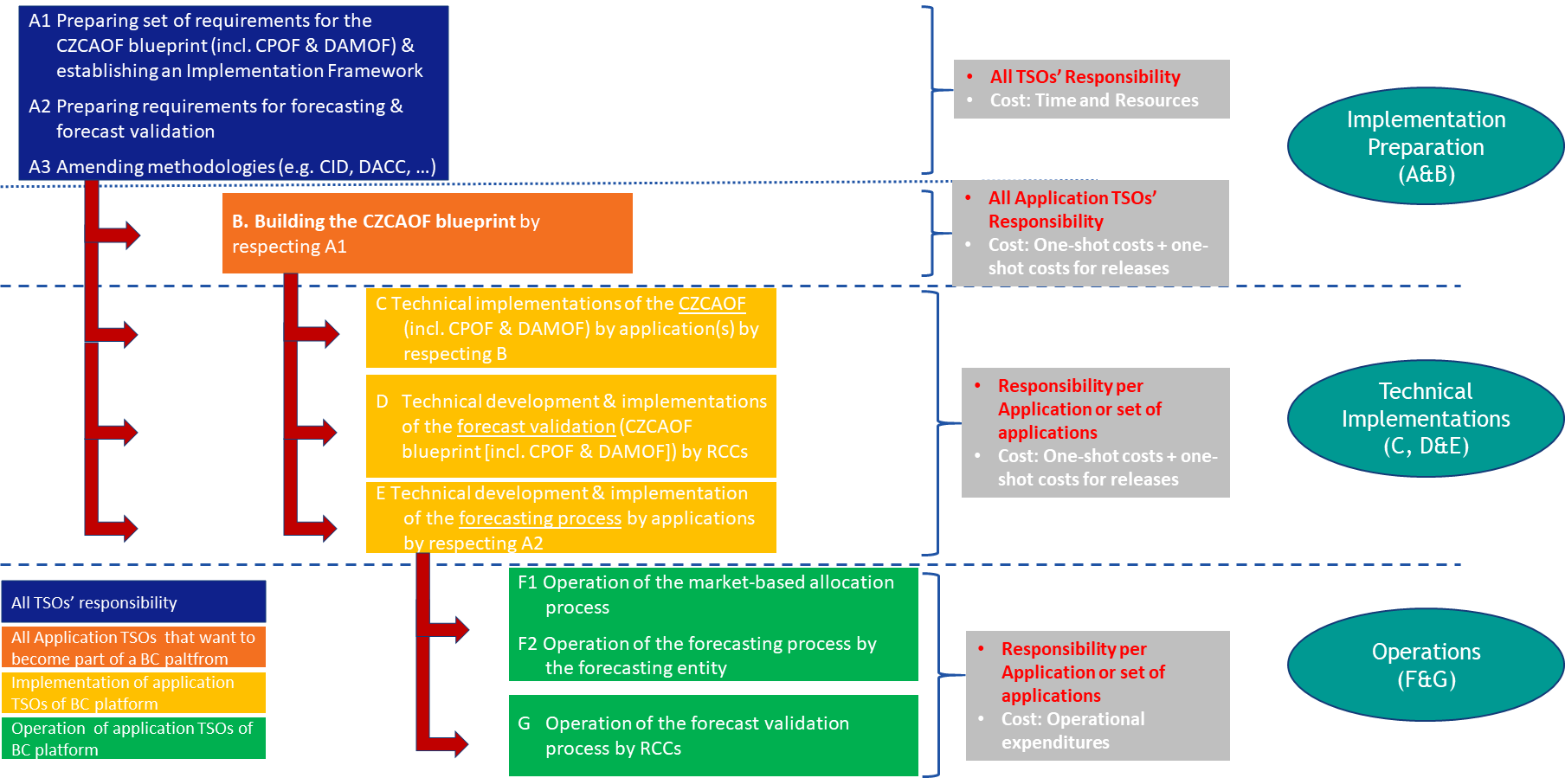

Figure 24: Cost sharing of the BC platform establishment in the market-based allocation process

If a TSO wants to join a BC platform after the start of the technical development, he needs to take the corresponding share of historical development and implementation costs of the CZCAOF, the forecast process and method and the forecast validation of the BC platform.
Implementation costs and their associated historical cost are described below with examples.
  - Cost-sharing: Step B. Building the CZCAOF blueprint
As shown in Figure 25, the costs associated with the building of a CZCAOF software (including DAMOF and CPOF) for the market-based allocation process shall be shared by Application TSOs and future Application TSOs per BC platform based on the predefined cost sharing key. The non-Application TSOs, don’t need to take a share of the costs of the building the CZCAOF software. Future Application TSOs will pay their historical cost share for building the CZCAOF software based on a predefined cost sharing key.
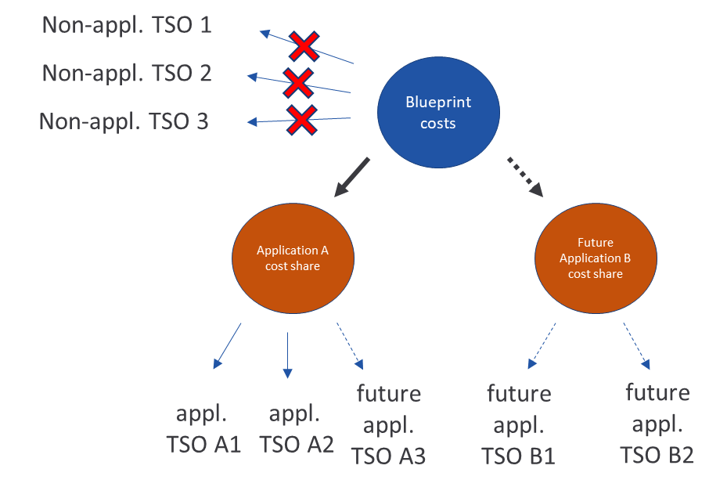
Figure 25: Cost sharing for Building the CZCAOF Software
  - Cost-sharing: Step C. Technical Implementation of the CZCAOF Software
The costs related to the technical implementation of a particular CZCAOF of the Market-Based Allocation approach shall be shared by all Application TSOs of the corresponding BC platform with the same sharing key. Future Application TSOs joining an existing or starting a new application as part of the BC platform shall bear the costs according to the historical cost-sharing key:
(a) the implementation costs are shared according to the historical cost-sharing key.
(b) the costs of historical implementation for TSOs starting a new application as part of the existing respective and single CZCAOF are shared according to the historical cost-sharing key.

Figure 26 shows an example of sharing the implementation costs of the CZCAOF Software. In this example, the existing Application TSO A1 and Application TSO A2 share the cost of implementing the CZCAOF Software equally (1). If TSO A3 joins later (2a), TSO A3 takes one-third of the cost and thus has to pay 1/6 of the total cost to TSO A1 and TSO A2.
Now suppose TSOs B1 and B2 join later with a new application (2b). TSO B1 and TSO B2 each take one-fifth of the cost and have to pay TSOs A1, A2 and A3 1/15 of the total cost each.
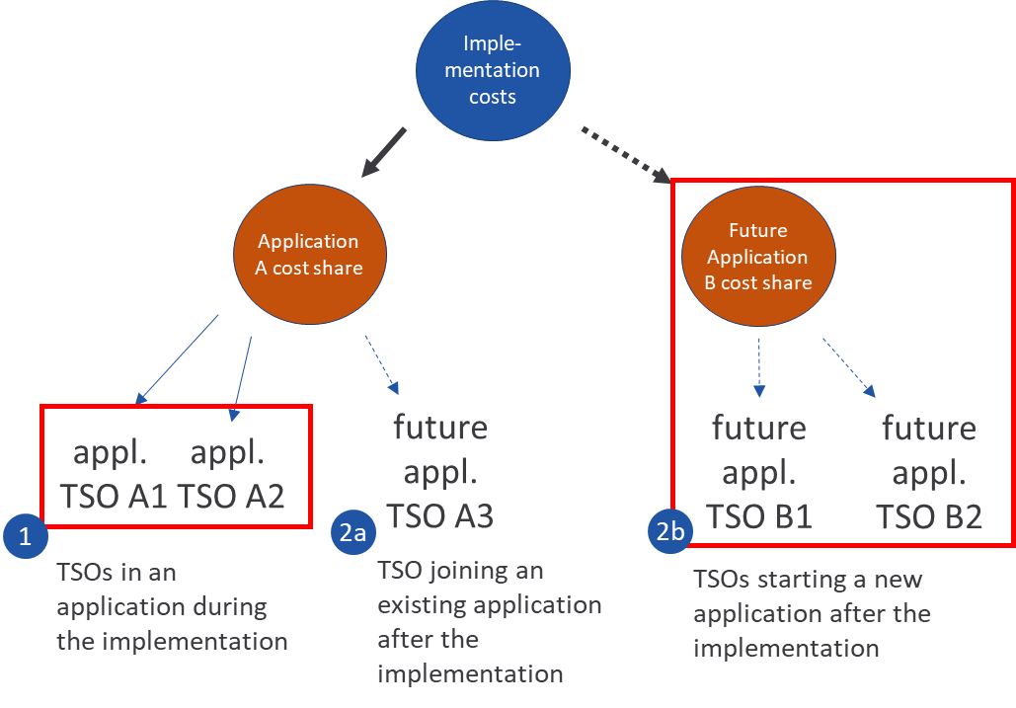
Figure 26: cost sharing for the Technical Implementation of the CZCAOF Software

  - Cost-sharing: Step D. Technical Implementation of the forecast validation process by RCCs
The costs associated with the technical implementation of a forecast validation process of the Market-Based Allocation approach by RCCs shall be shared by all Application TSOs belonging to the particular BC platform which includes one forecast process and one forecast validation process. Future Application TSOs joining an existing or starting a new application as part of this BC platform shall share the costs according to a predefined cost-sharing key.
  - Cost-sharing: Step E. Technical Implementation of the forecast process
Costs associated with the implementation of a certain forecast process of the Market-Based Allocation approach shall be shared by all Application TSOs of a BC platform. One BC platform has one single forecast process and future Application TSOs joining an existing or starting a new application as part of the respective BC platform and, consequently, the same forecast process, need to take their share of historical development and implementation costs based on a historical cost sharing key:
- Costs associated with the implementation of a new forecast process of the Market-Based Allocation approach shall be shared by all Application TSOs belonging to the BC platform.
- Costs of the historical implementation for:
  - future Application TSOs joining an existing application as part of the BC platform shall bear the historical development and implementation costs based on a historic cost-sharing key.
  - TSOs starting a new application as part of the respective BC platform shall bear the historical development and implementation costs based on a historic cost-sharing key.

Figure 27 shows an example of sharing the technical implementation costs of the forecast process. In this example, the existing Application TSO A1 and Application TSO A2 share the cost of implementing the CZCAOF blueprint equally (1). If TSO A3 joins later (2a), TSO A3 takes one-third of the cost and thus has to pay 1/6 of the total cost to TSO A1 and TSO A2.
Suppose that TSOs B1 and TSOs B2 join later with a new application (2b). TSO B1 and TSO B2 each take one-fifth of the cost and have to pay TSOs A1, A2 and A3 1/15 of the total cost each.

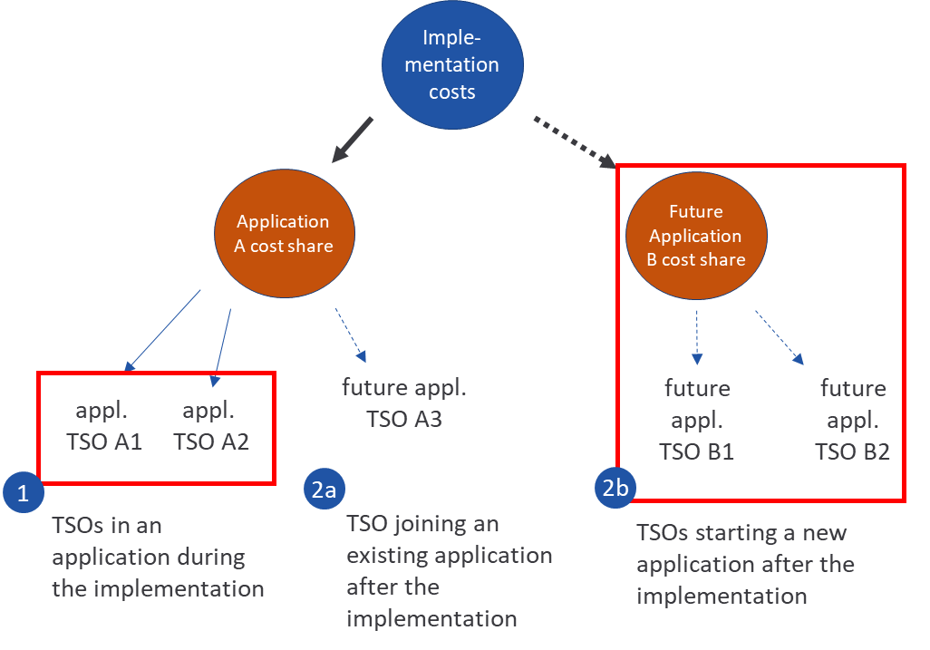
Figure 27: cost sharing for the Technical Implementation of the forecast process
- Governance

The following amendments with respect to governance have been implemented in the current version of the HCZCAM:
- Article 2: Definitions has been complemented with the definition of “Interdependency of Applications”. TSOs can be part of more than one application. A reason could be that a TSO is in one application for positive aFRR whereas it is in another for positive mFRR. As aFRR and mFRR partially interfere it can happen that the TSO applies substitution of reserves between the two applications. Another situation of interdependency of applications is two or more applications being part of one flow-based regime. Here the flow-based capacity calculation affects both applications.
Following Article 16(1), due to the interdependencies the TSOs of the affected applications shall integrate their individual applications into one common BC platform. Thus, the interdependencies can be adequately taken into account by one joint BC platform. The affected application TSOs should try to reach a unanimous agreement on which BC platform to combine the individual applications. In case the affected application TSO cannot agree on which BC platform to use, qualified majority voting according to Article 16(1)(b) in the HCZCAM shall be applied. The appropriate population “figures for voting” are taken from the ENTSO-E articles of association, as amended from time to time.”
- Article 15(2) describes two levels of change requests:
- Change requests concerning the functionality of the CZCAOF software: The CZCAOF software has been developed by All TSOs. Changes of the functionality of the CZCAOF software therefore need to be agreed by All TSOs as these changes affect the CZCAOF software implementation of all BC platforms. Consequently, a corresponding change request shall be addressed to and approved by All TSOs.
- Change requests concerning the operation of the CZCAOF software: The operation of the CZCAOF software is conducted by all application TSOs. Consequently, they are responsible for the way how the CZCAOF software is run. As this process shall be identical across applications, changes of the operation of the CZCAOF software need to be addressed to and approved by all application TSOs of all BC platforms.
Changes of the functionality or the operation of the CZCAOF software may only be requested by TSOs.
Change requests are always considered as change requests concerning the operation of the CZCAOF software. When a change requests also affects the functionality of the CZCAOF software, it is to be approved by all TSOs for their final approval.
For the avoidance of doubt: A change in the functionality of the CZCAOF software is expected to result in a change in the operation of the CZCAOF software. In contrast, a change in the operation of the CZCAOF software need not require a change in the functionality of the CZCAOF software.
Costs arising from a change request shall be shared among all application TSOs following the sharing keys defined in Article 28 HCZCAM.
- Article 16(2) requires all application TSOs per BC platform to establish three processes, for operating the CZCAOF, for performing the day-ahead bid curve forecast and for conducting the forecast validation. While an RCC per BC platform shall conduct the forecast validation pursuant to Article 16(4), Article 16(3) defines the designation of a TSO or a company owned by TSOs to operate the CZCAOF and a TSO or a company owned by TSOs to perform the forecasting process for the day-ahead energy bid curve. Operating the CZCAOF and performing the day-ahead bid curve forecast can be conducted by the same entity per BC platform.
- Article 16(9) defines the process of determining the GCT for balancing capacity bid submission by BSPs. Before deciding about a GCT, the application TSOs shall publicly consult with stakeholders at least three months ahead of its implementation and should last at least two weeks. Subsequently, application TSOs shall announce the corresponding GCT at least four weeks ahead of taking effect. The announcement shall include also exceptions for instances such as GCT delay or re-opening of the bidding window. If such an instance occurs the application TSOs shall publish the information as soon as possible and with a reasonable lead time before the affected MTU.
- Articles 16(7) and (8) define the establishment of a joint decision-making body per BC platform to ensure a fair and non-discriminatory process for the MBA process for all application TSOs of a BC platform. This decision-making body shall decide on matters and questions related to the BC platform. The wider scope of decisions shall be defined by the application TSOs per BC platform. All application TSOs of a BC platform shall appoint one representative to the decision-making body of the corresponding BC platform. The decision-making body shall be established when a BC platform starts operating at the latest. Any decisions to be taken by the decision-making body shall follow the rules defined in the HCZCAM.
- In Article 27(5) a maximum 24-month derogation has been added, which can be granted by the respective regulatory authorities if deemed necessary. This derogation should be justified towards the respective regulatory authorities according to Article 27(5)(a),(b),(c) and (d). The maximum 24-month derogation option only concerns those TSOs that prior to the HCZCA already had an approval of Article 41(1) of the EB Regulation.

- Provisions referring to specific topics in the HCZCAM document
This chapter provides background information on specific topics in the document “Methodology for a harmonized allocation process of cross-zonal capacity for the exchange of balancing capacity or sharing of reserves per timeframe”.

In Article 4: General principles on allocating cross-zonal capacity for the exchange of balancing capacity or sharing of reserves, number 3, it reads
“The maximum price of each bid of SBCP in both directions shall be equal to the maximum day-ahead market bid price for SDAC, both following Article 41(1) of Commission Regulation (EU) 2015/1222 of 24 July 2015.”

The reason for this limitation is due to the fact that reserving a generation unit fully or partly for balancing purposes withholds this part of the generation unit from providing energy to a DAM. The maximum price per MWh for DAM bids is +4000 EUR. As the SBCP price compensates for the opportunity costs of not providing energy from a generation unit to another energy market, the maximum SBCP price should be the same as the maximum DAM energy price.

In Article 4:, number 9, it reads
“For each application using an allocation process as defined in this methodology where the TSO BC demand for an SBCP exceeds the available amount of bids in all bidding zones of the application for the relevant SBCP, while taking into account the maximum volume of allocated cross-zonal capacity for the exchange of balancing capacity or sharing of reserves, a fallback procedure shall apply.”
A fallback is required after CZC is allocated. The CZCAOF is run and the DACC is, at least, started. This means that there is no additional possibility to re-allocated CZC to facilitate TSOs’ BC demand. Consequently, additional balancing capacity can only be reserved within the borders of a TSO’s individual scheduling area(s) or the balancing block. This is why the fallback procedure for such a situation should be implemented by a national solution.

In Articles 10(1) and 17(1), the maximum volume of allocation cross-zonal capacity for the exchange of balancing capacity or sharing of reserves has been defined. The maximum volume is defined for bidding zone borders which are between LFC Blocks and between TSOs, but not for the bidding zone borders within an LFC Block and/or bidding zone borders of a single TSO. The EB regulation states in Article 41 (2) that cross-zonal capacity allocated on a market-based process shall be limited to 10 % of the available capacity for the exchange of energy of the previous calendar year between the respective bidding zones or, in case of new interconnectors, 10 % of the total installed technical capacity of those new interconnectors, if the contracting of balancing capacity is done not more than two days in advance of the provision of the balancing capacity.
Although according to the EB regulation, application of the limit is not mandatory, it is applied in Article 17(1) in order to protect the day-ahead market from the adverse effects of balancing capacity markets and to ensure a smooth transition of national balancing capacity markets to the common European market.
However, balancing capacity cooperation can be most effectively organized within LFC Blocks, where it is not only an issue of economically efficient market operations but also one of security of supply. TSOs and/or bidding zones within an LFC Block engage in a common dimensioning process and face no specific requirements set on the location of FRR or FCR balancing capacity, such as has been defined in SOGL Annex 6 and SOGL Annex 7. The closer cooperation within an LFC block delivers the flexibility to use high-efficiency measures to ensure the required reserves for all bidding zones, such as sharing of reserves and high volumes of exchanged balancing capacity. Setting any kind of restrictions for CZC allocation for balancing capacity within an LFC Block (or on borders within a single TSO), can severely impact the efficient procurement of balancing capacity and jeopardize the cooperation between TSOs/bidding zones of a single LFC Block. Therefore, the possibility of not applying the 10% limit is used for bidding zone borders within an LFC block and borders of a single TSO.

In Article 17.2 and Article 17.3, the process of defining different limits per CNEC is outlined. Different maximum limits hold significant relevance in a Flow-Based region. For instance, on the inclusion of a new member into an existing application, TSOs may consider reducing the maximum capacity at the borders to the new member to address operational safety and assess market impacts, whilst maintaining the standard 10% limit at all other borders.

As a direct mapping between balancing capacity market borders and limits on a CNEC is not possible, a process to define the limits per CNEC needs to be established. Paragraph 17(3)a:
- the process to define the maximum limits per CNEC shall consider the impact of the limitation on all bidding zone borders. The aim of the process is to efficiently realize different intended limits per bidding zone-border. If contradicting intended limits occur due to a close interconnection of borders in the flow-based region, application TSOs shall aim to reach a unanimous decision on the implementation of the limits. If no unanimous decision can be reached, qualified majority voting applies.
A possible implementation for this process could include the following steps:
- Define borders for which a different limit than the standard shall apply.
- s
  - Define the threshold for PTDF such that only relevant CNECs for a border are included, but still a relevant number of CNECs per border remains, e.g. 0.15.
  - Sensitive CNECs are all CNECs where the zone-to-zone PTDF is larger than the threshold.
- Change the limit at all sensitive CNECs to the different maximum limit.
Following this process, an example has been calculated based on the data for the CCR Core for 12.10.23, 16:00-17:00. Employing a standard limit of 10%, and postulating an intended limit of 5% for the NL-BE border and 20% for the CZ-PL border, the following results were obtained:
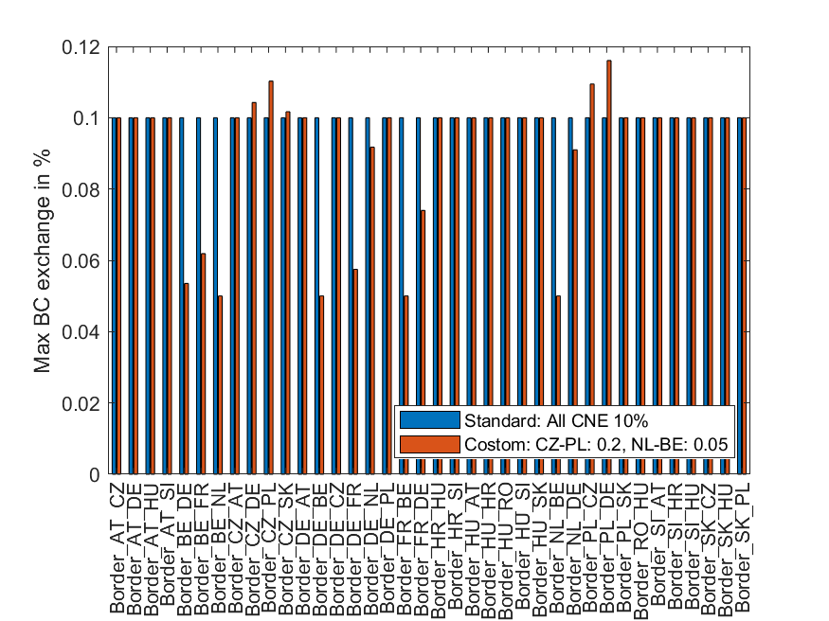

For this example, the reduction to 5% works very well (though also some neighbouring borders are affected), the increase to 20% only ends up at an exchange limit of approx. 12%. This exemplary process makes an increase of the intended exchange limits inherently difficult, because even though the limit on the most sensitive CNECs is increased, a 10% limit on a slightly less sensitive CNEC becomes restraining and limits the exchanges below the intended maximum.

When TSOs can take into account the specificities of their CCR and formulate a more elaborate process than the example before, the realization of the intended limits would surpass the results of this example, and the influence on neighbouring borders will decrease as well.

The process how to define the limits per CNEC and the intended limit per border shall be part of an application proposal according to 38(1) EBGL and consulted with all TSOs before the submission. If application TSOs aim for contradicting limits, which are not possible due to a close interconnection in the flow-based domain, they shall strive to find a unanimous agreement. If this cannot be reached, quality majority voting applies. If an application intends to increase the limit beyond 10% between two or more bidding zones, all TSOs neighbouring those bidding zones have a right to veto against this. This TSO then shall provide a justification for the veto.

In Article 24.2 and Article 24.3, calculations are included to ensure that applications of the methodology also respect the interests of congestion right holders and to avoid any missing money problem for the renumeration of LTAs.

Article 24.2 defines how to calculate the approximated congestion income which would have been generated in the day-ahead-market with the cross-zonal-capacity which was given to balancing. This is then compared against the congestion income actually obtained through the balancing capacity markets. If the monthly sum of the congestion income from the balancing markets is lower than value which would have been generated in day ahead market, the application TSOs shall provide a compensation to the CCR. This compensation is then attributed to the different borders in the CCR according to the shares of decreased congestion income as defined in Article 24.3.

An example calculation will demonstrate the principles for a flow based CCR. Assuming there are three hubs and only the interconnectors are the limiting CNECs with the following PTDFs and RAMs:
150 MW
Hub A
Hub C
Hub B
50 MW
No limit
CNEC | PTDF_{A} | PTDF_{B} | PTDF_{C} | RAM
CNEC_{A->C} | 2/3 | 1/3 | 0 | 150 MW
CNEC_{B->A} | -1/3 | 1/3 | 0 | 50 MW
CNEC_{B->C} | 1/3 | 2/3 | 0 | 9999 MW
Now, assume the following market results:

Area | DA Net position | DA Price | BC net position | BC price
Hub A | 140 MW | 0 €/MWh | -60 MW | 60 €/MW/h
Hub B | 170 MW | 10 €/MWh | +60 MW | 50 €/MW/h
Hub C | -310 MW | 100 €/MWh | 0 MW | -

To calculate the theoretical congestion income from the day-ahead market, the shadow prices of the day-ahead market and the allocation to balancing per CNEC are necessary:
$${CI'}_{CCR, T}={adj}_{CCR,T}×\sum_{t∈T, o∈{CNEC}_{CCR}}{µ_{o,t}^{CNEC}}×{BEC}_{o,t}$$
The adjustment factor adjCCR,T has a standard value of 1 for the moment, reasons to differ from this standard value will be given later. To calculate the reservation to balancing, no relieving effects on CNECs can be assumed, as a flow for balancing is not certain. Therefore, only positive values are considered.
$$BEC\left({CNE}_{X}\right)=max(\sum_{Hub}{{NP}_{BC,Hub}*{PTDF}_{X}},0)$$
$$BEC\left({CNE}_{A->C}\right)=\max\left(\left(-60\right)*\frac{2}{3}+60*\frac{1}{3}+0, 0\right)=0 MW$$
$$BEC\left({CNE}_{B→A}\right)=\max\left(\left(-60\right)*\frac{-1}{3}+60*\frac{1}{3}+0, 0\right)=40 MW$$
$$BEC\left({CNE}_{B→C}\right)=\max\left(\left(-60\right)*\frac{1}{3}+60*\frac{2}{3}+0, 0\right)=20 MW$$

The shadow prices associated with limiting CNECs, resulting from the DA allocation, with the assumed zonal prices, are as follows:
$$µ_{A→C}^{CNEC}=190\frac{€}{MWh}$$
$$µ_{B→A}^{CNEC}=80\frac{€}{MWh}$$
With this, the reduced congestion income in day-ahead market can be calculated:
$${CI'}_{CCR, T}=0MW*190\frac{€}{MWh}+40 MW*80\frac{€}{MWh}=3200€$$

The adjustment factor adjCCR,T for CI'CCR, T can be used to account for the overestimation of the congestion income which could have been generated in the day-ahead market due to the non-linearity of shadow prices.

Effectively this means, that the allocation to balancing uses some of the cross-border capacity, which increases price differences and therefore also shadow prices in day-ahead market. Consequently, also the congestion income which would have been generated in day-ahead market is overestimated. The adjustment allows to compensate for this effect.

As the congestion income from balancing is:
$${EBCI}_{CCR,T}= -\sum_{Hub}{{NP}_{BC,Hub}*{Price}_{BC,Hub}= 60MW*\frac{60€}{MWh}-60MW*\frac{50€}{MWh}=600 €}$$

According to CIDm Article 7.5, EBCI is shared using balancing capacity market spreads for borders that are part of the application (A->B in the example) and day-ahead market spreads for borders that are not part of the application (B->C and A->C in the example). This results in the following EBCI share per border.

$${EBCI}_{A→C}=285.72$$
$${EBCI}_{B→A}=57.14$$
$${EBCI}_{B→C}=257.14$$

Assuming, for the sake of the argument, that this was the only MTU with an allocation to balancing in the whole month the compensation to the CCR would be:
$$C_{CCR,T}=\max\left({{CI}^{'}}_{CCR,T}-{EBCI}_{CCR,T},0\right)=2600 €$$

In the second Article (24.3) the distribution of the compensation to to the borders of the CCR is calculated. For this, first the decreased congestion income per border is calculated:

${CI}_{b,t}^{DEC}=\sum_{p∈P}{|{MS}_{b,t}×\max\left({AAF}_{b,t}^{BC, p},0\right)×{SF}_{t}|}$ if ${AAF}_{b,t}^{ }≥0$
$${CI}_{b,t}^{DEC}=0 if {AAF}_{b,t}^{ }<0$$

To identify the relevant directions for which the congestion income from the DA could have been reduced, it is crucial to determine the directed borders where AAFb,t is positive.
$${AAF}_{A→C}^{ } =150$$
$${AAF}_{B→A}^{ }=10$$
$${AAF}_{B→C}^{ }=160$$

Consequently, only A->C, B->A, B->C directed borders are taken into account when computing the decreased CI. For directed borders C->A, A->B, C->B the compensation is zero.
Assuming a scaling factor SF = 1 and positive AAFs for all listed CNECs, the following results are obtained:
$${CI}_{A→C}^{DEC}=\left|100\frac{€}{MWh}×0MW×1\right|=0€$$
$${CI}_{B→A}^{DEC}=\left|-10\frac{€}{MWh}×40MW×1\right|=400€$$
$${CI}_{B→C}^{DEC}=\left|90\frac{€}{MWh}×20MW×1\right|=1800€$$

According to the formula for the compensation distribution,
$$c_{b,T}=\frac{\sum_{t∈T}{max\left({CI}_{b,t}^{DEC}×{Corr}_{t}-{EBCI}_{b,t},{0}\right)}}{\sum_{t∈T,b∈B_{CCR}}{max\left({CI}_{b,t}^{DEC}×{Corr}_{t}-{EBCI}_{b,t},{0}\right)}}×C_{CCR,T}$$
$${Corr}_{t}=\frac{{CI'}_{CCR,t}}{\sum_{b∈B_{CCR}}{{CI}_{b,t}^{DEC}}}$$

compensation shares per directed border are calculated:

$$Corr=\frac{3200}{2200}=1.45$$

$c_{A→C,T}^{ } =\frac{max⁡(0×1.45-285.72)×2600}{\max\left(0×1.45-285.72\right)+\max\left(400×1.45-57.14\right)+\max\left(1800×1.45-257.14\right)}$= 0

$c_{B→A,T}^{ }=\frac{\max\left(400×1.45-57.14\right)×2600}{\max\left(0×1.45-285.72\right)+\max\left(400×1.45-57.14\right)+\max\left(1800×1.45-257.14\right)}$= 472.73

$c_{B→C,T}^{ }=\frac{\max\left(1800×1.45-257.14\right)×2600}{\max\left(0×1.45-285.72\right)+\max\left(400×1.45-57.14\right)+\max\left(1800×1.45-257.14\right)}$= 2127.27

This means the border B->A receives 18% of the compensation and border B->C receives 82% of the compensation.

The compensation process described in Article 24.2. can be omitted in case there is agreement among the TSOs of the concerned CCR following the respective voting arrangement.

- Annex - Structure of applications, CPOF and CZCAOF
The following figures provide more detailed insights how applications should co-operate. The number of required CPOFs and CZCAOFs depends on the number of applications and if they co-operate in a flow-base domain or a cNTC domain.
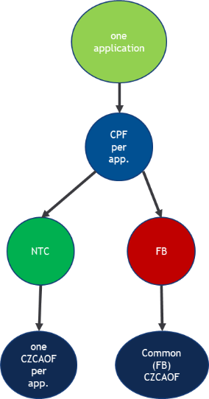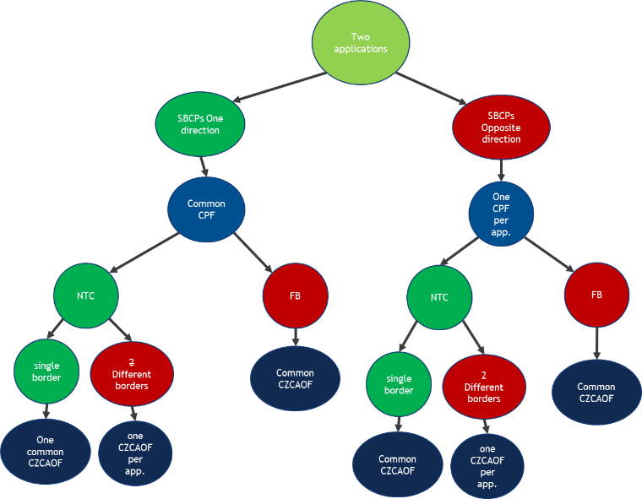
One Application Two Applications

In a flow-base domain the CZC allocated on one bidding-zone border has a direct impact on the CZC to be allocated at another bidding-zone border of the CCR. Consequently, only one single CZCAOF is able to determine the optimal CZC allocation in a flow-base domain.
In contrast, in the cNTC domain, each bidding-zone border is considered individually. Therefore, the CZC allocated at one bidding-zone border depends on the already allocated capacity per other SBCP and direction of this bidding-zone border only. As a result, we can define a minimum number of combinations of CZCAOFs and CPOFs.
If TSOs form applications for one SBCP in one direction at one bidding-zone border only one CZCAOF and one CPOF is required. In contrast, one SBCP in one direction at multiple bidding-zone borders could enable one CZCAOF per application with one common CPOF.

Any contract between two or more TSOs for CZCA for the exchange of balancing capacity or sharing of reserves already in place before the EB Regulation entered into force may remain valid until the contract expires.
Producer surplus equals 0 if pay-as-bid is applied.
It should be noted that this is a simplification, as the balancing capacity market includes non-convexities as start-up and shut-down costs along with minimum output requirements (which state that if a plant is running, it must produce at least a certain amount). This is further elaborated in 4.2.4.
The flow-based computation is explained, e.g., in the Explanatory Note DA FB CC methodology for Core CCR.
See chapters 8 and 9 of the Co-optimised CZC allocation process Implementation Impact Assessment report.
The linking code is the unique identifier which marks two cross-product linked bids as connected.
More details are provided in the ENTSO-E study “Methods for allocating cross-zonal capacities to the balancing capacity market”.
The co-optimised allocation approach should be implemented as a European allocation approach.
One CZCAOF for all SBCPs in both directions is required for application TSOs of the same flow-based CCR as the CZC allocated at one bidding zone border affects the CZC to be allocated at each other bidding zone border of the CCR.
In this example, these are CNECs, but in reality there will be N-1 CNECs as well.
The individual graphs take the findings of prior graphs as given and do not repeat as this would require many more additional repetitive cases.

