CCR Core TSOs’ Cooperation

1st amendment of the Core CCR fallback procedures in accordance with Article 44 of the Commission Regulation (EU) 2015/1222 of 24 July 2015 establishing a guideline
on capacity allocation and congestion management

Purpose: | □ methodology draft | ☒ for public consultation
 | □ for NRA approval | □ for final publication
Status: | □ draft | ☒ final
TSO  approval: | □ for approval | ☒ approved
NRA  approval: | ☒ outstanding | □ approved

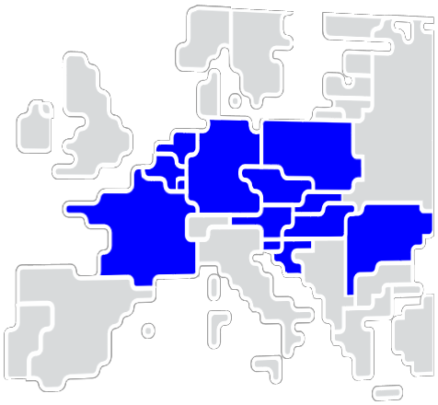

Transmission System Operators (hereafter referred to as “TSOs”) of the Core Capacity Calculation Region (hereafter referred to as “Core CCR”), taking into account

Whereas
- ACER Decision No 10/2018 of 27 September 2018 approving the Core CCR in accordance with Article 44 of the Commission Regulation (EU) 2015/1222 of 24 July 2015 establishing a guideline on capacity allocation and congestion management (CACM Regulation);
- All European TSOs aim at harmonizing shadow allocation rules on all European bidding zone borders, where they are applied as fallback solution in case the single day-ahead coupling (SDAC) fails to deliver market coupling results. This process leads to the need for amendment of the Core CCR fallback procedures and the Regional Shadow Allocation Rules attached to the Core CCR fallback procedures;
- The SDAC Joint Steering Committee has decided to shift operational timings of the SDAC in order to cope with increasing performance restrictions of the European Market Coupling Algorithm. As consequence of these shift of operational timings, the full decoupling deadline and thus the deadline for shadow auction results publication shall be shifted from D-1 13h50 to D-1 14h00;
- The first amendment of the Core CCR fallback procedures was publicly consulted from xx July 2020 until xx August 2020 in accordance with article 12 of the CACM Regulation;
- This first amendment to the Core CCR fallback procedures does not change the impact of the previously approved Core CCR fallback procedures on the objectives of the CACM Regulation. The evaluation of the impact on the objectives of the CACM Regulation contained in the already approved Core CCR fallback procedures is therefore also valid for this amendment;

developed the following first amendment of the Core CCR fallback procedures:

Article 1
Changes to the main body of the Core CCR fallback procedures
In Article 4(5) of the Core CCR fallback procedures the phrase “13:50 CET” is to be replaced by “14:00 CET” and be read accordingly:
“5. The respective allocation platform operator shall publish on the allocation platform’s website the shadow auction results as soon as the day‐ahead decoupling is finally declared by the MCOs, but no later than at 14:00 CET on the day preceding delivery.”

Article 2
Changes to the annex of the Core CCR fallback procedures
The Regional Shadow Allocation Rules annexed to the present Core CCR fallback procedures shall be replaced by the Regional Shadow Allocation Rules attached to this first amendment of the Core CCR fallback procedures.

Article 3
Publication and implementation of the fallback procedures
- The Core TSOs shall publish this first amendment to the Core CCR fallback procedures without undue delay after the decision has been taken by relevant national regulatory authorities in accordance with Article 9(8) of the CACM Regulation.
- This first amendment to the Core CCR fallback procedures shall be applied as of the go-live of the amended Single Day-Ahead Coupling (SDAC) operational timings. The start of the application of the new SDAC operational timings will be published on the website of the allocation platform operator 30 calendar days before application.
- The annexed shadow allocation rules shall be published on the concerned Core TSOs’ websites and on the website of the allocation platform operator without undue delay after the decision has been taken by relevant national regulatory authorities in accordance with Article 9(8) of the CACM Regulation.

Article 4
Entry into force
This first amendment of the Core TSOs fallback procedures shall enter into force with the approval by the relevant national regulatory authorities in accordance with Article 9(8) of the CACM Regulation.

