|  |
| --- |
| Determination of capacity calculation regions |
|  |
| All TSOs’ proposal for amendment of the Determination of capacity calculation regions methodology in accordance with Article 15(1) of the Commission Regulation (EU) 2015/1222 of 24 July 2015 establishing a guideline on capacity allocation and congestion management  [For consultation]  13 May 2025 |

**DISCLAIMER *for consultation phase only***

This document is released on behalf of the all transmission system operators (“TSOs”) only for the purposes of the public consultation on the proposal for Determination of Capacity Calculation Regions (“Determination of CCR”) in accordance with Article 15(1) of the Commission Regulation (EU) 2015/1222 of 24 July 2015 establishing a guideline on capacity allocation and congestion management. This version of the Determination of CCR Proposal does not, in any case, represent a firm, binding or definitive TSOs’ position on the content.

Contents

Whereas 2

TITLE 1 General Provisions 12

Article 1 Subject matter and scope 12

Article 2 Definitions and interpretation 12

TITLE 2 Capacity Calculation Regions 13

Article 3 Capacity Calculation Region 1: Nordic 13

Article 4 Capacity Calculation Region 2: Hansa 13

Article 5 Capacity Calculation Region 3: Core 14

Article 6 Capacity Calculation Region 4: Italy North 16

Article 7 Capacity Calculation Region 5: Central Europe 16

Article 8 Capacity Calculation Region 6: Greece-Italy (GRIT) 16

Article 9 Capacity Calculation Region 7: South-west Europe (SWE) 16

Article 10 Capacity Calculation Region 8: Baltic 17

Article 11 Capacity Calculation Region 9: South-East Europe (SEE) 17

Article 11a Temporary Capacity Calculation Region 10: East-Central Europe (ECE) 18

Article 11c Capacity Calculation Region 12: Eastern Europe (EE) 19

TITLE 3 Final provisions 19

Article 12 Implementation date of CCRs 19

Article 13 Future assessment 19

Article 14 Language 21

Appendix 1: Maps of the CCRs 22

Appendix 2: List of TSOs subject to the approved determination of CCRs methodology 34

Whereas

(1) This document is a common proposal for the amendment developed by all Transmission System Operators (hereafter referred to as “TSOs”) to the Determination of Capacity Calculation Regions (hereafter referred to as “CCRs”) methodology as defined in accordance with Article 15(1) of the Commission Regulation (EU) 2015/1222 of 24 July 2015 establishing a Guideline on Capacity Allocation and Congestion Management (hereafter referred to as the “Proposal for Amendment”).

(2)This Proposal for Amendment of the Determination of CCRs takes into account Annex I of the Regulation (EU) 2015/1222 of 24 July 2015 establishing a Guideline on Capacity Allocation and Congestion Management, as incorporated into the Energy Community legal framework by the Energy Community Ministerial Council Decision 2022/03/MC-EnC of 15 December 2022 (hereafter referred to as “EnC CACM Regulation”) which defines three CCRs of the Energy Community: Capacity Calculation Region Shadow South-East Europe (Shadow SEE CCR), Capacity Calculation Region Italy-Montenegro (ITME CCR) and Capacity Calculation Region Eastern Europe (EE CCR). In addition, TSOs proposed to modify the CCR Determination in accordance with Annex 1, Article 1(2) of the EnC CACM Regulation and propose splitting of Shadow SEE CCR between CORE/CE (EMS, CGES and NOSBiH) and SEE CCR (MEPSO, OST and KOSTT). However, accession of EMS, CGES and NOSBiH to Core/Central Europe (CE CCR) at this point would have negative impacts on ongoing projects. Therefore, a temporary capacity calculation region, limited in scope and time, East-Central Europe CCR (ECE CCR) is established consisting of a subset of nC TSOs: EMS, CGES, NOSBiH and a subset of CE TSOs: HOPS, MAVIR and Transelectrica. Temporary ECE CCR will become operational upon the full implementation of the Electricity Integrationm Package, consisting of the EU Clean Energy Package and five Network codes and Guidelines as incorporated and adapted by the EnC Ministerial Council Decision 2022/03/MC-EnC of 15 December 2022.

Upon full implementation of the day-ahead capacity calculation processes according to Article 20(1) CACM and Article 20(2) amended EnC CACM by CE CCR and ECE CCR respectively and the participation of all East-Central Europe’s CCR bidding zone borders in the single day-ahead coupling as set out in Article 8(1) CACM as well as amended EnC CACM Regulation, an amendment of the Determination of CCR Methodology will be triggered to enable ECE CCR accession to CE CCR for capacity calculation in day ahead timeframe. All other obligations related to the ECE CCR accession to CE CCR and according to the Clean Energy Package and five Network codes and Guidelines shall apply using a stepwise approach.

Full implementation of the Electricity Integration Package into national law by all relevant Energy Community Contracting Parties is a precondition for the amended SEE CCR to become effective.

(3) Following the approval of the previous Amendment of the Determination of CCRs by means of ACER Decision No. 4/2024 of 19 March 2024, which merged the Core and Italy North capacity calculation regions into the Central Europe CCR for day ahead capacity calculation in conjunction with the obligations deriving from Article 13(3) of the Determination of CCR Methodology, CE TSOs drafted the roadmap for the full merger of the CCRs Core and Italy North into the Central Europe CCR for all CCR-related methodologies, using a stepwise approach and taking into account potential interdependencies with existing regional implementation projects under the applicable European Union law. The roadmap was developed with the aim to achieve a full merger of both Core and IN CCRs as expeditiously as possible by merging projects based on their maturity level while at the same time reducing overall efforts and not delaying already clear go-live dates from Core/IN.

As a result of the roadmap, and as the next step in the merger, all TSOs are submitting an amendment to the determination of CCRs in accordance with Article 9(13) of the CACM Regulation.

(4) This Proposal for Amendment of the Determination of CCRs further merges the Core and Italy North capacity calculation regions into the CE CCR for intraday capacity calculation as well as for regional operational security coordination (ROSC) in accordance with Article 76 of the Commission Regulation (EU) 2017/1485 of 2 August 2017 establishing a guideline on electricity transmission system operation (SO Regulation), coordinated redispatching and countertrading (RDCT) in accordance with Article 35 of the CACM Regulation and redispatching and countertrading cost sharing methodology (RDCT CS) in accordance with Article 74 of the CACM Regulation. It aligns with the objectives of the CACM Regulation that CCR Core and CCR Italy North are merged and apply a common capacity calculation using the flow-based approach. However, full merger would be premature considering the ongoing development in Core LTCC and expected amendments of Commission Regulation (EU) 2016/1719 of 26 September 2016 establishing a guideline on forward capacity allocation (the FCA Regulation) and the fact that CE BTCC would come at the end of implementation chain. Therefore, a further stepwise merger for the purpose of implementing the common intraday capacity calculation methodology and ROSC, RDCT, and CS methodologies is currently preferable, along with the already approved merger of capacity calculation in the day-ahead timeframe. All other obligations related to the CCRs according to the CACM Regulation, FCA Regulation), Commission Regulation (EU) 2017/2195 of 23 November 2017 establishing a guideline on electricity balancing (the EB Regulation) and the SO Regulation, as well as any other applicable European legislation shall apply to the CCR Central Europe using a stepwise approach, by transferring these obligations from the CCRs Core and Italy North, which will cease to exist at the end of this process. The involved TSOs and NRAs shall agree on the respective steps and timeline based on the progress of the existing regional implementation projects and further work on a concept for the merger of all remaining CCR-related obligations. CCR determination methodology shall be amended correspondingly to future merging steps of the CCRs Core and Italy North.

(5) This Proposal for Amendment takes into account the general principles and goals set in the CACM Regulation as well as Regulation 2019/943 on internal market for electricity (Electricity Regulation). The goal of the CACM Regulation is the coordination and harmonisation of capacity calculation and allocation in the day-ahead and intraday cross-border markets, and it sets requirements for the TSOs to co-operate on the level of CCRs, on a pan-European level and across bidding zone borders.

(6) According to Article 9(9) of the CACM Regulation, the expected impact of the proposal on the objectives of the CACM Regulation has to be described. This Proposal for Amendment contributes to, and does not hamper in any way, the achievement of the objectives of the CACM Regulation.

(7) In particular, this Proposal for Amendment contributes to ensuring optimal use of the transmission infrastructure (objective of Article 3(b) of the CACM Regulation), ensuring operational security (objective of Article 3(c) of the CACM Regulation) and optimising the calculation of cross-zonal capacity (objective of Article 3(d) of the CACM Regulation), as follows:

a. The determination of new ECE, EE and ITME CCRs, as well as assignment of MEPSO, OST and KOSTT to the SEE CCR enables the coordinated cross-zonal capacity calculation on respective BZ borders.

b. The merger of Core and Italy North CCRs into the Central Europe CCR for intraday capacity calculation, enables the coordinated flow-based capacity calculation on respective BZ borders, enlarging the geographical scope of coordination in intraday timeframe in comparison with Core.

c. The merger of ROSC, RDCT and CS would allow larger geographical scope for security coordination which would result in least cost and optimal application of remedial actions without a need for implementation of additional cross-regional coordination between Core and IN.

(8) The coordinated capacity calculation within a CCR could reveal constraining elements in the transmission network, which contributes to the long-term operation and development of the electricity transmission system and electricity sector in the Union. The Amendment of Determination of CCRs contributes to this objective of Article 3(g) of the CACM Regulation as it expands with the merger of Core and Italy North CCRs into CE CCR to intraday timeframe, as well as encompasseing3 new CCRs and expanding the geographical scope of SEE CCR.

(9) An immediate accession of the newly created ECE CCR at the time of this Proposal for Amendment of Determination of CCRs might have negative impacts on existing implementation projects and the fulfilment of legal obligations in the current Core and CE CCRs, and therefore might hamper the objective of efficient long-term operation and development of the electricity transmission system (Article 3(g) of the CACM Regulation).

(10) To ensure that the objectives of Article 3(b), (d) and (g) of the CACM Regulation are respected, this Proposal for Amendment foresees the accession of ECE CCR to the CE CCR when certain conditions are met in both regions, as prescribed in Article 13(4) of this Proposal for Amendment. Clear conditions for future ECE CCR accession to CE are setting the path for even larger geographical scope of flow-based capacity calculation, first on day ahead time frame, followed by other time frames and all other CCR related obligations, which would further contribute to all above mentioned CACM objectives.

(11) This Proposal for Amendment encompasses three new CCRs – ECE, EE and ITME, expansion of SEE CCR, and a merger of CE CCR together with setting a condition for future ECE CCR accession to CE CCR. The aim of this holistic approach is to streamline the process outlined in Article 9(13) of the CACM Regulation by combining all foreseeable amendments in one proposal and thus reducing the number of proposals to the minimum needed.



TITLE 1  
General Provisions

Article 1  
Subject matter and scope

1. The CCRs cover the following:
2. all existing bidding zone borders within and between Member States, to which the CACM Regulation applies;
3. all existing bidding zone borders between Member States and Energy Community Contracting Parties, to which the amended EnC CACM Regulation applies and has been transposed by the Energy Community Contracting Parties;
4. all existing bidding zone borders between Energy Community Contracting Parties, to which the amended EnC CACM Regulation applies and has been transposed by the Energy Community Contracting Parties ~~have transposed CACM/in line with the Ministerial Council Decision XX on amended CACM~~ ;
5. future bidding zone borders established as a result of interconnections operated by legal entities certified as TSOs which are under construction at the time of the approval of this Determination of CCRs and planned to be commissioned.
6. Any changes in the bidding zone border configuration of Member States or Energy Community Contracting Parties shall be taken into account in proposals for amendments to this document in accordance with Article 9(13) of the CACM Regulation as well as Article 9 (13) of the amended EnC CACM Regulation.
7. This determination of CCRs shall apply to the TSOs listed in Appendix 2.

Article 2  
Definitions and interpretation

1. Terms used in this document shall have the meaning of the definitions included in Article 2 of the CACM Regulation and Article 2 of the Electricity Regulation and, where bidding zones and bidding zone borders of the Energy Community are mentioned, their equivalent provisions in the EnC CACM Regulation and the EnC Electricity Regulation. .
2. In this document, unless the context clearly indicates otherwise:
3. the singular also includes the plural and vice versa;
4. headings are inserted for convenience only and do not affect the interpretation of this document;
5. any reference to legislation, regulations, directive, order, instrument, code or any other enactment shall include any modification, extension or re-enactment of it then in force; and
6. in case of inconsistency between any of the provisions in Title 2 and the maps included in the Appendix to this document the provisions in Title 2 shall prevail.
7. This document shall be binding upon and shall ensure to the benefit of the TSOs as referred to herein and their permitted successors and assigns and irrespective of any change in the TSOs’ names.

TITLE 2  
Capacity Calculation Regions

Article 3  
Capacity Calculation Region 1: Nordic

1. The CCR Nordic shall include the bidding zone borders listed below, and shown on map 1 included in the Appendix 1 to this document, as attributed to the referred TSOs:
2. Denmark 1 - Sweden 3 (DK1 - SE3), Energinet and Svenska kraftnät;
3. Denmark 2 - Sweden 4 (DK2 - SE4), Energinet and Svenska kraftnät;
4. Denmark 1 - Denmark 2 (DK1 - DK2), Energinet;
5. Sweden 4 - Sweden 3 (SE4 - SE3), Svenska kraftnät;
6. Sweden 3 - Sweden 2 (SE3 - SE2), Svenska kraftnät;
7. Sweden 2 - Sweden 1 (SE2 - SE1), Svenska kraftnät;
8. Sweden 3 - Finland (SE3 - FI), Svenska kraftnät, Kraftnät Åland AB and Fingrid Oyj;
9. Sweden 1 - Finland (SE1 - FI), Svenska kraftnät and Fingrid Oyj;
10. Norway 1 - Norway 2 (NO1 - NO2), Statnett SF;
11. Norway 1 - Norway 3 (NO1 - NO3), Statnett SF;
12. Norway 1 - Norway 5 (NO1 - NO5), Statnett SF;
13. Norway 2 - Norway 5 (NO2 - NO5), Statnett SF;
14. Norway 3 - Norway 5 (NO3 - NO5), Statnett SF;
15. Norway 3 - Norway 4 (NO3 - NO4), Statnett SF;
16. Norway 1 - Sweden 3 (NO1 - SE3), Statnett SF and Svenska kraftnät;
17. Norway 3 - Sweden 2 (NO3 - SE2), Statnett SF and Svenska kraftnät;
18. Norway 4 - Sweden 2 (NO4 - SE2), Statnett SF and Svenska kraftnät;
19. Norway 4 - Sweden 1 (NO4 - SE1), Statnett SF and Svenska kraftnät;
20. Norway 4 - Finland (NO4 - FI), Statnett SF and Fingrid Oyj; and
21. Norway 2 - Denmark 1 (NO2 - DK1), Statnett SF and Energinet.
22. The NO4-FI bidding zone border shall be included in the market coupling and capacity calculation process from the go-live of flow-based capacity calculation in CCR Nordic onwards.

Article 4  
Capacity Calculation Region 2: Hansa

The CCR Hansa shall include the bidding zone borders listed below, and shown on map 2 included in the Appendix 1 to this document, as attributed to the referred TSOs:

1. Denmark 1 - Germany/Luxembourg (DK1 - DE/LU), Energinet and TenneT TSO GmbH;
2. Denmark 2 - Germany/Luxembourg (DK2 - DE/LU), Energinet and 50Hertz Transmission GmbH;
3. Sweden 4 - Poland (SE4 - PL), Svenska Kraftnät and Polskie Sieci Elektroenergetyczne S.A.;
4. Denmark 1 - Netherlands (DK1 - NL), Energinet and TenneT TSO B.V.;
5. Sweden 4 - Germany/Luxembourg (SE4 - DE/LU), Svenska Kraftnät, TenneT TSO GmbH and Baltic Cable AB;
6. Norway 2 - Netherlands (NO2 - NL), Statnett SF and TenneT TSO B.V.; and
7. Norway 2 - Germany/Luxembourg (NO2 - DE/LU), Statnett SF and TenneT TSO GmbH.

Article 5  
Capacity Calculation Region 3: Core

1. Without prejudice to Article 7, the CCR Core shall include the bidding zone borders listed below, and shown on map 3 included in the Appendix 1 to this document, as attributed to the referred TSOs:
2. France – Belgium (FR – BE), RTE – Réseau de transport d’électricité and Elia Transmission Belgium NV/SA ;
3. Belgium – Netherlands (BE – NL), Elia Transmission Belgium NV/SA and TenneT TSO B.V.;
4. France – Germany/Luxembourg (FR – DE/LU), RTE – Réseau de transport d’électricité ; Amprion GmbH and TransnetBW GmbH ;
5. Netherlands – Germany/Luxembourg (NL – DE/LU), TenneT TSO B.V., TenneT TSO GmbH and Amprion GmbH ;
6. Belgium – Germany/Luxembourg (BE – DE/LU), Elia Transmission Belgium NV/SA, Creos Luxembourg S.A. and Amprion GmbH ;
7. Germany/Luxembourg – Poland (DE/LU – PL), 50Hertz Transmission GmbH and Polskie Sieci Elektroenergetyczne S.A. ;
8. Germany/Luxembourg – Czech Republic (DE/LU – CZ), TenneT TSO GmbH, 50Hertz Transmission GmbH and ČEPS, a.s. ;
9. Austria – Czech Republic (AT – CZ), Austrian Power Grid AG and ČEPS, a.s.;
10. Austria – Hungary (AT – HU), Austrian Power Grid AG and MAVIR Hungarian Independent Transmission Operator Company Ltd.;
11. Austria – Slovenia (AT – SI), Austrian Power Grid AG and ELES, d.o.o.;
12. Czech Republic – Slovakia (CZ – SK), ČEPS, a.s. and Slovenská elektrizačná prenosová sústava, a.s.;
13. Czech Republic – Poland (CZ – PL), ČEPS, a.s. and Polskie Sieci Elektroenergetyczne S.A.;
14. Hungary – Slovakia (HU – SK), MAVIR Hungarian Independent Transmission Operator Company Ltd. And Slovenská elektrizačná prenosová sústava, a.s.;
15. Poland – Slovakia (PL – SK), Polskie Sieci Elektroenergetyczne S.A. and Slovenská elektrizačná prenosová sústava, a.s.;
16. Croatia – Slovenia (HR – SI), Croatian Transmission System Operator Plc. (HOPS d.d.) and ELES, d.o.o.;
17. Croatia – Hungary (HR – HU), Croatian Transmission System Operator Plc. (HOPS d.d.) and MAVIR Hungarian Independent Transmission Operator Company Ltd.;
18. Romania – Hungary (RO – HU), Compania Naţională de Transport al Energiei Electrice “Transelectrica” S.A. and MAVIR Hungarian Independent Transmission Operator Company Ltd.;
19. Hungary – Slovenia (HU – SI), MAVIR Hungarian Independent Transmission Operator Company Ltd. And ELES, d.o.o.; and
20. Germany/Luxembourg – Austria (DE/LU – AT), Austrian Power Grid AG, TransnetBW GmbH, TenneT TSO GmbH and Amprion GmbH;
21. Single Electricity Market in Ireland and Northern Ireland – France (SEM-FR), EirGrid – EirGrid plc and RTE – Réseau de transport d’électricité.
22. The assignment of the bidding zone border SEM-FR to the CCR Core shall be effective from the date of operation of the interconnector on the respective bidding zone border.
23. In order to accommodate the specific case of the Single Electricity Market in Ireland and Northern Ireland, SONI is assigned to the CCR Core.

Article 6  
Capacity Calculation Region 4: Italy North

Without prejudice to Article 7, the CCR Italy North shall include the bidding zone borders listed below, and shown on map 4 included in the Appendix 1 to this document, as attributed to the referred TSOs:

1. Italy NORD - France (NORD - FR), TERNA Rete Elettrica Nazionale S.p.A. and RTE - Réseau de transport d’électricité;
2. Italy NORD - Austria (NORD - AT), TERNA Rete Elettrica Nazionale S.p.A. and Austrian Power Grid AG; and
3. Italy NORD - Slovenia (NORD - SI), TERNA Rete Elettrica Nazionale S.p.A. and ELES d.o.o..

Article 7  
Capacity Calculation Region 5: Central Europe

The CCR Central Europe shall be established for capacity calculation in the day-ahead timeframe and intraday timeframe as well as for the methodologies for Regional operational security coordination in accordance with Article 76 of the SOGL Regulation, coordinated redispatching and countertrading in accordance with Article 35 of the CACM Regulation and redispatching and countertrading cost sharing methodology in accordance with Article 74 of the CACM Regulation and shall include all bidding zone borders and attributed TSOs listed in Articles 5 and 6 and shown on map 5 included in the Appendix 1 to this document.

Article 8  
Capacity Calculation Region 6: Greece-Italy (GRIT)

The CCR GRIT shall include the bidding zone borders listed below, and shown on map 6 included in the Appendix 1 to this document, as attributed to the referred TSOs:

1. Italy SUD - Greece (SUD - GR), TERNA Rete Elettrica Nazionale S.p.A. and Independent Power Transmission Operator S.A.;
2. Italy NORD - Italy CNOR (NORD - CNOR), TERNA Rete Elettrica Nazionale S.p.A.;
3. Italy CNOR - Italy CSUD (CNOR - CSUD), TERNA Rete Elettrica Nazionale S.p.A.;
4. Italy CNOR - Italy SARD (CNOR - SARD), TERNA Rete Elettrica Nazionale S.p.A.;
5. Italy SARD - Italy CSUD (SARD - CSUD), TERNA Rete Elettrica Nazionale S.p.A.;
6. Italy CSUD - Italy SUD (CSUD - SUD), TERNA Rete Elettrica Nazionale S.p.A.;
7. Italy SUD - Italy CALA (SUD - CALA), TERNA Rete Elettrica Nazionale S.p.A.; and
8. Italy CALA - Italy SICI (CALA - SICI), TERNA Rete Elettrica Nazionale S.p.A..

Article 9  
Capacity Calculation Region 7: South-west Europe (SWE)

The CCR SWE shall include the bidding zone borders listed below, and shown on map 7 included in the Appendix 1 to this document, as attributed to the referred TSOs:

1. France - Spain (FR - ES), RTE - Réseau de transport d’électricité and REE - Red Eléctrica de España, S.A.U.; and
2. Spain - Portugal (ES - PT), REE - Red Eléctrica de España, S.A.U. and REN - Rede Eléctrica Nacional, S.A..

Article 10  
Capacity Calculation Region 8: Baltic

The CCR Baltic shall include the bidding zone borders listed below, and shown on map 8 included in the Appendix 1 to this document, as attributed to the referred TSOs:

1. Estonia - Latvia (EE - LV), Elering AS and Augstsprieguma tīkls;
2. Latvia - Lithuania (LV - LT), Augstsprieguma tīkls and Litgrid AB;
3. Estonia - Finland (EE - FI), Elering AS and Fingrid Oyj;
4. Lithuania – Sweden 4 (LT - SE4), Litgrid AB and Svenska kraftnät; and
5. Lithuania - Poland (LT - PL), Litgrid AB and Polskie Sieci Elektroenergetyczne S.A..

Article 11  
Capacity Calculation Region 9: South-East Europe (SEE)

The CCR SEE shall include the bidding zone borders listed below, and shown on map 9 included in the Appendix 1 to this document, as attributed to the referred TSOs:

1. Independent Power Transmission Operator S.A. (IPTO) and Elektroenergien Sistemen Operator (ESO) EAD;
2. Elektroenergien Sistemen Operator (ESO) EAD and Compania Naţională de Transport al Energiei Electrice "Transelectrica" S.A.;
3. Crnogorski elektroprenosni sistem AD (CGES) and Operatori i Sistemit Te Transmetimit – OST sh.a.;
4. Operatori i Sistemit te Transmetimit – OST sh.a. and Operator sistemi, transmisioni dhe tregu Sh.A. (KOSTT)
5. Operatori i Sistemit te Transmetimit – OST sh.a and Makedonski elektroprenosen sistem operator a.d. (MEPSO)
6. Makedonski elektroprenosen sistem operator a.d. (MEPSO) and Elektromreža Srbije AD (EMS);
7. Crnogorski elektroprenosni sistem AD (CGES) and Operator sistemi, transmisioni dhe tregu Sh.A. (KOSTT);
8. Makedonski elektroprenosen sistem operator a.d. (MEPSO) and Operator sistemi, transmisioni dhe tregu Sh.A. (KOSTT);
9. Elektromreža Srbije AD (EMS) and Operator sistemi, transmisioni dhe tregu Sh.A. (KOSTT);
10. Elektroenergien Sistemen Operator (ESO) EAD and Elektromreža Srbije AD (EMS);
11. Elektroenergien Sistemen Operator (ESO) EAD and Makedonski elektroprenosen sistem operator a.d. (MEPSO)
12. Independent Power Transmission Operator S.A. (IPTO) and Makedonski elektroprenosen sistem operator a.d.(MEPSO);
13. Independent Power Transmission Operator S.A. (IPTO) and Operatori i Sistemit Te Transmetimit – OST sh.a.;

Article 11a  
 Temporary Capacity Calculation Region 10: East-Central Europe (ECE)

1. Without prejudice to Article 7, the temporary CCR East-Central Europe shall include the bidding zone borders listed below, and shown on map 12 included in the Appendix 1 to this document, as attributed to the referred TSOs:

1. Croatian Transmission System Operator Plc. (HOPS d.d.) and Nezavisni operator sistema u Bosni i Hercegovini (NOS BiH);
2. Croatian Transmission System Operator Plc. (HOPS d.d.) and Elektromreža Srbije AD (EMS);
3. Elektromreža Srbije AD (EMS) and MAVIR Hungarian Independent Transmission Operator Company Ltd.;
4. Compania Naţională de Transport al Energiei Electrice “Transelectrica” S.A. and Elektromreža Srbije AD (EMS);
5. Elektromreža Srbije AD (EMS) and Nezavisni operator sistema u Bosni i Hercegovini (NOS BiH);
6. Crnogorski elektroprenosni sistem AD (CGES) and Nezavisni operator sistema u Bosni i Hercegovini (NOS BiH);
7. Crnogorski elektroprenosni sistem AD (CGES) and Elektromreža Srbije AD (EMS).

(2) The CCR ECE shall be established for capacity calculation in the day-ahead timeframe.

**Article 11b**  
**Capacity Calculation Region 11: Italy-Montenegro (ITME)**

The CCR ITME shall include the bidding zone border listed below, and shown on map 10 included in the Appendix 1 to this document, as attributed to the referred TSOs:

1. Italy CSUD and Montenegro (CSUD-ME), TERNA Rete Elettrica Nazionale S.p.A (TERNA) and Crnogorski elektroprenosni sistem AD (CGES),

Article 11c  
 Capacity Calculation Region 12: Eastern Europe (EE)

The CCR EE shall include the bidding zone borders listed below, and shown on map 11 included in the Appendix 1 to this document, as attributed to the referred TSOs:

1. ,Ukraine and Moldova (UA - MD), concerning PJSC "National Power Company” "Ukrenergo" and S.E. “Moldelectrica”.
2. Ukraine - Poland (UA - PL), concerning PJSC "National Power Company” "Ukrenergo" and Polskie Sieci Elektroenergetyczne S.A
3. Ukraine - Slovakia (UA - SK), concerning PJSC "National Power Company” "Ukrenergo" and Slovenská elektrizačná prenosová sústava, a.s.
4. Ukraine - Hungary (UA - HU), concerning PJSC "National Power Company” "Ukrenergo" and MAVIR Hungarian Independent Transmission Operator Company Ltd
5. Ukraine - Romania (UA - RO), concerning PJSC "National Power Company” "Ukrenergo" and Compania Nationalã de Transport al Energiei Electrice “Transelectrica” S.A
6. Moldova . Romania (MD - RO), concerning S.E. “Moldelectrica”  and Compania Nationalã de Transport al Energiei Electrice “Transelectrica” S.A .

TITLE 3  
Final provisions

Article 12  
Implementation date of CCRs

All TSOs shall apply the CCRs as described in Title 2 as soon as the decision has been taken by ACER in accordance with Article 9(6)(b) of the CACM Regulation and Article 5(2)(b) Regulation (EU) 2019/942.

* + - 1. Article 13  
         Future assessmentNo later than three months after the implementation of the first version of the regional operational security coordination in accordance with Article 76(1) of Commission Regulation 2017/1485 of 2 August 2017 establishing a guideline on electricity transmission system operation (hereafter referred to as the “SO Regulation”) in the Core CCR, all TSOs shall submit to ACER an assessment analysing alternative determinations of at least the CCRs Hansa, Nordic and Core in terms of:

1. efficiency of capacity calculation and allocation in all timeframes; and
2. efficiency of regional operational security coordination in accordance with Article 76(1) of the SO Regulation, coordinated redispatching and countertrading in accordance with Article 35 of the CACM Regulation and redispatching and countertrading cost sharing in accordance with Article 74 of the CACM Regulation and cross-regional operational security coordination in accordance with Article 75(1) of the SO Regulation.
   * + 1. In case this assessment pursuant to paragraph (1) identifies a more efficient alternative Determination of CCRs, all TSOs shall submit to ACER a proposal for amendment of the Determination of CCRs in accordance with Article 9(13) of the CACM Regulation by the same deadline as for the assessment.
       2. The TSOs shall, in coordination with the competent regulatory authorities, work on the full merge of the CCRs Core and Italy North into the CCR Central Europe for all CCR-related methodologies, using a stepwise approach and taking into account potential interdependencies with existing regional implementation projects under the applicable Union law. To this end, the TSOs shall submit to ACER corresponding amendments of the Determination of CCRs in accordance with Article 9(13) of the CACM Regulation, for each subsequent phase of the merger.

All TSOs shall make a proposal for an amendment of this methodology including all bidding zone borders and attributed TSOs listed in Article 11a and shown on map 12 included in Appendix 1 to this document into the CCR Central Europe until 12 months after 1) full transposition of the electricity integration package into national law by all Energy community Contracting Parties of the CCR ECE as required by Decision 2022/03/MC-EnC of the Ministerial Council of the Energy Community, and 2) the full implementation of the day-ahead capacity calculation processes according to Article 20 (1) CACM and amended EnC CACM Regulation by the capacity calculation regions set out in Article 7 and Article 11a and 3) the participation of the CCR ECE’s TSOs in the single day-ahead coupling as set out in Article 8 (1) CACM and amended EnC CACM Regulation. The proposal shall contain a roadmap and an implementation plan that enables a gradual integration of all these bidding zone borders of CCR ECE jointly into the applicable tasks within the CCR Central Europe.Full transposition of the Electricity Integration Package into national law by all relevant Energy Community Contracting Parties, mentioned in Article 11, is a precondition for the amended SEE CCR, as described in Article 11., to become effective. Where necessary, the application of the full Terms, Conditions, and Methodologies related to the operationalisation of the amended SEE CCR, shall be implemented in a stepwise manner that takes into consideration the readiness of the EnC TSOs and does not impact the ongoing implementation processes of the EU TSOs and does not hamper the compliance with EU law obligations.

Article 14  
 Language

The reference language for this document shall be English. For the avoidance of doubt, where TSOs need to translate this document into their national language(s), in the event of inconsistencies between the English version published by all TSOs in accordance with Article 9(14) of the CACM Regulation and any version in another language, the relevant TSOs shall, in accordance with national legislation, provide the relevant national regulatory authorities with translation of this document.

Appendix 1: Maps of the CCRs

1. Capacity Calculation Region 1: Nordic

1. Capacity Calculation Region 2: Hansa

Note: The DE/LU - PL, NL - DE/LU, NO2 - DK1, DK2 - SE4 and DK1 - DK2 bidding zone borders are not part of this CCR.

1. Capacity Calculation Region 3: Core

**SEM**

1. Capacity Calculation Region 4: Italy North

Note: The AT-SI bidding zone border is not part of this CCR.

1. Capacity Calculation Region 5: Central Europe

**SEM**

1. Capacity Calculation Region 6: Greece-Italy (GRIT)

1. Capacity Calculation Region 7: South-west Europe (SWE)

1. Capacity Calculation Region 8: Baltic

Note: The SE4-PL bidding zone border is not part of this CCR.

1. Capacity Calculation Region 9: South-east Europe (SEE)

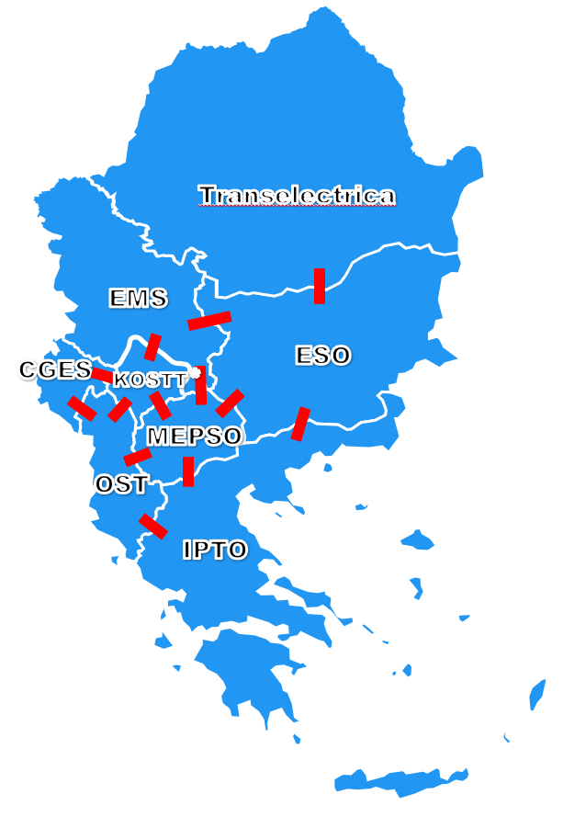

1. Capacity Calculation Region 10: Italy Montenegro (ITME)

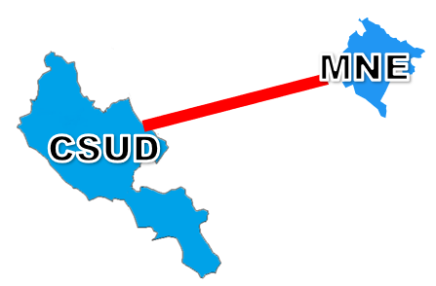

1. Capacity Calculation Region 11: Eastern Europe (EE)

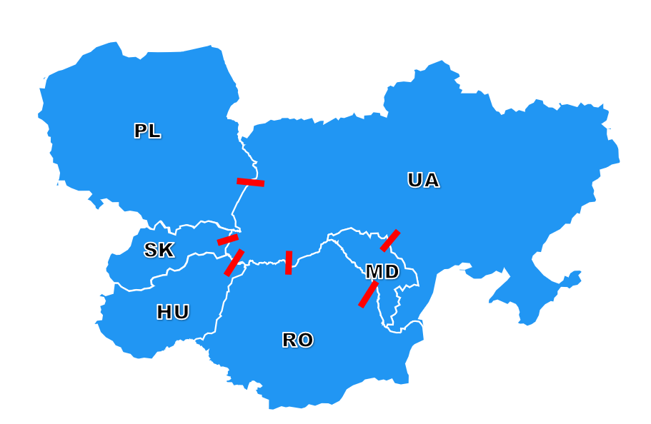

1. Capacity Calculation Region 12: East-Central Europe (ECE)

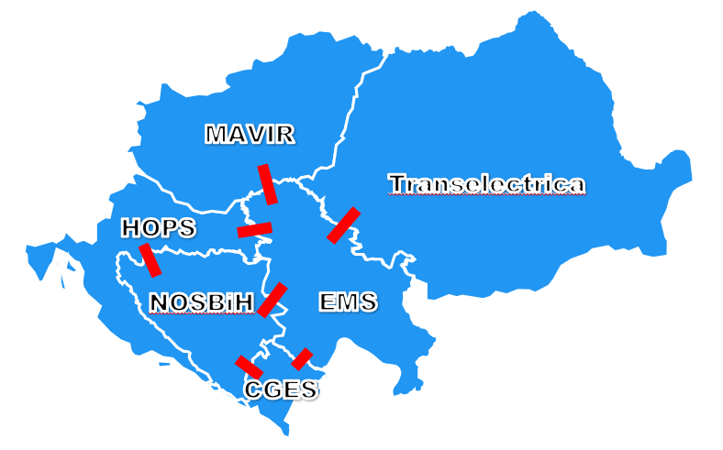

Appendix 2: List of TSOs subject to the approved determination of CCRs methodology

* APG - Austrian Power Grid AG,
* VÜEN-Vorarlberger Übertragungsnetz GmbH
* Elia - Elia Transmission Belgium S.A.
* ESO – Electroenergien Sistemen Operator EAD
* HOPS d.d. - Croatian Transmission System Operator Plc.
* ČEPS - ČEPS, a.s.
* Energinet – Energinet
* Elering - Elering AS
* Fingrid - Fingrid OyJ
* Kraftnät - Kraftnät Åland Ab
* RTE - Réseau de Transport d'Electricité S.A
* Amprion - Amprion GmbH
* BCAB - Baltic Cable AB
* TransnetBW -TransnetBW GmbH
* TenneT GER - TenneT TSO GmbH
* 50Hertz - 50Hertz Transmission GmbH
* IPTO - Independent Power Transmission Operator S.A.,
* MAVIR - MAVIR Hungarian Independent Transmission Operator Company Ltd.
* EirGrid - EirGrid plc
* Terna - Terna SpA
* Augstsprieguma tïkls - AS Augstsprieguma tïkls
* LITGRID - LITGRID AB
* CREOS Luxembourg - CREOS Luxembourg S.A.
* TenneT TSO - TenneT TSO B.V.
* PSE - Polskie Sieci Elektroenergetyczne S.A.
* REN - Rede Eléctrica Nacional, S.A.
* Transelectrica - Compania Nationala de Transport al Energiei Electrice S.A.
* SEPS - Slovenská elektrizačná prenosová sústava, a.s.
* ELES - ELES,d.o.o
* – Red Eléctrica. Red Eléctrica de España S.A.U,
* Svenska Kraftnät - Affärsverket Svenska Kraftnät
* SONI - System Operator for Northern Ireland Ltd
* NOS BiH – Nezavisni operator sistema u Bosni i Hercegovini
* CGES – Crnogorski elektroprenosni sistem AD
* EMS – Elektromreza Srbije AD
* OST – Operatori i Sistemit te Transmetimit sh.a. (OST)
* MEPSO – Makedonski Elektroprenosen Sistem Operator AD (MEPSO)
* Ukrenergo NPC SE (Ukrenergo) - PJSC “National Power Company” "Ukrenergo" (NPC Ukrenergo)
* MEL– SE Moldelectrica
* KOSTT – Operator sistemi, transmisioni dhe tregu Sh.A.

**[Annexes:** material that should bee presented separately, where necessary. This material includes technical or other requirements or specifications, in particular because they would be by their very nature too lengthy or too detailed to be in the enacting terms. They are referenced in the relevant part of the enacting terms. They are numbered in Roman numerals (I, II, III, …).]

The annexes can also contains specifications that needs to be amended regularly without amending the TCM itself (parameters for calculationof sharing keys, coefficient for formulas, etc) they are not part of the approved TCM. The updated annexes should always be published on ENTSO-E website

The annex with the contact details of the TSOs listed in whereas 10 should always be added